



Introduction to Information and Communication Technology

Lab Manual

Instructor: Mazhar Iqbal

|  |  |  |  |
| --- | --- | --- | --- |
| Course Title | Introduction to Information & Communication Technology | | |
| Course Code | CL3001 | | |
| Credit Hours | 3 | | |
| Semester | Fall-2021 | | |
| **Course Instructor** | Mazhar Iqbal |  |  |

**List of Experiments**

|  |  |  |
| --- | --- | --- |
| **Lab#** | **Title of Experiment** | **CLO** |
| **1** | Introduction to ICT, Introduction to computer, accessories, Start Button, start menu, managing files and folders, icons on desktop, keyboard, mouse, and their use | 3 |
| **2** | Introduction to MS Word, Features of MS Word, Elements of Word interface, exploring different tabs of MS Word, Basic Data entry in MS Word, Basic Editing | 3 |
| **3** | Operating System (Microsoft windows), exploration of windows desktop, mobile apps, Working on Proofing Features, Character and Paragraph Formatting in MS word | 3 |
| **4** | Working on Page Layout, Customize Styles and Tables in MS word | 3 |
| **5** | Using illustrations and graphics in MS Word | 3 |
| **6** | Introduction to MS Excel, Features of MS Excel, Elements of Excel interface, Excel Calculation, Formatting cells, font formatting, text alignments, cell border and fill color, cell styles, formatting text and numbers, modifying columns, rows and cells, wrapping text and margin cells. | 3 |
| **7** | Excel Fill Handle with Text and Numbers, Excel Formulas, Relative and absolute cell Referencing | 3 |
|  |  |  |
| **8** | Functions, IF conditions Count, CountIf, and CountIfs Functionin MS Excel | 3 |
| **9** | Introduction to MS power point, features and interface of MS power point, creating a presentation, slides lay out, slide design | 3 |
| **10** | Insert Picture and Clip Art, Bulleted or Numbered lists, Working with Charts in MS PowerPoint | 3 |
| **11** | Working on slide transition, slide animation, audio and video, hyperlinking, Slide Viewers | 3 |
| **12** | Introduction to Data base, Intro to MS Access, Creation of Table, Primary key, Field properties, | 3 |
| **13** | Working with Forms and Reports in MS Access and Working with Macro and modules in MS Access | 3 |
| **14** | Develop a CURD Application in Excel using Forms and Macros. | 3 |
| **15** | Html | 3 |
| **16** | CSS | 3 |
|  |  |  |

Lab Instructor:

Mazhar Iqbal

Table of Contents

Experiment # 01 12

Basic Mouse Functions 12

Keyboard Shortcut 13

The Desktop: 17

The Recycle Bin 21

E-Mail Address 22

Mail settings 31

Experiment # 02 37

MS Word/ word processor: 37

Getting Started 37

Quick Access Toolbar 40

Title Bar 41

Ribbon and Tabs 42

Basic Text: 45

Insert Text in MS Word 45

Delete Text in MS Word 46

Select Text in MS Word 47

Copy and Paste Text in MS Word 48

Save the Document in MS Word 50

Experiment#3 51

Proofing Features 51

Correct Errors in Ms Word 51

Check Word Count in Ms Word 51

Formatting Text 51

Change Font Size in MS Word 51

Change Font Style in MS Word 51

Format Font Color in MS Word 51

Change Text Case in MS Word 51

Change Text Alignment in MS Word 51

Insert a Text Box in MS Word 51

Bold, Italic and Underline Commands in MS Word 51

Formatting Paragraph 51

Create First Line Indent in MS Word 51

Apply Style in MS Word 51

Customize Style in MS Word 51

Create New Style in MS Word 51

Experiment#4 51

Modify Page Layout 51

Change Page Orientation in MS Word 51

Change Page Size in MS Word 51

Change Page Margins in MS Word 51

Insert Page Break in MS Word 51

insert a header and footer in Microsoft Word document 51

Insert the Date or Time in a Header or Footer 51

Edit Header and Footer in Word document 51

Delete Header and Footer from Word document 51

Working with Tables 51

Insert Table in MS Word 51

To Convert Text to Table 51

Add Row in Table 51

Add Column in Table 51

Delete Column or Row in Table 51

Modify Table 51

Split Text to Columns 51

Experiment#5 51

Inserting Illustrations 51

Insert Smart Art Graphics 51

Insert Smart Art Graphics 51

Add Text in Smart Art Graphics 51

Insert Picture in Document 51

Insert Clip Art 51

Format Picture or Clip Art 51

Bulleted and Numbered Lists 51

Experiment#6 51

Microsoft Excel 51

Open Microsoft Excel 51

Excel Interface 51

Application Window 51

Excel Calculation 51

Do addition in Excel 51

Using Sigma Button to do addition in Excel 51

Do subtraction in Excel 51

To calculate average in Excel 51

Using Sigma Button to calculate average in Excel 51

Experiment#7 51

Excel Fill Handle 51

Excel Fill Handle with Text 51

Excel Fill Handle with Text and Numbers 51

Excel Formula 51

Creating Formulas 51

Relative Referencing 51

Absolute Referencing 51

Experiment#8 51

Excel If Function 51

Excel If Function with Calculations 51

Count, Countif, And Countifs Function: 51

Excel COUNT 51

Syntax 51

Syntax 51

Experiment#9 51

MS PowerPoint 51

Quick Access Toolbar 51

Slide, Placeholder and Notes 51

Creating a Presentation 51

Add Slide 51

Apply Themes 51

Change the Background of a Theme 51

Experiment#10 51

Insert Picture and Clip Art 51

Edit Picture and Clip Art 51

Create Bulleted or Numbered lists 51

Working with Charts 51

Insert Chart 51

Enter Chart Data 51

Experiment#11 51

Slide Effects 51

Apply Animation Effect 51

Apply Slide Transition Effects 51

Set Slide Transition Sound 51

Set Slide Transition Speed 51

How to Advance Slides 51

Viewing Slides 51

Experiment#12 51

Microsoft Access 51

Database File: 51

Datatypes: 51

Table 51

Query 51

Form 51

Report 51

Macros 51

Modules: 51

Start Microsoft Access 51

Option 1) From Windows, Start button. 51

Option 2) From Desktop, 'New' option. 51

Create Database from Template 51

Create a Blank Database 51

How to Create Table 51

Create Table – Datasheet View 51

Create Table – Design View 51

How to Switch views between Datasheet and Design 51

MS Access- Adding Data 51

Summarizing views: 51

Experiment#13 51

Forms in MS Access 51

How to Create a form 51

1. Create using Form Wizard 51

2. Create using Form 51

3. Create form by 'Multiple Item.' 51

4. Create form by 'Split from'. 51

Edit the existing record via Form. 51

Add a record to a Form. 51

Report 51

Experiment#14 51

Macro 51

Module 51

Experiment#15 51

OBJECTIVES 51

PRE-LAB READING ASSIGNMENT 51

How to Create User Forms in Excel? 51

What Are Excel User Forms? 51

How to Create an Excel User Form? 51

Labels: 51

Command Buttons: 51

Refresh the User Form – Button: RefreshBtn 51

Images: 51

Coding an Excel User Form 51

Creating a Macro for Excel User Form 51

Create Cart on students records 51

Tasks for students: 51

References 51

https://www.simplilearn.com/tutorials/excel-tutorial/userform-in-excel?source=sl_frs_nav_playlist_video_clicked 51

https://powerspreadsheets.com/create-excel-userforms/ 51

https://www.contextures.com/xluserform01.html 51

https://trumpexcel.com/data-entry-form/ 51

https://thedatalabs.org/how-to-create-a-multi-user-data-entry-form-in-excel-step-by-step-guide/ 51

Experiment#16 51

# Experiment # 01

## Basic Mouse Functions

Point: Move the mouse until the pointer rests on what you want to open or use on the screen. The form of the mouse will change depending on what you are asking it to look at in Windows, so you need to be aware of what it looks like before you click.

Single**-**click: The **left mouse button** is used to indicate choices from menus and indicate choices of options within a “dialog box” while you are working in an application program. Roll the mouse pointer on top of the choice and press the left mouse button once.

Right-click**:** With a single quick press on the **right mouse button,** it will bring up a shortcut menu, which will contain specific options depending on where the right-click occurred.

Click and drag: This is used for a number of functions including choosing text to format, moving items around the screen, and choosing options from menu bars. Roll the mouse pointer over the item, click and hold down the left mouse button, and drag the mouse while still holding the button until you get to the desired position on the screen. Then release the mouse button.

Double-click: This is used to choose an application program. Roll the mouse pointer on top of the icon (picture on the desktop or within a window) of the application program you want to choose and press the left mouse button twice very rapidly. This should bring you to the window with the icons for that software package. Double-click on the icon with the name of the program.

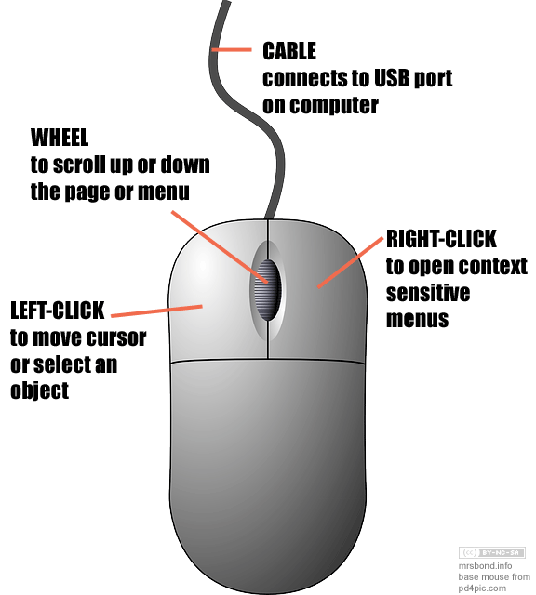

## Keyboard Shortcut

|  |  |
| --- | --- |
| Shortcut Keys | Description |
| [**Alt+F**](https://www.computerhope.com/jargon/a/alt-f.htm) | File menu options in current program. |
| [**Alt+E**](https://www.computerhope.com/jargon/a/alt-e.htm) | Open *Edit* options in current program. |
| [**Alt+Tab**](https://www.computerhope.com/jargon/a/alt-tab.htm) | Switch between open [programs](https://www.computerhope.com/jargon/p/program.htm). |
| [**F1**](https://www.computerhope.com/jargon/f/f1.htm) | View [help](https://www.computerhope.com/jargon/h/help.htm) information (F1 is used by almost every Windows program to display help). |
| [**F2**](https://www.computerhope.com/jargon/f/f2.htm) | [Rename](https://www.computerhope.com/jargon/r/rename.htm) a selected file. |
| [**F5**](https://www.computerhope.com/jargon/f/f5.htm) | [Refresh](https://www.computerhope.com/jargon/r/refresh.htm) the current program window. |
| [**Ctrl+D**](https://www.computerhope.com/jargon/c/ctrl-d.htm) | [Bookmarks](https://www.computerhope.com/jargon/b/bookmark.htm) the current page in most [Internet browsers](https://www.computerhope.com/jargon/b/browser.htm). |
| [**Ctrl+N**](https://www.computerhope.com/jargon/c/ctrl-n.htm) | Create a new or blank [document](https://www.computerhope.com/jargon/d/document.htm) in some software, or open a new [tab](https://www.computerhope.com/jargon/t/tab.htm) in most [Internet browsers](https://www.computerhope.com/jargon/b/browser.htm). |
| [**Ctrl+O**](https://www.computerhope.com/jargon/c/ctrl-o.htm) | [Open](https://www.computerhope.com/jargon/o/open.htm) a file in the current software. |
| [**Ctrl+A**](https://www.computerhope.com/jargon/c/ctrl-a.htm) | [Select all](https://www.computerhope.com/jargon/s/selectall.htm) text. |
| [**Ctrl+B**](https://www.computerhope.com/jargon/c/ctrl-b.htm) | Change selected text to be [bold](https://www.computerhope.com/jargon/b/bold.htm). |
| [**Ctrl+I**](https://www.computerhope.com/jargon/c/ctrl-i.htm) | Change selected text to be in [italics](https://www.computerhope.com/jargon/i/italic.htm). |
| [**Ctrl+U**](https://www.computerhope.com/jargon/c/ctrl-u.htm) | Change selected text to be [underlined](https://www.computerhope.com/jargon/u/underlin.htm). |
| [**Ctrl+F**](https://www.computerhope.com/jargon/c/ctrl-f.htm) | Open [find](https://www.computerhope.com/jargon/f/find.htm) window for current document or window. |
| [**Ctrl+S**](https://www.computerhope.com/jargon/c/ctrl-s.htm) | [Save](https://www.computerhope.com/jargon/s/save.htm) current document file. |
| [**Ctrl+X**](https://www.computerhope.com/jargon/c/ctrl-x.htm) | [Cut](https://www.computerhope.com/jargon/c/cut.htm) selected item. |
| **Shift+Del** | Cut selected item. |
| [**Ctrl+C**](https://www.computerhope.com/jargon/c/ctrlc.htm) | [Copy](https://www.computerhope.com/jargon/c/copy.htm) selected item. |
| [**Ctrl+Ins**](https://www.computerhope.com/jargon/c/ctrl-ins.htm) | Copy selected item |
| [**Ctrl+V**](https://www.computerhope.com/jargon/c/ctrl-v.htm) | [Paste](https://www.computerhope.com/jargon/p/paste.htm) |
| **Shift+Ins** | Paste |
| [**Ctrl+Y**](https://www.computerhope.com/jargon/c/ctrl-y.htm) | [Redo](https://www.computerhope.com/jargon/r/redo.htm) last action. |
| [**Ctrl+Z**](https://www.computerhope.com/jargon/c/ctrl-z.htm) | [Undo](https://www.computerhope.com/jargon/u/undo.htm) last action. |
| [**Ctrl+K**](https://www.computerhope.com/jargon/c/ctrl-k.htm) | Insert [hyperlink](https://www.computerhope.com/jargon/h/hyperlink.htm) for selected text. |
| [**Ctrl+P**](https://www.computerhope.com/jargon/c/ctrl-p.htm) | [Print](https://www.computerhope.com/jargon/p/print.htm) the current page or document. |
| [**Home**](https://www.computerhope.com/jargon/h/homekey.htm) | Goes to beginning of current [line](https://www.computerhope.com/jargon/l/line.htm). |
| [**Ctrl+Home**](https://www.computerhope.com/jargon/c/ctrl-home.htm) | Goes to beginning of document. |
| [**End**](https://www.computerhope.com/jargon/e/endkey.htm) | Goes to end of current line. |
| [**Ctrl+End**](https://www.computerhope.com/jargon/c/ctrl-end.htm) | Goes to end of document. |
| **Shift+Home** | [Highlights](https://www.computerhope.com/jargon/h/highligh.htm) from current position to beginning of line. |
| **Shift+End** | Highlights from current position to end of line. |
| **Ctrl+Left arrow** | Moves one [word](https://www.computerhope.com/jargon/w/word.htm) to the left at a time. |
| **Ctrl+Right arrow** | Moves one word to the right at a time. |
| [**Ctrl+Esc**](https://www.computerhope.com/jargon/c/ctrl-esc.htm) | Open the [Start menu](https://www.computerhope.com/jargon/s/startmen.htm). |
| [**Ctrl+Shift+Esc**](https://www.computerhope.com/jargon/c/ctrl-shift-esc.htm) | Open Windows [Task Manager](https://www.computerhope.com/jargon/t/taskmana.htm). |
| [**Alt+F4**](https://www.computerhope.com/jargon/a/alt-f4.htm) | Close the currently active program. |
| [**Alt+Enter**](https://www.computerhope.com/jargon/a/alt-enter.htm) | Open the [properties](https://www.computerhope.com/jargon/p/properti.htm) for the selected item (file, folder, shortcut, etc.). |

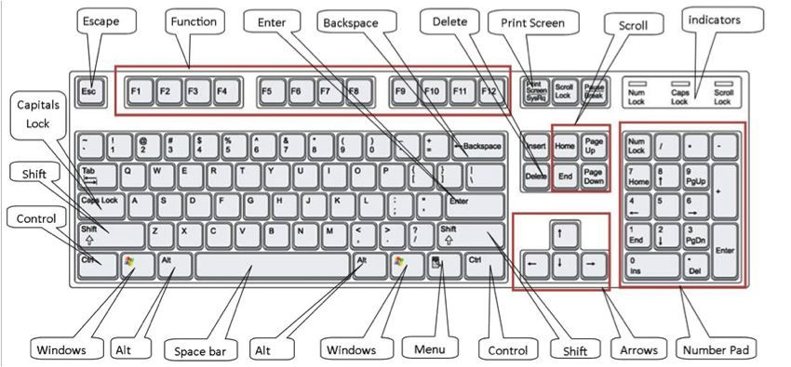

## The Desktop:

The desktop is the main screen area that you see after you turn on your computer and log on to Windows. Like the top of an actual desk, it serves as a surface for your work. When you open programs or folders, they appear on the desktop. You can also put things on the desktop, such as files and folders, and arrange them however you want.

The desktop is sometimes defined more broadly to include the taskbar and Windows Sidebar. The taskbar sits at the bottom of your screen. It shows you which programs are running and allows you to switch between them. It also contains the Start button , which you can use to access programs, folders, and computer settings. On the side of the screen, Sidebar contains small programs called gadgets.

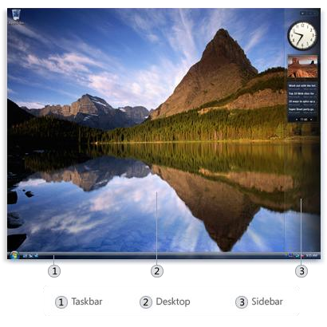

Working with desktop icons

Icons are small pictures that represent files, folders, programs, and other items. When you first start Windows, you'll see at least one icon on your desktop: the Recycle Bin (more on that later). Your computer manufacturer might have added other icons to the desktop. Some examples of desktop icons are shown below.

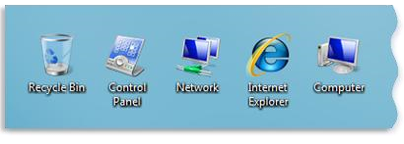

Examples of desktop icons

Double-clicking a desktop icon starts or opens the item it represents. For example, double-clicking the Internet Explorer icon starts Internet Explorer.

Adding and removing icons from the desktop

You can choose which icons appear on the desktop—you can add or remove an icon at any time. Some people like a clean, uncluttered desktop with few or no icons. Others place dozens of icons on their desktop to give them quick access to frequently used programs, files, and folders.

If you want easy access from the desktop to your favorite files or programs, create shortcuts to them. A shortcut is an icon that represents a link to an item, rather than the item itself. When you double-click a shortcut, the item opens. If you delete a shortcut, only the shortcut is removed, not the original item. You can identify shortcuts by the arrow on their icon.

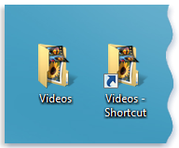

A folder icon (left) and a shortcut icon (right)

To add a shortcut to the desktop

1. Locate the item that you want to create a shortcut for (within Windows Explorer, or your Computer folder, for example).
2. Right-click the item, click Send To, and then click Desktop (create shortcut). The shortcut icon appears on your desktop.

To add or remove common desktop icons

### 

Common desktop icons include Computer, your personal folder, Network, the Recycle Bin, Internet Explorer, and Control Panel.

1. Right-click an empty area of the desktop, and then click Personalize.
2. In the left pane, click Change desktop icons.
3. Under Desktop icons, select the check box for each icon that you want to add to the desktop, or clear the check box for each icon that you want to remove from the desktop, and then click OK.

To move a file from a folder to the desktop

1. Open the folder that contains the file.
2. [Drag](mshelp://windows/?id=a02f310e-c1c4-4bc9-8706-4d0aadd51b6d#gtmt_gls_drag_def) the file to the desktop.

To remove an icon from the desktop

• Right-click the icon, and then click Delete. If the icon is a shortcut, only the shortcut is removed; the original item is not deleted.

Moving icons around

Windows stacks icons in columns on the left side of the desktop. But you're not stuck with that arrangement. You can move an icon by dragging it to a new place on the desktop.

You can also have Windows automatically arrange your icons. Right-click an empty area of the desktop, click View, and then click Auto Arrange. Windows stacks your icons in the upper-left corner and locks them in place. To unlock the icons so that you can move them again, click Auto Arrange again, clearing the check mark next to it.

**Note:** By default, Windows spaces icons evenly on an invisible grid. To place icons closer together or with more precision, turn off the grid. Right-click an empty area of the desktop, click View, and then click Align to Grid to clear the check mark. Repeat these steps to turn the grid back on.

Selecting multiple icons

To move or delete a bunch of icons at once, you must first select all of them. Click an empty area of the desktop and drag the mouse. Surround the icons that you want to select with the rectangle that appears. Then release the mouse button. Now you can drag the icons as a group or delete them.

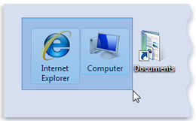

Select multiple desktop icons by dragging a rectangle around them.

Hiding desktop icons

If you want to temporarily hide all of your desktop icons without actually removing them, right-click an empty part of the desktop, click View, and then click Show Desktop Icons to clear the check mark from that option. Now no icons are displayed on the desktop. You can get them back by clicking Show Desktop Icons again.

## The Recycle Bin

When you delete a file or folder, it doesn't actually get deleted right away—it goes to the Recycle Bin. That's a good thing, because if you ever change your mind and decide you need a deleted file, you can get it back.



The Recycle Bin when empty (left) and full (right)

If you're sure that you won't need the deleted items again, you can empty the Recycle Bin. Doing that will permanently delete the items and reclaim any disk space they were using.

Picking a desktop background

One of the easiest ways to personalize your computer is to change the desktop background, also called the wallpaper. You can choose one of the backgrounds provided with Windows, pick a favorite digital picture from your own collection, or use a solid background color. You can also find pictures on the Internet designed to be used as desktop backgrounds.

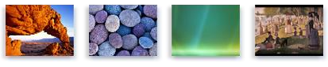

Sample desktop backgrounds provided with Windows

To change the desktop background

1. Right-click on your desktop and choose Personalize.
2. Click the Desktop Background link.
3. Click the picture or color you want for your desktop background.

If the picture you want to use is not in the list of desktop background pictures, click Browse to search for the picture on your computer. When you find the picture you want, double-click it. It will become your desktop background and appear in the list of desktop backgrounds.

1. Under How should the picture be positioned, choose to have the picture fit the screen, tile, or be centered on the screen, and then click OK.

**Note:** If you choose to have a centered picture as your desktop background, you can also have a color background to frame your picture. Under How should the picture be positioned, click Change background color, click a color, and then click OK.

Tip

• You can make any picture on your computer your desktop background by right clicking the picture, and then clicking Set as Desktop Background.

To change the theme to Windows Classic

1. Right-click on your desktop and choose Personalize.
2. Under Theme, select the Windows Classic theme in the drop-down list, and then click OK.

## E-Mail Address

To send or receive an email, you must have an email address. This address is unique in nature and it has two important parts. The first part is the ‘user name’ and the other is the ‘domain name’. These two are separated by a special symbol @. The domain name can be same for lots of people. For example cmfri@gmail.com and cmfri1@gmail.com are two addresses with the same domain name gmail.com. But the user names cmfri and cmfri1 are different and hence the addresses are different.

Creating an E-Mail Account

Email, short for Electronic Mail, is a component of internet. It is a fast and economic way of sending messages to individuals and groups of people. Messages can include text, pictures or animations.



This section discusses on creation and accession of an email account, opening and reading of received mails and composing and sending mails. Several sites on the internet allow you to create an email account and send and receive email and attachments for free, for example gmail.com, hotmail.com, rediff.com, yahoo.com. This session focus on the services available through Gmail as it is free and is the most popular email service available today.

Setting up an email account

1. Connect to the Internet by double-clicking the Google chrome, Internet Explorer or Firefox desktop icon.
2. Go to the Gmail site by typing gmail.com into the address bar at the top of the screen, and press the Enter key on your keyboard.
3. You should see a screen that looks like this:



1. Click on the Create an Account link at the bottom of the box and following window will be displayed. Complete all starred information in the form, beginning with the Get Started section. Finally, you have to agree to the Terms of Service. Read through the text, and then click "I Agree." So now you have created an email account and your email address is your Google Login Name followed by "@gmail.com."

Checking Your Email

Once you have set up your email account, you can check your mail anywhere that you can access the Internet. For this follow the steps given below.

1. Connect to the Internet by double-clicking the Google chrome, Internet Explorer or Firefox icon.
2. Go to the Gmail site by typing gmail.com into the address bar at the top of the screen.
3. Type your Google Login Name and Password into the box on the right.
4. The next page will show you the number of new messages in your Inbox.

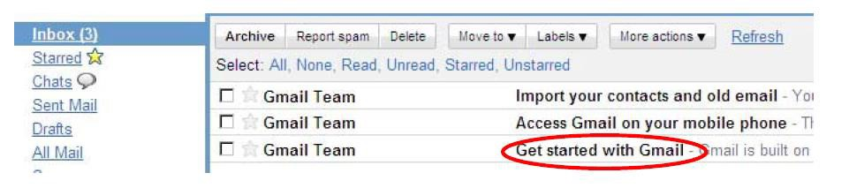

The inbox is where all of your incoming messages are stored. Click on the subject of the message to open and read it.

Composing and Sending Messages

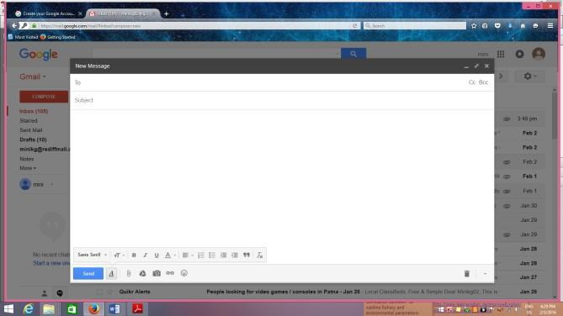To create a new message, click the Compose button on the top left side of the screen. Type the email address of the person(s) to whom you wish to send the email in ‘To‘. Once you have completed your message, send it by clicking on the Send button at the bottom of the window.

Gmail Help

For any help in connection with Gmail, Help link is given at the top right corner of the Gmail page.

Setting up a Gmail account

To create a Gmail address, you'll first need to create a Google account. Gmail will redirect you to the Google account signup page. You'll need to provide some basic information like your name, birth date, gender, and location. You will also need to choose a name for your new Gmail address. Once you create an account, you'll be able to start adding contacts and adjusting your mail settings.

To create an account:

1. Go to [**www.gmail.com**](https://www.gmail.com/).
2. Click Create account.

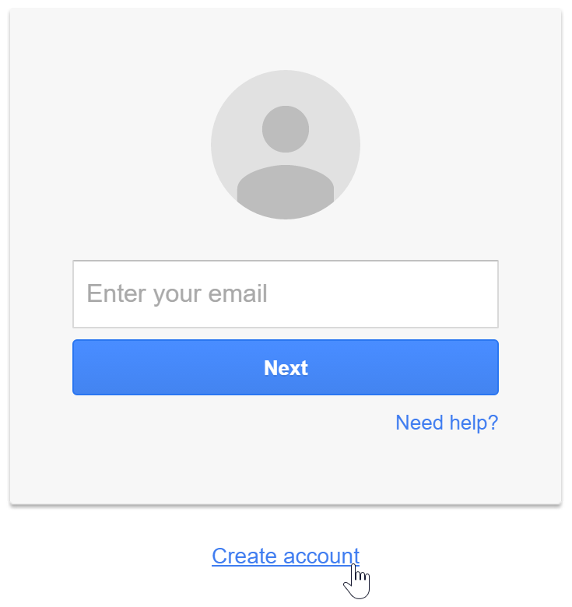

1. The signup form will appear. Follow the directions and enter the required information.

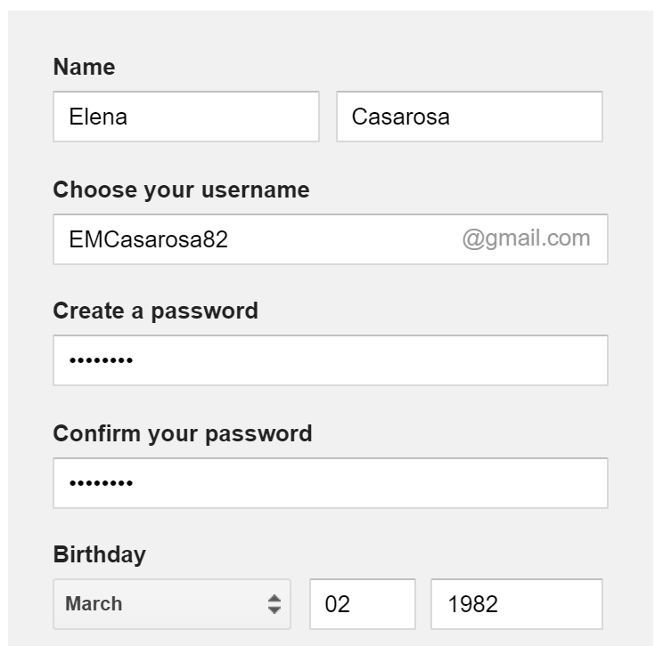

1. Review [**Google's Terms of Service**](https://www.google.com/intl/en/policies/terms/) and [**Privacy Policy**](https://www.google.com/intl/en/policies/privacy/), click the check box, then click Next step.

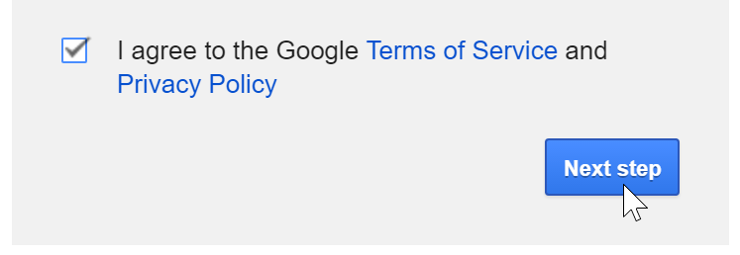

1. Here, you'll have an opportunity to set up recovery options. Recovery options are helpful if you forget your password or if someone tries to access your account. If you don't want to set up recovery options at this time, click Done.



1. Your account will be created, and the Google welcome page will appear.



Signing in to your account

When you first create your account, you will be automatically signed in. Most of the time, however, you'll need to sign in to your account and sign out when you're done with it. Signing out is especially important if you're using a shared computer (for example, at a library or office) because it prevents others from viewing your emails.

To sign in:

Go to [**www.gmail.com**](https://www.gmail.com/).

Type your user name (your email address) and password, then click Sign in.

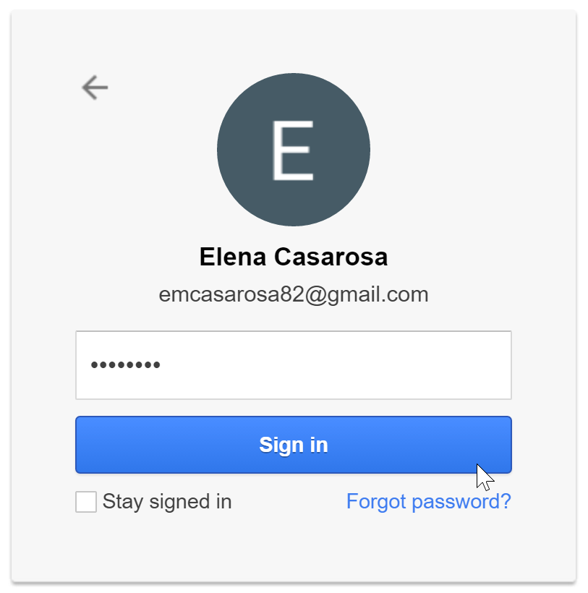

**To sign out:**

In the top-right corner of the page, locate the circle that has your first initial (if you've already selected an avatar image, it will show the image instead). To sign out, click the circle and select Sign out.

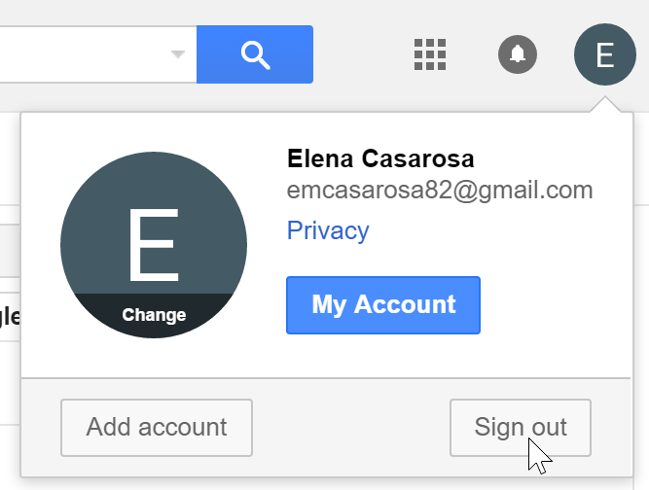

### Mail settings

Occasionally, you may want to make adjustments to Gmail's appearance or behavior. For example, you could create a signature or vacation reply, edit your labels, or change the theme. These adjustments can be made from your mail settings.

To access your mail settings:

1. Click the gear icon in the top-right corner of the page, then select Settings.

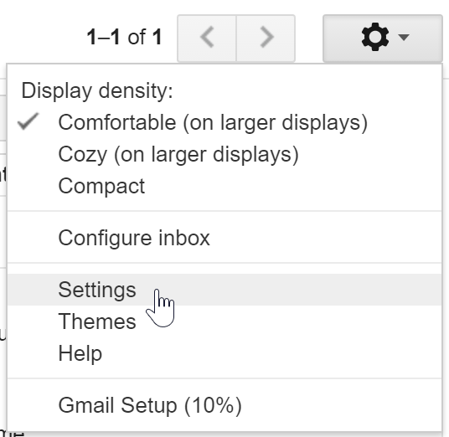

1. From here, you can click any of the categories at the top to edit the desired settings.

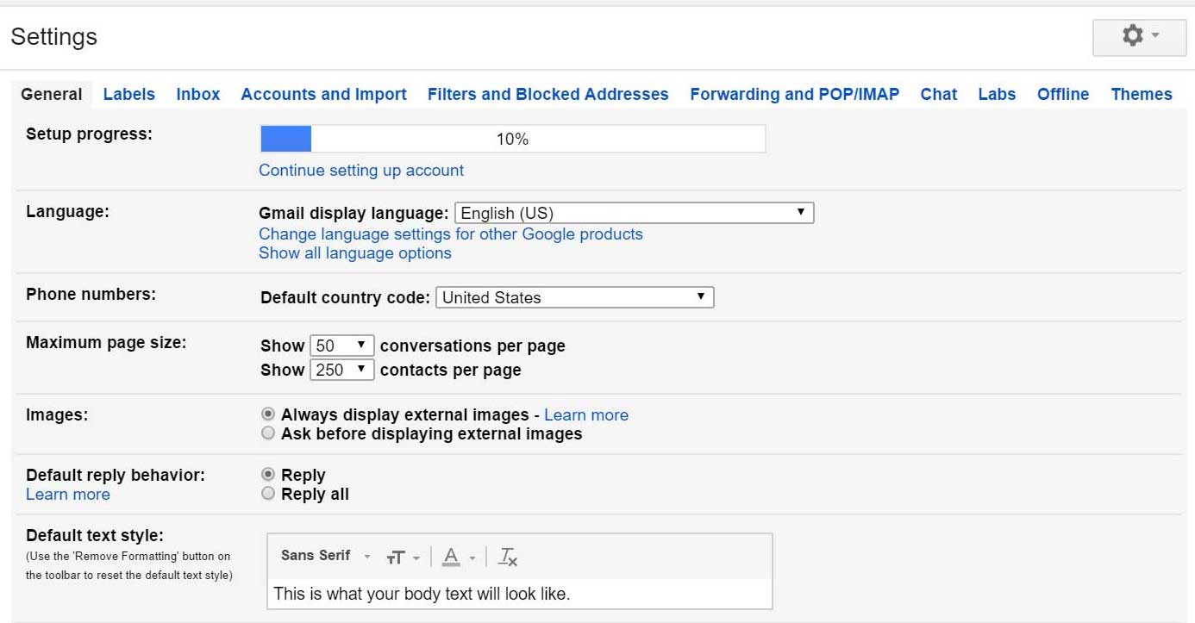

Adding contacts

Like all major email providers, Gmail lets you keep an address book of contacts so you don't have to memorize everyone's email addresses. You can also add other contact information, like phone numbers, birthdays, and physical addresses.

To add a contact:

1. In the Gmail drop-down menu, select Contacts.

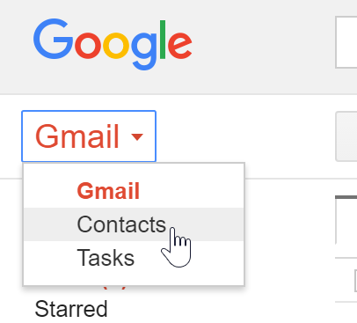

1. Your contacts screen will appear. Click Add new contact.



1. Type the person's name or email address. If they have a Google+ profile, it may appear below. Click Create to add the contact.

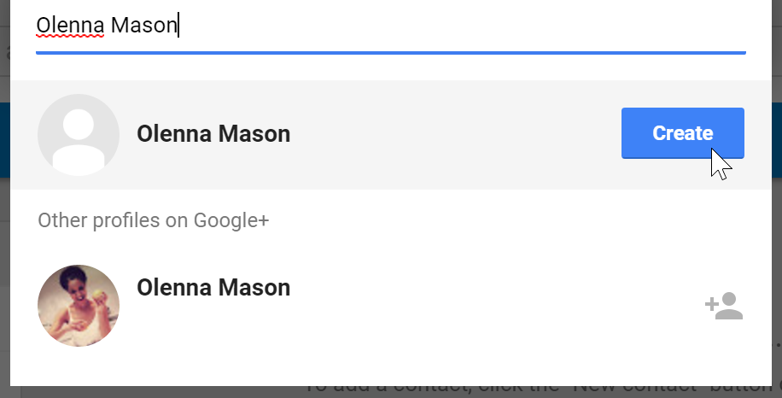

1. You can also type additional contact information if desired. All changes you make will be saved automatically.

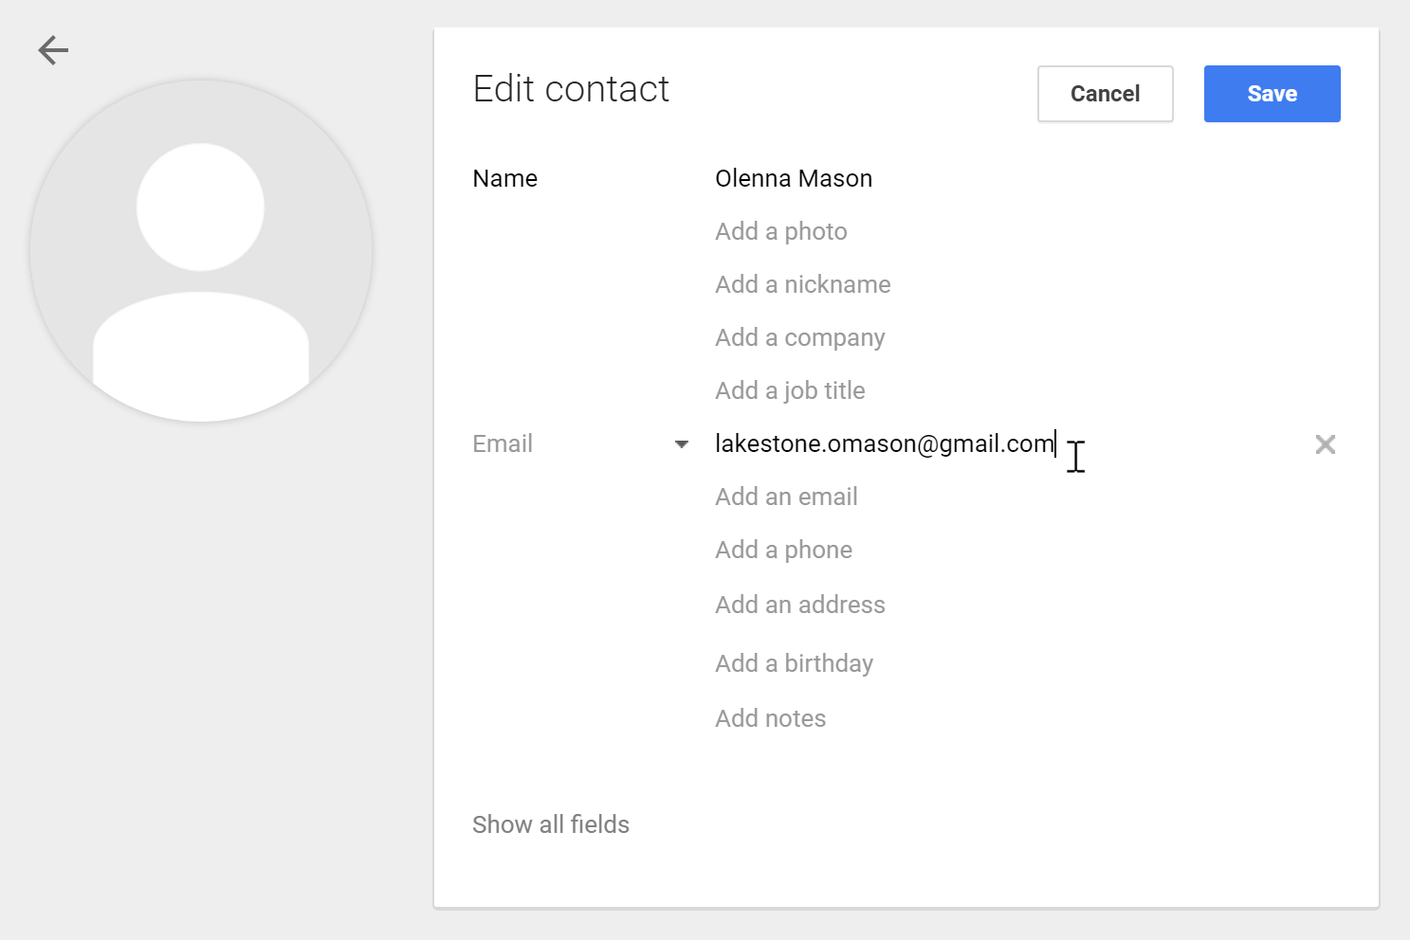

To edit a contact:

1. In the Gmail drop-down menu, select Contacts.



1. Click the contact you want to edit.

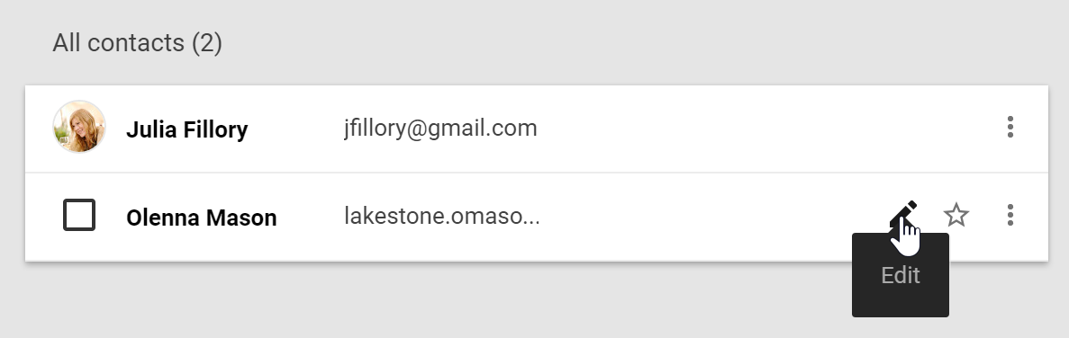

1. You can now make any changes you want to the contact.

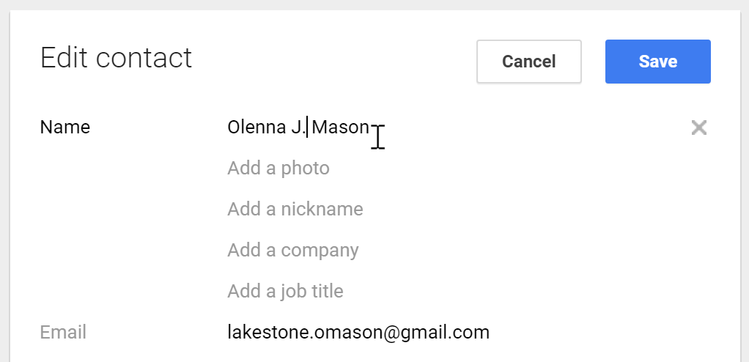

By default, when you send an email to a new address, Gmail adds the address to your contacts. You can then go to your contacts to edit the person's information as needed.

Importing mail and contacts

You may already have a contact list from another email address, and it would be a lot of work to re-enter all of this information manually. Gmail allows you to import your contacts from another email account, and you can even import all of your email messages from that account. Several email providers are supported, including Yahoo!, Hotmail, and AOL.

To add other accounts:

1. Click the gear icon in the top-right corner of the page, then select Settings.
2. Go to Accounts and click Add a POP3 mail account you own. You can then follow the instructions on the screen to import your mail.

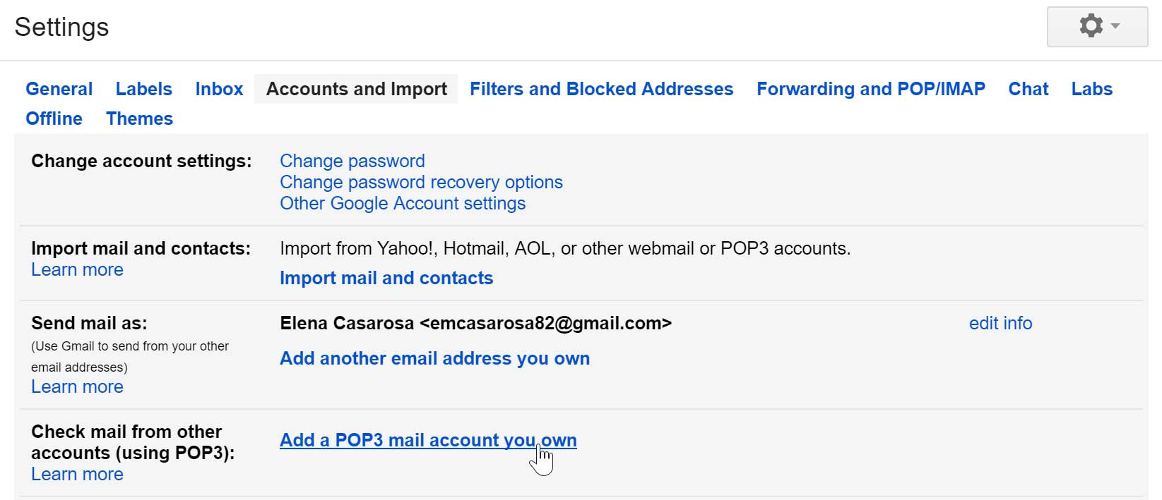

# Experiment # 02

## MS Word/ word processor:

**The MS word package is used to prepare and edit text.** Word processors are used to create all types of documents such as letters, reports and essays. Using a word processor you can type, revise and correct a document on the screen before printing it out. The layout of the page can be changed and a wide variety of different styles of text can be used to improve the presentation of a document. Tools such as spelling checkers can help ensure that the contents of a document are accurate.

The functions of a word processor can be divided up into several different categories:

* **Page Layout**: The page layout functions let you decide how each page will be set out.
* **Text Presentation**: The appearance of text can be easily altered. Different fonts and styles can be used and the size of text can be varied. Text can be neatly lined up on the page.
* **Editing of Text**: Text editing functions are used to revise and change text that you have entered.
* **Blocks of Text**: The style and position of selected blocks of text can be changed.
* **Text Analysis**: The word processor can look at your document and try to highlight any errors such as spelling or grammatical mistakes that you have made.
* **Templates**: Template files let you save favorite document layouts that you have created so that you can use them over and over again.
* **Other Features**: Most modern word processors will offer lots of extra features such as tables, bullet points and fancy text effects.
* **Mail Merging**: A database of names and addresses can be used to personalize letters that have been created in a word processor.

## Getting Started

Microsoft Office Icon/ File Menu

Microsoft Office Button is located on the top left corner of the window.It is a new user interface feature that replaced the traditional "File" menu. You can also see this button in Outlook while creating a new message, task, contact, etc.

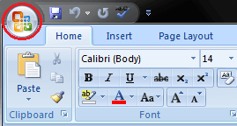

Click the button it offers a list of commands to perform different tasks which are New, Open, Save, Save As, Print, Prepare, Send, Publish and Close. These commands are described below the following image.

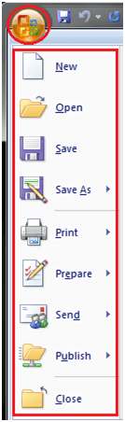

New: This command enables you create a new file, i.e. Word document.

Open: This command allows you to open an existing file on the computer.

**Save:** This command is used to save a file after completing the work. You can also save the changes made to the currently open file.

**Save As:** This command helps you save a new file with a desired file name to a desired location on the hard drive.

**Print:** This command is used to print a hard copy of the currently open document.

**Prepare:** This command allows you to prepare the document for distribution, i.e. you can view and edit the document properties and inspect the hidden metadata.

**Send:**This command allows you share the document with other users, i.e. you can send a document through e-mail or by posting to a blog.

**Publish:** This command allows you distribute the document to other people, i.e. you can create a blog with the content of the document.

Close: This command is used to close the currently open file.

### Quick Access Toolbar

Quick Access Toolbar lies next to the Microsoft Office Button. It is a customizable toolbar that comes with a set of independent commands. It gives you quick access to commonly used commands such as Save, Undo, Redo, etc.

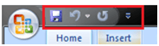

When you click the drop-down arrow next to toolbar it offers more commands. With a left click you can add any of these commands to Quick Access Toolbar. You can also remove the commands added to the tool bar. The indent, spacing values, individual styles and other features that appear on the ribbon cannot be added to quick access toolbar. The following image is showing the menu of quick access toolbar.

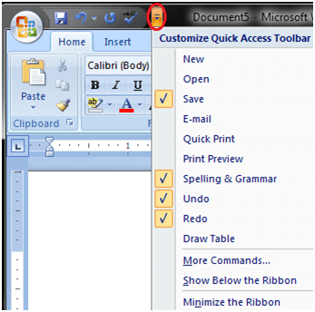

### Title Bar

It lies next to the Quick Access Toolbar. It displays the title of the currently open document or application. It is present on almost all windows displayed on your computer. So, if there are several windows across the screen, you can identify each window by looking at the title bar. In many graphical user interfaces, you can also move a window by dragging the title bar.



### Ribbon and Tabs

The Ribbon is a user interface element which was introduced by Microsoft in Microsoft Office 2007. It is located below the Quick Access Toolbar and the Title Bar. It comprises seven tabs; Home, Insert, Page layout, References, Mailing, Review and View. Each tab has specific groups of related commands. It gives you quick access to the commonly used commands that you need to complete a task.

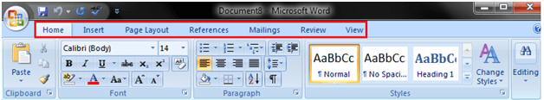

Home tab:

The Home tab is the default tab in Microsoft Word. It has five groups of related commands; Clipboard, Font, Paragraph, Styles and Editing. It helps you change document settings like font size, adding bullets, adjusting styles and many other common features. It also helps you to return to the home section of the document.

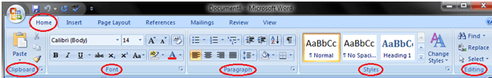

Insert tab:

Insert Tab is the second tab in the Ribbon. As the name suggests, it is used to insert or add extra features in your document. It is commonly used to add tables, pictures, clip art, shapes, page number, etc. The Insert tab has seven groups of related commands; Pages, Tables, Illustrations, Links, Header & Footer, Text and Symbols.

SQL CREATE TABLE

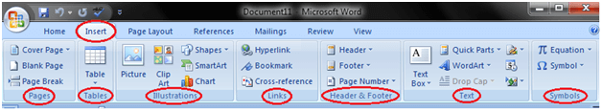

Page Layout tab:

It is the third tab in the Ribbon. This tab allows you to control the look and feel of your document, i.e. you can change the page size, margins, line spacing, indentation, documentation orientation, etc. The Page Layout tab has five groups of related commands; Themes, Page Setup, Page Background, Paragraph and Arrange.

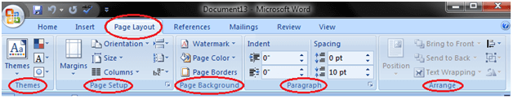

References tab:

It is the fourth tab in the Ribbon. It allows you to enter document sources, citations, bibliography commands, etc. It also offers commands to create a table of contents, an index, table of contents and table of authorities. The References tab has six groups of related commands; Table of Contents, Footnotes, Citations & Bibliography, Captions, Index and Table of Authorities.

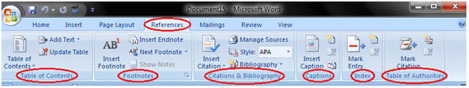

Mailings tab:

It is the fifth tab in the ribbon. It is the least-often used tab of all the tabs available in the Ribbon. It allows you merge emails, writing and inserting different fields, preview results and convert a file into a PDF format. The Mailings tab has five groups of related commands; Create, Start Mail Merge, Write & Insert Fields, Preview Results and Finish.

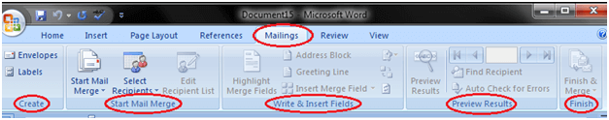

Review tab:

It is the sixth tab in the Ribbon. This tab offers you some important commands to modify your document. It helps you proofread your content, to add or remove comments, track changes, etc. The Review tab has six groups of related commands; Proofing, Comments, Tracking, Changes, Compare and Protect.

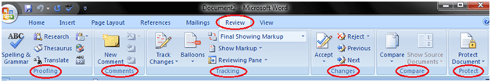

View tab:

The View tab is located next to the Review tab. This tab allows you to switch between Single Page and Two Page views. It also enables you to control various layout tools like boundaries, guides, rulers. Its primary purpose is to offers you different ways to view your document. The View tab has five groups of related commands; Document Views, Show/Hide, Zoom, Window and Macros.

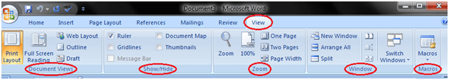

Ruler

The Ruler is located below the Ribbon around the edge of the document. It is used to change the format of the document, i.e. it helps you align the text, tables, graphics and other elements of your document. It uses inches or centimeters as the measurements unit and gives you an idea about the size of the document.

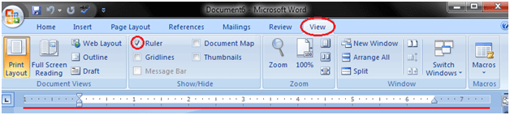

## Basic Text:

### Insert Text in MS Word

The basic steps to insert text or to create a new document in Word are listed below;

* Go to the start menu and look for Microsoft Word icon
* Click the icon to open the Microsoft Word
* You will see a blinking cursor or insertion point in the text area below the ribbon
* Now, as you start typing, the words will appear on the screen in the text area
* To change the location of insertion point press spacebar, Enter or Tab keys

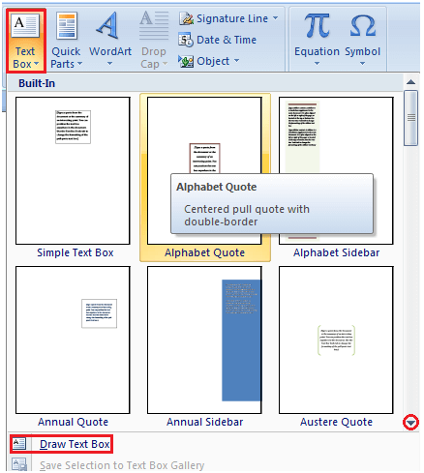

### Delete Text in MS Word

You can easily delete the text in Word including characters, paragraphs or all of the content of your document. Word offers you different methods to delete the text; some of the commonly used methods are given below;

* Place the cursor next to the text then press Backspace key
* Place the cursor to the left of the text then press Delete key
* Select the text and press the Backspace or Delete key
* Select the text and type over it the new text.

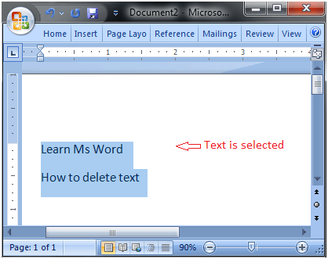

### Select Text in MS Word

Place the cursor next to the text then left click the mouse and holding it down move it over the text then release it. The text will be selected.

Some shortcuts for selecting text are:

* To select a single word double click within the word
* To select the entire paragraph triple click within the paragraph
* To select entire document, in Home tab, in Editing group click Select then choose Select All option or press CTRL+A
* o Shift + Arrow; hold down the shift key then press the arrow key, the word will select the text in the direction of the arrow key. There are three arrow keys, so you can select the text in three different directions.

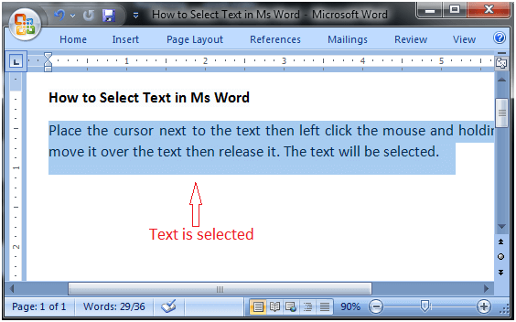

# 

### Copy and Paste Text in MS Word

Word offers different methods to copy and paste text. Some of the popular methods are given below;

Method 1;

* Select the text you want to copy
* Select the Home tab and click the Copy command
* Place the cursor where you want to paste the text
* Click the Paste command in Home tab

Method 2;

* Select the text
* Place the cursor over the text and right click the mouse
* A menu will appear; with a left click select the "Copy" option
* Now, move the cursor to a desired location and right click the mouse
* A menu will appear; with a left click select the 'Paste" option.

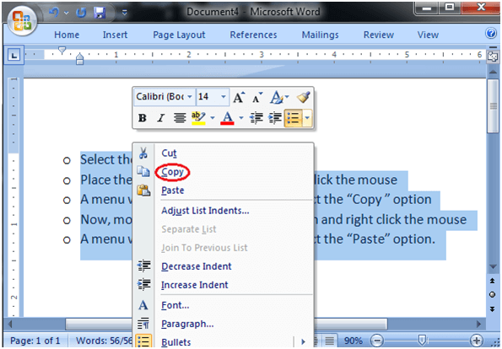

### Save the Document in MS Word

When you create a document it is important to save the document so that it can be viewed or reused later. The basic steps to save a document are listed below;

* Click the Microsoft Office Button
* A list of different commands appears
* Click the 'Save As' command
* it displays 'Save As' Dialogue Box
* Save the document to desired location with a desired name

You can also choose 'Save' command from the list to save the document to its current location with same title. If you are saving a fresh document it displays 'Save As' dialogue box.

The shortcut method to save a document is to press "Ctrl+S" keys. It opens the 'Save As' dialogue box where you can name you document and save it to a desired location.

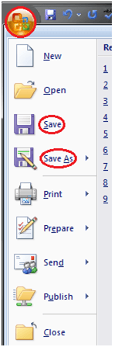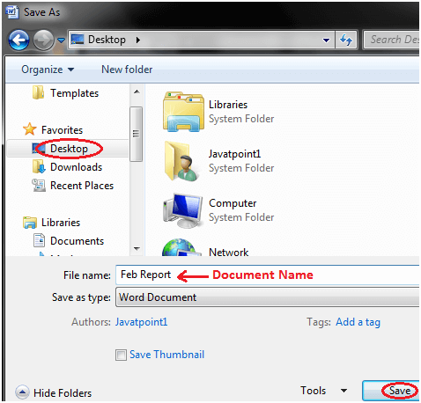

# 

# Experiment#3

## Proofing Features

### Correct Errors in Ms Word

When you type text in a document, by default the Word informs you if there is any contextual, spelling or grammatical error. Word informs you in different ways for different errors;

If there is any contextual error in the document, it will underline the text with blue line.

If there is any spelling error in the document, it will underline the text with red line.

If there is any grammar error in the document, it will underline the text with green line.

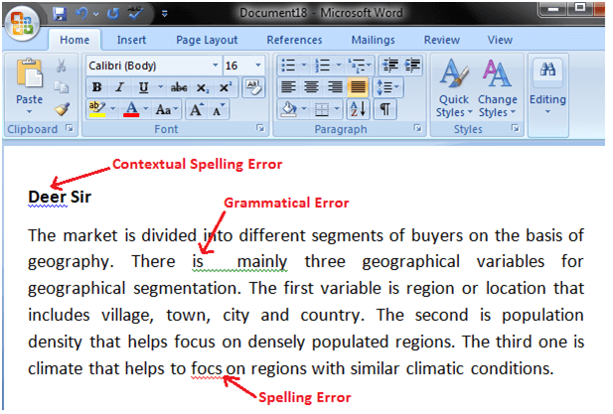

* Place the cursor over the text that you want to correct
* Right click the mouse
* A list of suggestions appears
* Choose the correct word with a left click

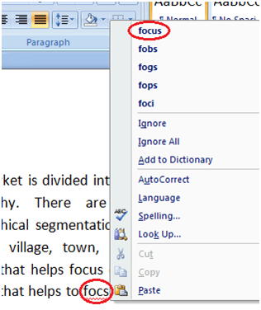

### Check Word Count in Ms Word

When you start typing, the Word automatically counts the number of words and number of pages and displays the information on the status bar. If the word count is not available on the status bar, you can right click the status bar and select the Word Count option from the menu. Basic steps to check the word count are listed below;

* Open the document
* Look at left bottom corner of the document
* You will see the total world count and the number of pages

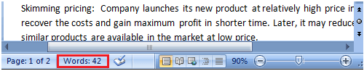

To know the word count of a specific line or paragraph you have to select it then Word will display its word count along with the total word count, e.g. 15/40. In this example, the selection has 15 words out of the total number of words (40).

## Formatting Text

### Change Font Size in MS Word

You can easily change the font size of your text in the document. The basic steps to change the Font size are listed below;

* Select the text that you want to modify
* In Home tab locate the Font group
* In Font group click the drop-down arrow next to font size box
* Font size menu appears
* Select the desired font size with a left click
* Select the text and click the increase or decrease font size buttons

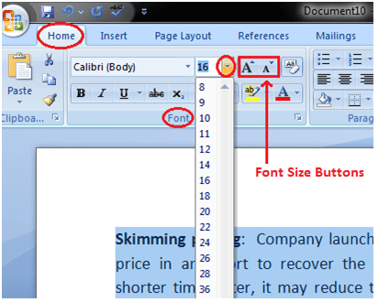

### Change Font Style in MS Word

The basic steps to change the font of a text in a document are given below;

* Select the text you want to modify
* Select the Home tab and locate the Font group
* Click the drop-down arrow next to font style box
* Font style menu appears
* With a left click select the desired font style
* If you want to change the font to bold or italic, click the 'B' or 'I' icons on the format bar.

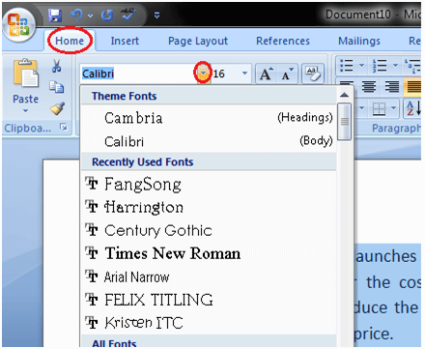

## Format Font Color in MS Word

MS Word allows you to change the Font color of your text. If you want to emphasize a particular word or phrase, you can change its font color. The basic steps to change the Font color are given below;

* Select the text you want to modify
* In Home tab locate the Font group
* Click the drop-down arrow next to Font color button
* Font color menu appears
* Select the desired font color with a left click
* Word will change the Font color of the selected text.

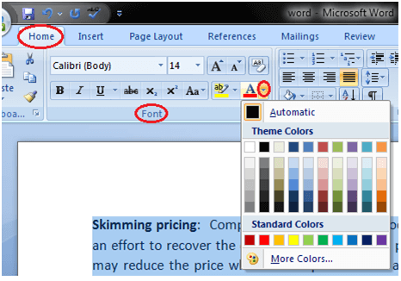

### Change Text Case in MS Word

You can easily change the text case in your document by following the steps given below;

* Select the text you want to change
* In Home tab locate the Font group
* Click the drop-down arrow in 'Change Case' button
* It displays text case menu
* Select the desired case with a left click

The case menu offers four options;

Sentence case: It capitalizes the first letter of each sentence.

Lowercase: It changes the text from uppercase to lowercase.

Uppercase: It capitalizes all the all letters of your text.

Capitalize Each Word: It capitalizes the first letter of each word.

Toggle Case: It allows you to shift between two case views, e.g. to shift between Capitalize Each Word and cAPITALIZE eACH wORD .

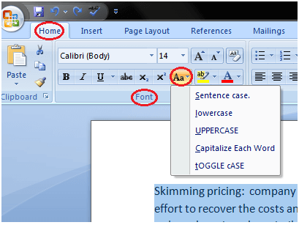

### Change Text Alignment in MS Word

You can change the text alignment in your document to make it more presentable and readable. The basic steps to change the text alignment are given below;

* Select the content you want to modify
* In Home tab locate the Paragraph group
* It has four alignment options ;

Align Text Left: Aligns the text towards left margin

Center: Brings the text at centre

Align Text Right: Aligns the text towards right margin

Justify: Aligns the text to both left and right margins

* Select the desired alignment option with a left click

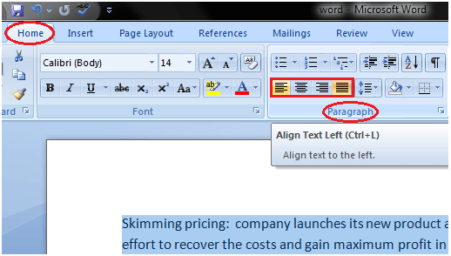

### Insert a Text Box in MS Word

Text box allows you to control the position of a block of text in your document. You can also format them with borders and shading. The two commonly used methods to insert Text Boxes are given below:

Method 1:

* Select the Insert tab
* Locate the Text group
* Click the Text Box button
* It displays Built-In text box menu and an option to draw table
* With a left click select the desired text box format from the menu

Method 2:

• Select 'Draw Text Box' option

• A cross shaped cursor appears

• Left click the mouse and holding it down drag it to draw the box of desired dimensions



### Bold, Italic and Underline Commands in MS Word

These commands are given in the Font group in the Home tab. Their functions are given below;

* Bold: It allows you to Bold the text of your document
* Italic: It allows you to Italicize the text of your document
* Underline: It allows you to underline the text of your document

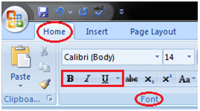

## Formatting Paragraph

### Create First Line Indent in MS Word

You can create indent within your paragraph by following these steps;

* Select the paragraph or place the cursor anywhere within the paragraph
* Select the Home tab
* Locate the Paragraph group and click the arrow at right bottom corner
* 'Paragraph' dialog box appears
* In 'Indents and Spacing' section click the drop down arrow in 'Special' field
* Select the 'First Line' option
* Enter desired indent in 'By' field and click Ok

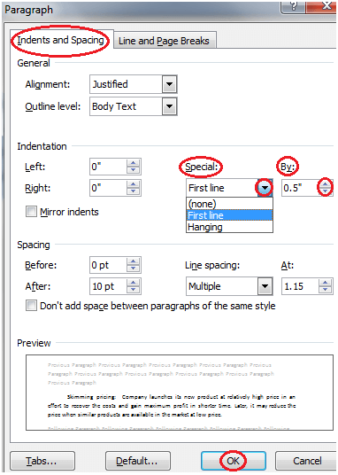

### Apply Style in MS Word

You can create professional and presentable documents in MS Word by applying different styles. The basic steps to apply a style in a document are listed below;

* Select the text to which you want to apply the style
* Select the Home tab
* In Styles group you will see different styles;

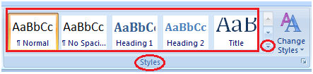

* To view more styles click the drop-down arrow
* It displays style menu
* Select the desired style with a left-click

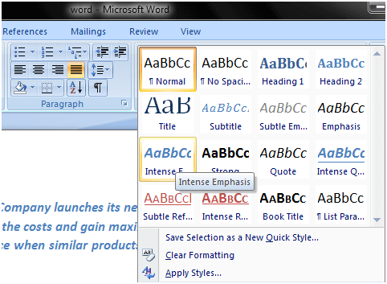

## Customize Style in MS Word

If you are looking for formatting options that are not given in the built-in styles, you can modify or customize an existing style to fulfill your needs. The steps to customize a style are as follows;

* Select the style that you want to modify
* Right click the mouse
* It displays a list of different commands
* Select the 'Modify' option;

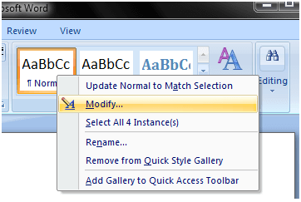

* 'Modify Style' dialogue box appears

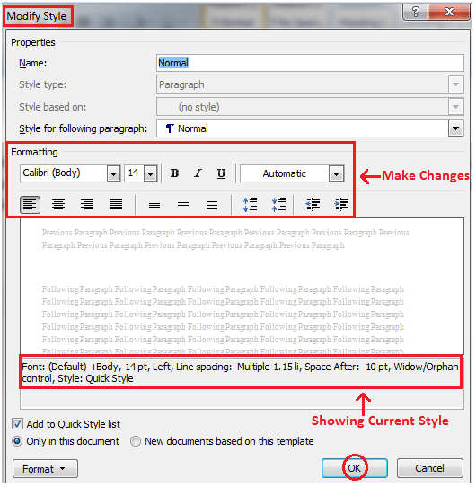

* Make the desired changes to formatting
* Click OK to apply the changes to style

### Create New Style in MS Word

You can add new styles to your list of styles, i.e. Word allows you to set the styles for font, figure, paragraph, etc. It helps you to keep consistency in all the documents of a topic or subject. The steps to create new styles are given below;

* Select the Home tab
* In Styles group click the arrow at the right bottom corner of the group
* It displays the 'Styles' task pane;

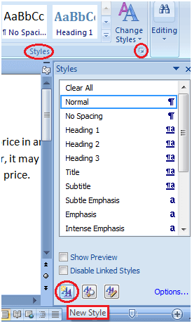

In 'Styles' task pane click the 'New Style' button

It displays 'Create New Style from Formatting' dialogue box;

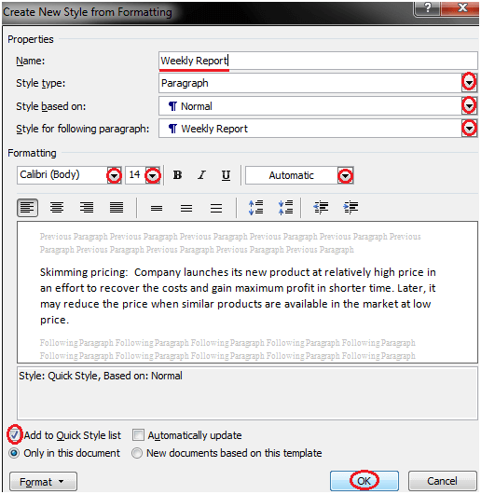

* Enter the name for new style and make all the desired changes
* Click OK, the new style will be added to the list of styles

# Experiment#4

## Modify Page Layout

### Change Page Orientation in MS Word

Page Orientation refers to the direction in which a document is displayed. It is of two types; portrait (vertical) and landscape (horizontal). The default orientation is portrait; it can be changed to landscape by following these steps;

* Select the Page Layout tab
* Locate the Page Setup group
* In Page Setup group click the Orientation command
* It displays two options, Portrait and Landscape
* Select the desired page orientation

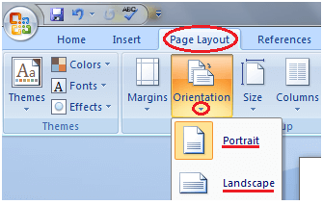

### Change Page Size in MS Word

The default paper size in Word is 8.5 x 11 inches which easily fits in printers. This size is not fixed; you can change it if you want a document with different paper size. The steps to change the paper size are given below;

* Click the Page Layout tab
* In Page Setup group click the Size command
* Paper size menu will appear
* With a left click select the desired paper size
* To customize page size click the 'More Paper Sizes' option

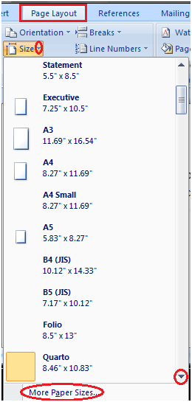

### Change Page Margins in MS Word

The margin is the space between the text and border of a document. By default, it is a one-inch space. Depending on your needs, it can be changed by following the below-listed steps;

* Select the Page Layout tab
* In Page Setup group click the Margins command
* A list of Margins appears
* Select the desired Margin with a left click

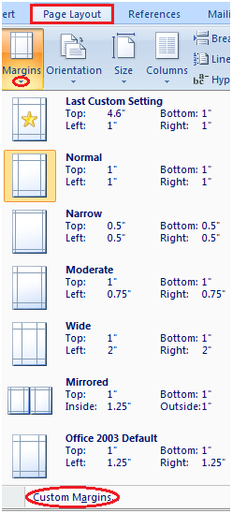

### Insert Page Break in MS Word

Word inserts a page break at the end of each page. It also allows you to insert a page break at some other place in the document. The steps to insert page break are given below;

* Place the cursor where you want to insert the break
* Select the Page Layout tab
* In Page Setup group click the 'Breaks' command
* A list of Page Breaks appears
* With a left click select the desired page break from the list

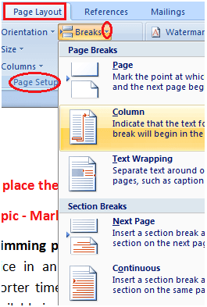

### insert a header and footer in Microsoft Word document

In Microsoft Word, Headers and Footers are used to insert additional information such as title, file name, date, page numbers, etc. The presence of both header and footer in the Word document makes your document more professional and easier to read as well as understand.

Headers appear at the top margin of the Word document, while Footers appear at the bottom margin of the Word document.

To insert a header and footer in [Microsoft Word](https://www.javatpoint.com/ms-word-tutorial), follow the below given basic steps -

Step 1: Open the new or an existing Word document in which you want to insert header and footer.

Step 2: Go to the Insert tab at the top of the Ribbon.

Step 3: Click on either header or footer drop-down menu in the Header & Footer section.

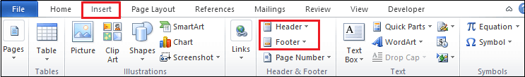

Step 4: A Header or Footer drop-down menu will display on the screen with a list of built-in Header or Footer options. Select your desired option from the Built-in list.

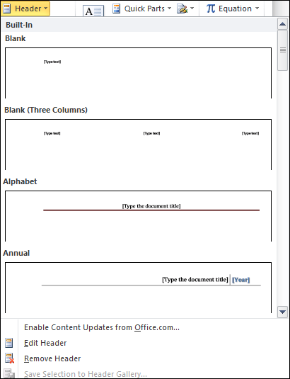

Step 5: A Design tab with Header & Footer option will appear at the top of the document (on the Ribbon), as shown in the below screenshot.

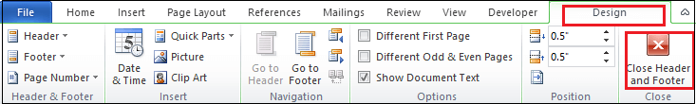

Step 6: Type your desired information into the header or footer section.

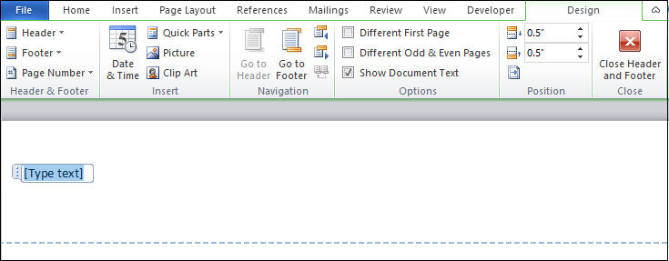

Step 7: Once you type your desired text in the Header section, click on Close Header and Footer under the Design section on the Ribbon or press the Esc key from the keyboard to remove the dotted underline. Now, you can see that the Header is inserted to the Word document.

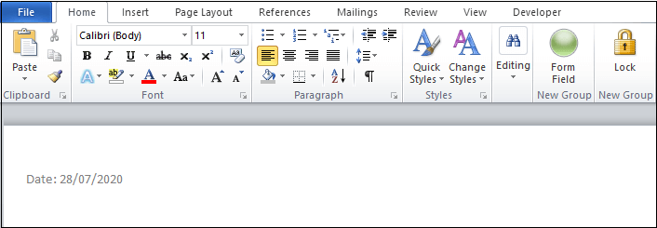

### Insert the Date or Time in a Header or Footer

To insert the Date or Time in a Header or Footer, follow the below instructions -

1. Go to the Insert tab on the Ribbon and click on the Date & Time option in the Text section.

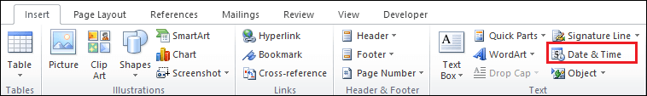

2. A Date and Time dialog box will appear on the screen in which do the following -

* Select Date format from the Available format.
* Select your desired language.
* Tick on the Update automatically checkbox.
* Click on the OK button at the bottom of the dialog box.

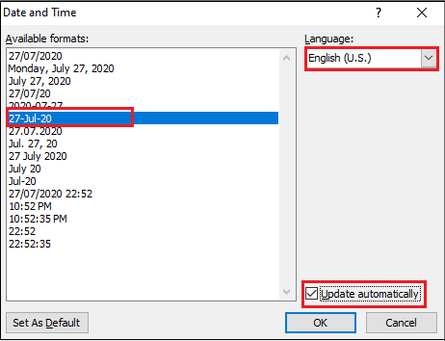

Now, you can see that your selected format will appear on the Word document.

### Edit Header and Footer in Word document

Once you create Header and Footer in Word document, you can also edit it based on your requirement.

There are the following steps to edit Header and Footer in Word document.

Step 1: Go to the Insert tab on the Ribbon and click on either Header or Footer drop-down menu that you want to Edit.

Step 2: A Built-In Header option window will appear on the screen. Click on the Edit Header option.

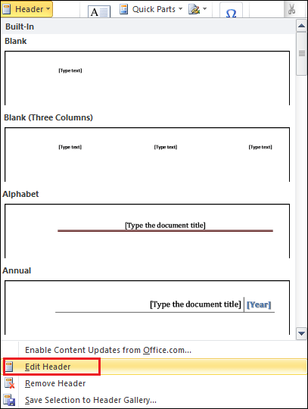

Step 3: Edit Header based on your requirement. Once you edit Header, click on the Close Header and Footer option at the top right corner of the document to disappear the blue dotted lines.

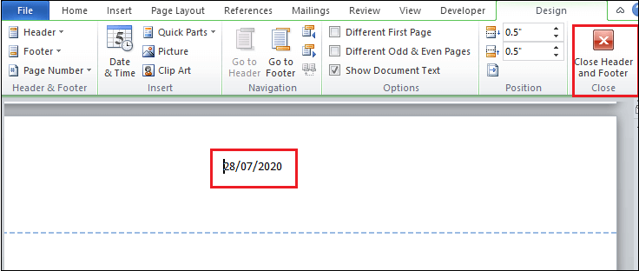

Now, you can see that Header is edit based on your requirement.

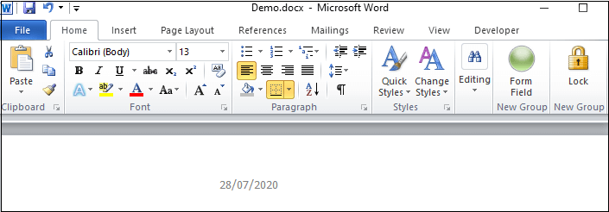

### Delete Header and Footer from Word document

To Delete Header and Footer from Word document, follow the below steps -

1. Go to the Insert tab on the Ribbon and click on the Header & Footer option.
2. A Header or Footer dialog will appear on the screen. Click on the Remove Header or Remove Footer option.

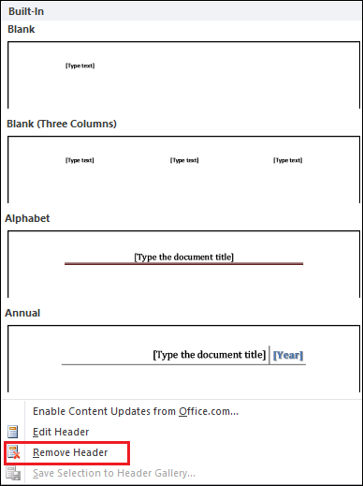

## Working with Tables

### Insert Table in MS Word

Table is a versatile tool of MS Word. It allows you to organize your information, i.e. you can align text, present numerical data and create forms and calendar. The steps to insert table are given below;

* Place the cursor where you want to insert the table
* Select the Insert tab
* In Tables group click the Table command
* It displays different options to insert the table
* Select the desired option to insert the table

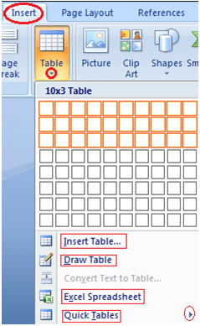

## To Convert Text to Table

* Select the text
* Select the Insert tab
* In Tables group click the Table command
* Select the 'Convert Text to Table' option;

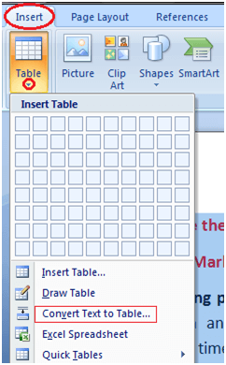

* It displays a dialog box
* In 'Separate text at' section select the desired option
* Click OK, the text will convert to a table

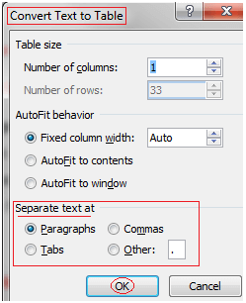

### Add Row in Table

If you want to increase or add a new row in your table, you can follow the steps given below;

* Place the cursor in a row above or below which you want to add row
* Right click the mouse
* A menu appears
* Place the arrow over Insert option
* It will display a menu
* As required select 'Insert Rows Above' or 'Insert Rows Below'

### Add Column in Table

If you want to increase or add a new column in your table, you can follow these steps;

* Place the cursor in the column adjacent to which you want to add the column
* Right click the mouse
* It displays a menu
* Place the arrow over Insert option
* It shows a list of commands
* As required select 'Insert Columns to the Right' or 'Insert Columns to the Left'

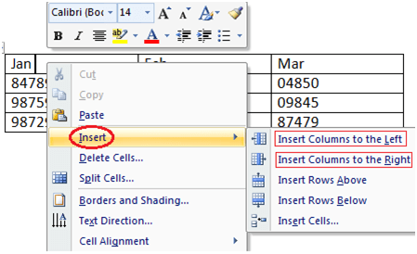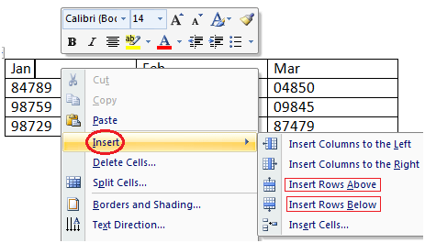

### Delete Column or Row in Table

The table command also allows you to delete a column or row in your table. You can delete the unwanted columns or rows by following these steps;

* Select the column or row of the table
* Right click the mouse
* A menu appears
* As required select 'Delete Columns' or 'Delete Rows'

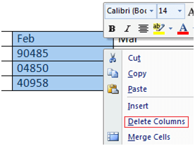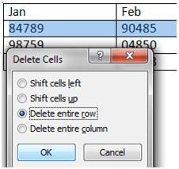

### Modify Table

Word allows you to customize tables as per your requirement. You can modify your table in different ways, i.e. you can choose a table style, table design, draw borders. The steps to modify a table are given below;

* Select the table
* Two new tabs Design and Layout appear on the Ribbon
* On Design tab you will see three groups of commands to modify table; Table Style Options, Table Styles and Draw Borders;

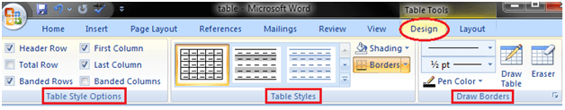

* Layout tab has six groups of commands to format table;

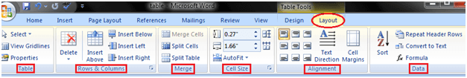

### Split Text to Columns

You can split your text to columns as shown in the image given below. It helps you make your text more readable and presentable. The steps involved in this process are given below;

* Open the document
* Select the Page Layout tab
* In Page Setup group click the Columns command
* It displays a list of options to split text into columns
* Select the desired option

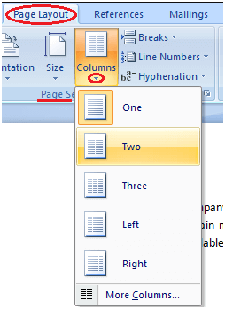

# Experiment#5

## Inserting Illustrations

### Insert Smart Art Graphics

You can insert Smart Art Graphics in your document to effectively communicate your message. You can insert a process flow, a relationship or an organization hierarchy. The steps to insert smart art graphics are given below;

* Place the cursor in the document where you want to insert graphics
* Select the Insert tab
* In Illustrations group select the 'Smart Art' command;

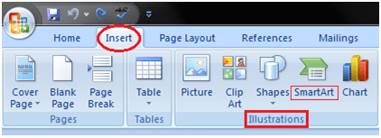

* On left side, a dialog box appears with list of categories
* In the center you will see the illustrations available in a category
* Select the desired illustration and click Ok

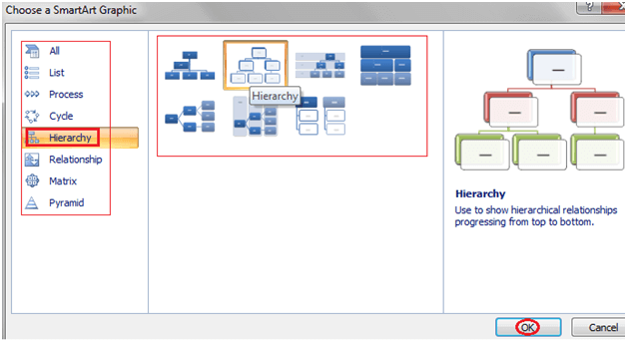

### Insert Smart Art Graphics

You can insert Smart Art Graphics in your document to effectively communicate your message. You can insert a process flow, a relationship or an organization hierarchy. The steps to insert smart art graphics are given below;

* Place the cursor in the document where you want to insert graphics
* Select the Insert tab
* In Illustrations group select the 'Smart Art' command;



* On left side, a dialog box appears with list of categories
* In the center you will see the illustrations available in a category
* Select the desired illustration and click Ok



### Add Text in Smart Art Graphics

Word also allows you to add text in Smart Art Graphics; you can add facts, figures and any other information. The steps to add smart art graphics are given below;

* Select the graphic
* Task pane appears on the left side if it is not visible then click the arrow on left side of graphic
* Type the text in task pane fields it will appear in the graphic
* You can also directly type the text in the graphic in text area
* Close the task pane after entering the text and click outside the graphic

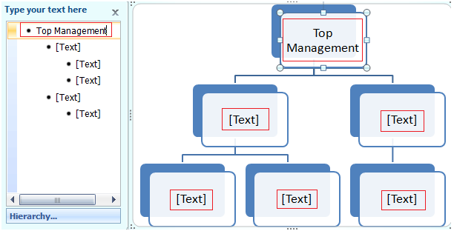

### Insert Picture in Document

Pictures make our text more attractive and readable. You can insert relevant pictures in your text by following these steps;

* Place the cursor where you want to insert the picture
* Select the Insert tab on Ribbon
* In Illustrations group click the Picture command;

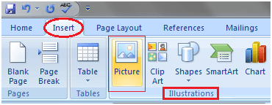

* It displays 'Insert Picture' dialog box
* Select the desired image
* Click Insert to insert the picture

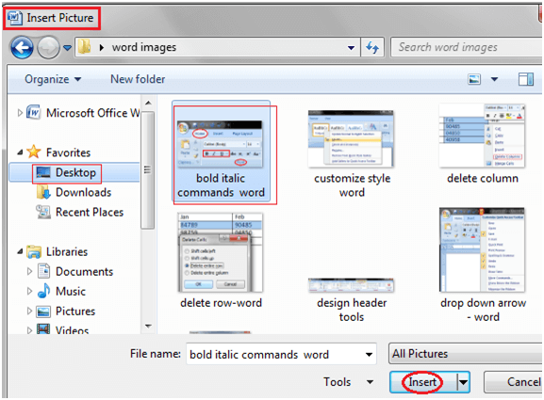

### Insert Clip Art

Clip art refers to a graphic or a picture that you can insert in your document. It comes in different formats and styles. It is used to enhance the appearance of a document. The steps to insert a clip art are given below;

* Place the cursor where you want to insert the clip art
* Select the Insert tab
* In Illustrations group click the Clip Art command;

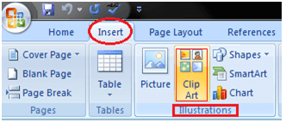

* A task pane appears on the right side of document
* Enter the keyword in 'Search for' field and select the suitable option in 'Search in' and 'Results should be' fields
* Click Go, clip art menu will appear
* Select the desired clip art with a left click

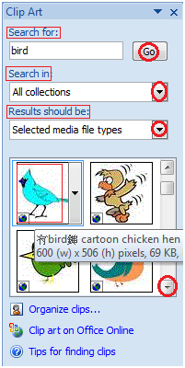

### Format Picture or Clip Art

You can change the appearance of your picture or clip art to enhance its visual impact. The format tab offers you various options for formatting pictures like contrast, changing color, line style, cropping, etc. The steps to format picture or clip art are given below;

* Select the picture or clip art that you want to format
* Format tab appears in the Ribbon
* Click the Format tab
* It displays four groups of related commands to modify or format picture or clip art

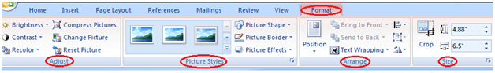

### Bulleted and Numbered Lists

Bullets and numbers are used to make a list more presentable and readable. A bulleted list attracts more than a simple list. Word offers you various styles of bullets and numbers. The steps to create bulleted lists are given below;

* Select the text you want to convert to bulleted or numbered list
* Select the Home tab
* In Paragraph group click the Bullets or Numbering command
* It displays Bullets or Numbering menu
* With a left click select the desired Bullet or Numbering style
* To increase the list place the cursor at the end of list and press Enter key

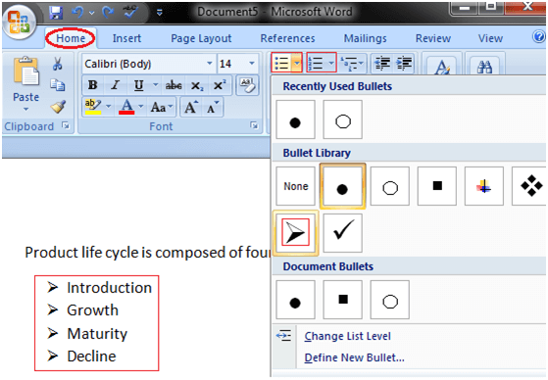

# Experiment#6

## Microsoft Excel

Microsoft Excel is one of the most suitable spreadsheet functions that help us manage data, create optically logical charts, and thought-provoking graphs. Microsoft Excel is supported by both Mac and PC platforms. Microsoft Excel can also be used to balance a checkbook, create an expense document, build formulas, and edit them.

It mainly comprises tabs, groups of commands, and worksheets. The worksheet is made of rows and columns that intersect each other to form cells where data is entered. It is capable of performing multiple tasks like calculations, data analysis, and integrating data.

Microsoft Office button, ribbon, and quick access toolbar are the three main features of excel that you need to focus on while learning excel.

### Open Microsoft Excel

When you open Excel 2016 for the first time, the Excel Start Screen will occur. From here, we'll be able to create a new workbook, choose a template, and access our recently edited workbooks.

1. From the Excel Start Screen, locate and select the Blank workbook to create the Excel interface.
2. To click Open Other Workbooks to work on an existing workbook.

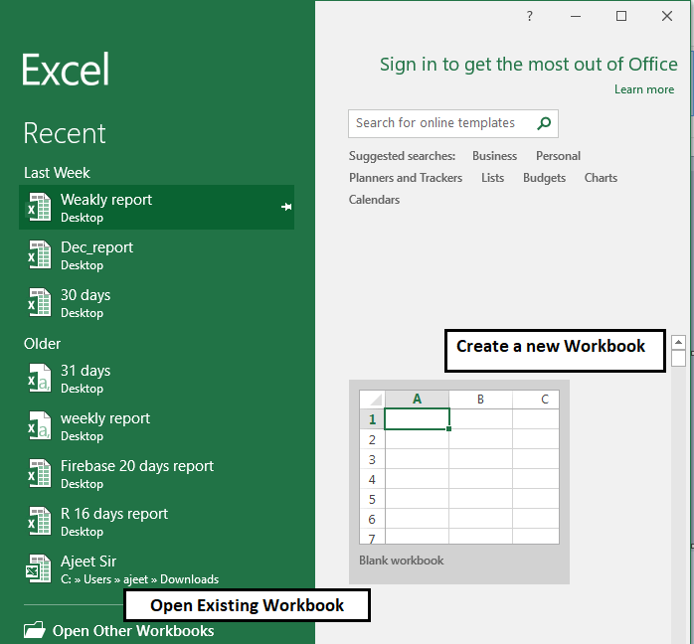

To set up Excel, so it automatically accessible a new workbook

1. Click File then Options.
2. On the General tab, under the Startup option, uncheck the display the Start screen when this program starts box.
3. The next time we start Excel, it opens a blank workbook automatically same to older versions of Excel.

### Excel Interface

After starting Excel, we will see two windows - one within the other. The outer window is the Application Window, and the inner window is a Workbook Window. When maximized, the Excel Workbook Window composite in with the Application Window.

After completing this module, we should be able to:

* Identify the components of the Application Window.
* Identify the components of the Workbook Window.

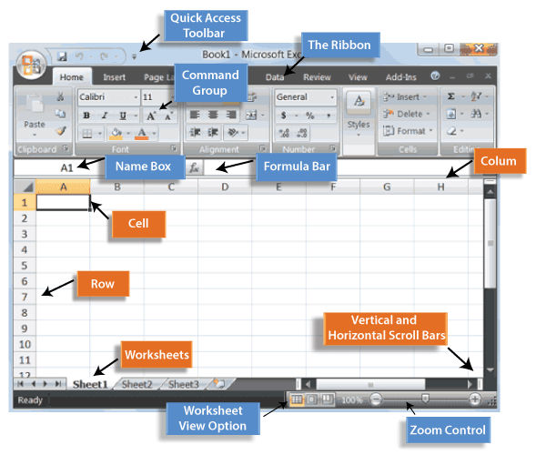

### Application Window

The Application Window provides the space for our worksheets and workbook items, such as charts. The components of the Application Window are defined below.

Quick Access Toolbar

The Quick Access Toolbar lets us access common commands no matter which tab is selected.

By default, it involves the Save, Undo, and Repeat commands. We can add other commands depending on our preference.

To add the command to the Quick Access toolbar

1. To click the drop-down arrow to the right of the Quick Access toolbar.
2. Select the command we wish to add from the drop-down menu. To choose from more commands, select More Commands.  
   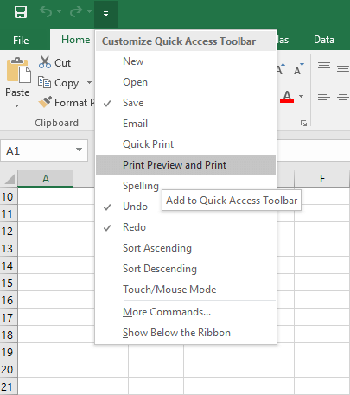
3. The command will be joined to the Quick Access toolbar.

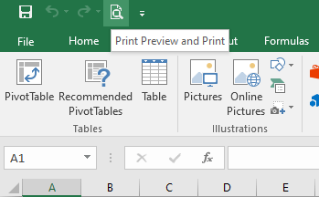

**The Ribbon**

Excel 2016 utilizes a **tabbed Ribbon system** instead of traditional menus. The **Ribbon** includes multiple tabs, each with several **groups of commands**. We will use these tabs to perform the most common function in Excel.

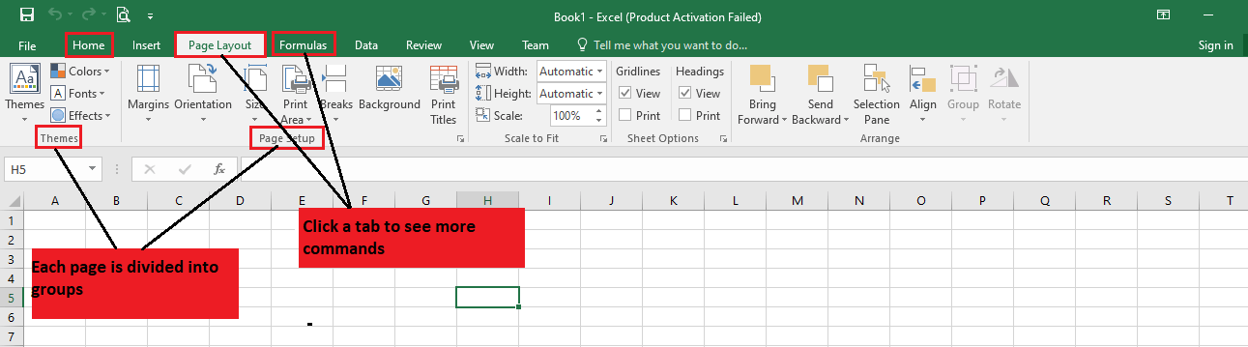

**To minimize and maximize the Ribbon**

The Ribbon is designed to respond to our current function, but we can choose to minimize it if we find that it takes up too much screen space.

1. To click the Ribbon Display Options arrow in the upper-right corner of the Ribbon.  
   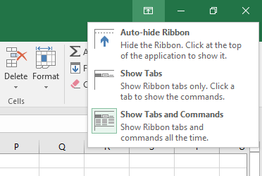
2. Select the desired minimizing options from the drop-down menu:

* **Auto-hide Ribbon:** Auto-hide shows our workbook in full-screen mode and completely hides the Ribbon. To **show the Ribbon**, click **Expand Ribbon** command at the top of the screen.  
  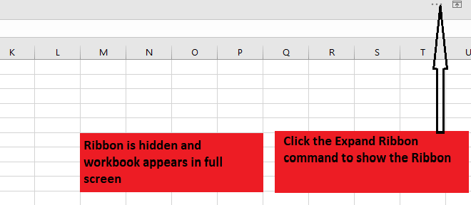
* **Show Tabs:** This option hide all command groups when not in use, but **tabs** will remain clear. To **show the Ribbon**, simply click the tab.
* **Show Tabs and Commands:** This option maximize the Ribbon. All of the tabs and command will be clear. This option is selected by default when we open Excel for the first time.

**To Customize the Ribbon in Excel 2016**

We can customize the Ribbon by creating your **tabs** with whichever commands we want. Commands are always housed within a **group**, and we can create as many groups as we want to keep our tab organized. If we want, we can even add commands to any of the default tabs, as long as we create a custom group in the tab.

1. Right-click the **Ribbon** and then choose **Customize** the Ribbon from the drop-down menu.  
   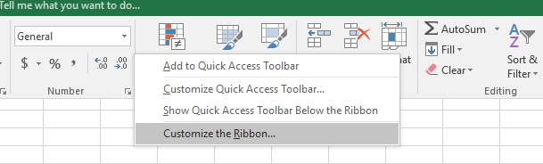
2. The **Excel Options** dialog box will occur. Locate and select **New Tab**.  
   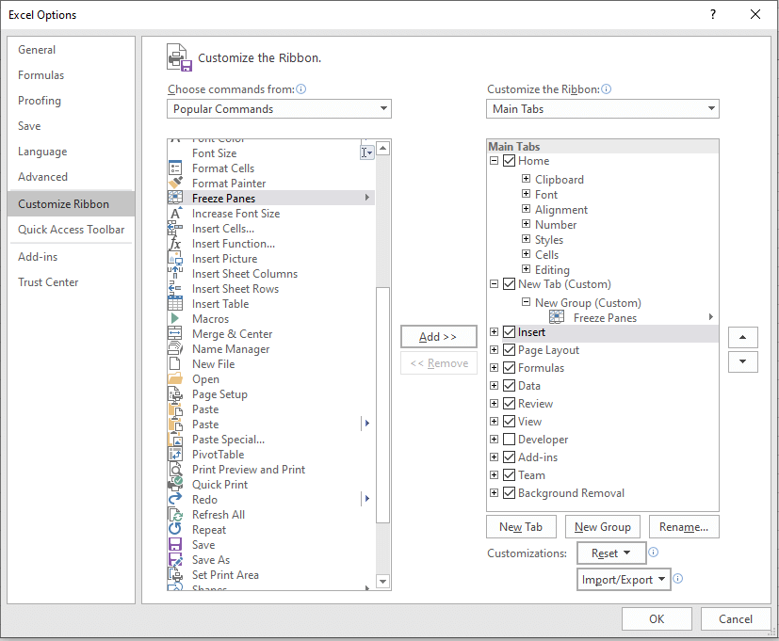
3. To make sure the New Group is selected, select a command, and then click Add. We can also drag commands directly into a group.
4. When we are done adding commands, click OK. The commands will be added to the Ribbon.  
   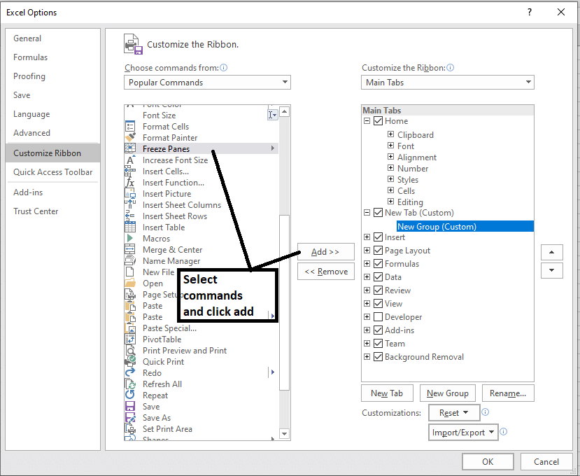

**The Formula Bar**

In the **formula bar**, we can enter or edit data, a formula, or a function that will occur in a specific cell.

In the image below, cell C1 is selected, and 2000 is entered into the formula bar. Note how the data contains in both the formula bar and in cell C1.

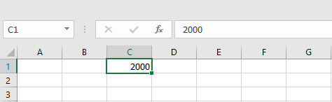

**The Name Box**

The Name box present the location or **"name"** of a **selected cell**.

In the image below, cell B4 is selected. Noted that cell B4 is where column B and row 4 intersect.

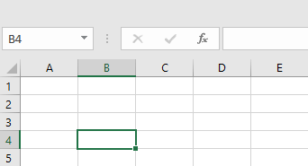

**The Backstage View (The File Menu)**

Click the **File** tab on the Ribbon. The **Backstage view** will emerge.

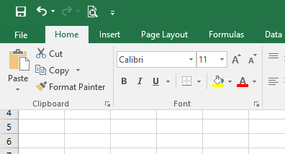  
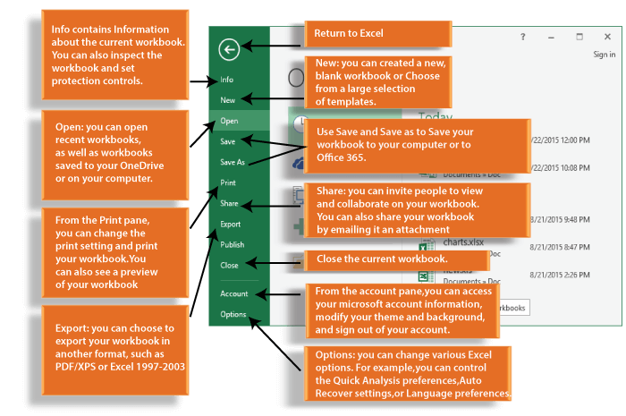

**The Worksheet Views**

Excel 2016 has a variety of displaying options that change how our workbook is showed. We can choose to view any workbook in the **Normal view, Page Layout view,** or **Page Break view**. These views can be useful for several tasks, especially if we're planning to **print** the spreadsheet.

To change the worksheet views, locate and choose the desired worksheet view command in the bottom-right corner of the Excel window.

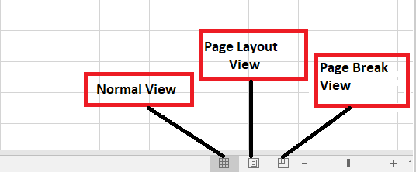

**Zoom Control**

To use a **Zoom control**, click and drag the **slider**. The number to the right of the slider reverse the **zoom percentage**.

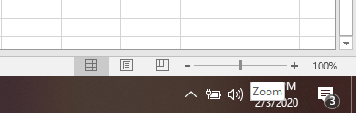

## Excel Calculation

### Do addition in Excel

See the image, showing the addition of 10, 20 and 30.

Choose the cell where you want the result to appear as cell C6 in this example. Then type = sign in the cell, now select first cell C3 then type "+" sign then select second cell C4, again type + and select third cell C5. Now press the enter key, you will get the sum of these three numbers.

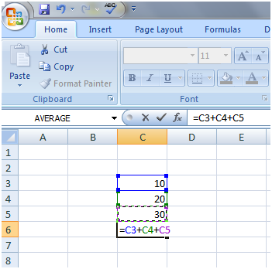

The red arrow is showing the result of addition.

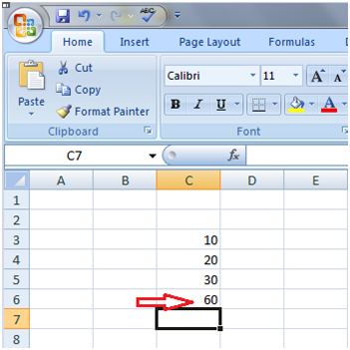

### Using Sigma Button to do addition in Excel

Select the cell to display the result then in Home tab click on the Sigma button, on the right end of the ribbon. You will see the image given below:

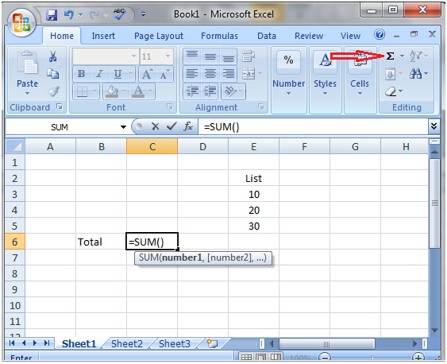

Now select the list of data you want to add. You will see the image shown below, and then press the Enter key to get the result.

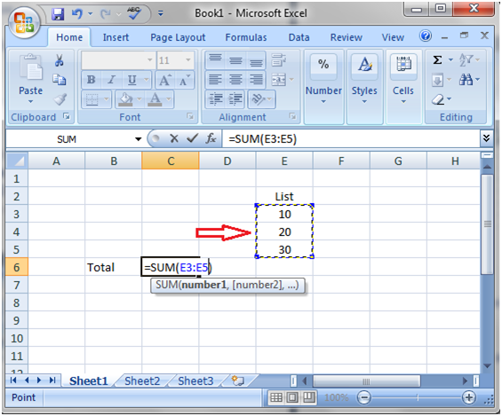

### Do subtraction in Excel

It is similar to addition just replace the plus "+" sign with minus sign "-".

Choose the cell where you want the result to appear as cell C6 in this example. Then type = sign in the cell, now select first cell C3 then type "-" sign then select second cell C4. Now press the enter key, you will get the subtraction of these two numbers.

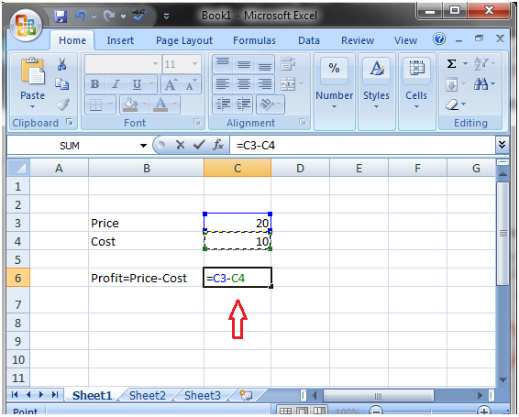

### To calculate average in Excel

Select the cell to display the result e.g. cell C9 in the image shown below. Now type "=" sign in the cell and type "average" then type opening parenthesis. Now select the data, cells from C4 to C7 then press the Enter key to get the result.

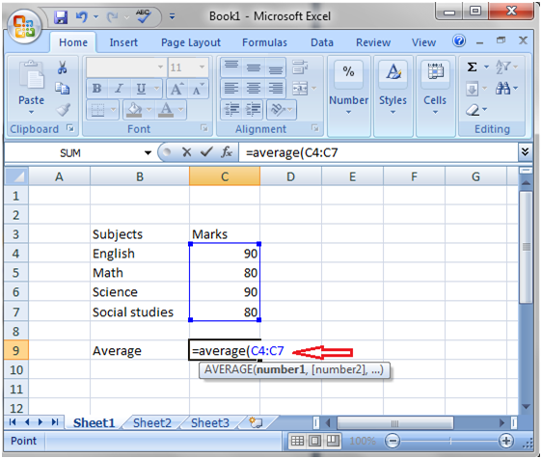

### Using Sigma Button to calculate average in Excel

Select the cell to display the result. In the Home tab click on the small arrow next to the Sigma button and left click on the Average option. You will see the image shown below. Then press the Enter key to get the result.

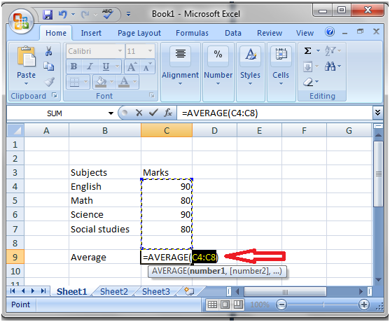

# Experiment#7

## Excel Fill Handle

The fill handle is a convenient Excel tool that is used to fill data with a specific pattern. You can extend a series of numbers, dates and text combinations to desired number of cells.

To use fill handle bring the mouse cursor at right bottom corner of the cell it will change into a + sign. Now left click on it and drag it downward to the desired range of cells.

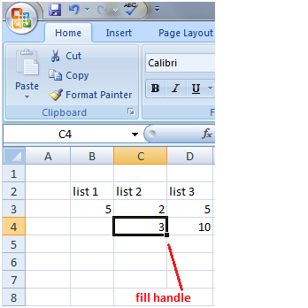

If you select one cell the value in the cell will be copied to other cells and if you choose multiple cells with specific pattern like difference between cells then the same pattern will be copied to other cells. See the image shown below.

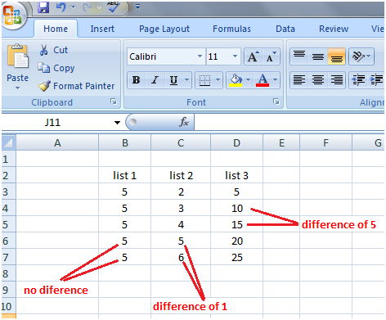

### Excel Fill Handle with Text

Fill handle works in a similar way with texts. It helps repeat the text to desired range of cells.

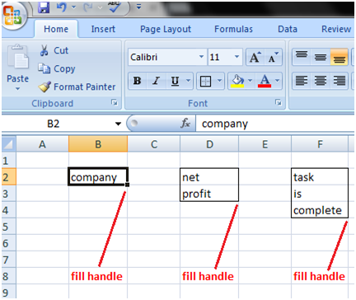

The text is selected and then copied to other cells using fill handle.

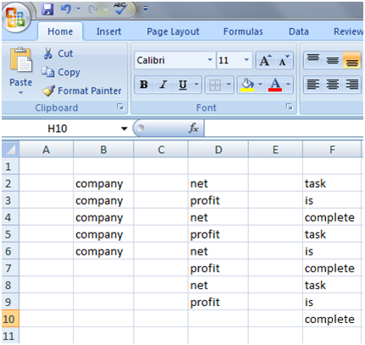

### Excel Fill Handle with Text and Numbers

Fill handle also works with cells containing both text and number. In this case, the text does not change but the number increases by one for every cell you select.

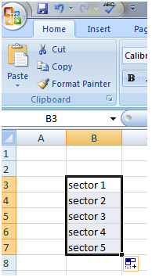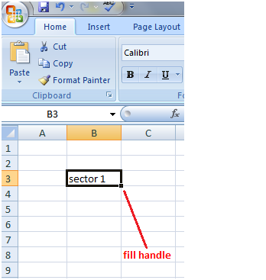

## Excel Formula

### Creating Formulas

In cell C5 enter the number 20, now in cell E5 type the formula: =C5+5 then press the Enter key. You will get the result. The formula says 5 is added to the value entered in the cell C5 as the value is 20 the result is 25. See the image:

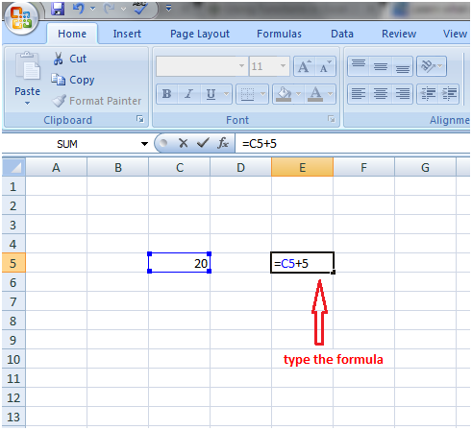

In a similar way other formulas can be created:

=C2*5 for multiplication, the value in the cell C2 is multiplied with 5.

=C2-5 for subtraction, 5 is subtracted from the value in the cell C2.

More formulas can be created by typing = in the cell then selecting the appropriate values and typing correct mathematical symbol in between.

See the formula created to calculate the distance in the image given below:

Exception Handling in Java - Javatpoint

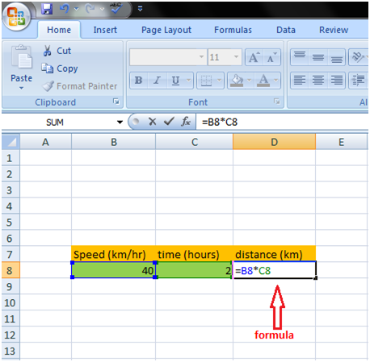

### Relative Referencing

Relative referencing tells that you don't need to type the formula separately for each calculation in a column or a row. See the image:

Type the formula in the first cell D3 and press Enter key to get the result, then use the fill handle. The formula will change automatically in the respective cells and all values of list 1 will get multiplied with respective values of list 2.

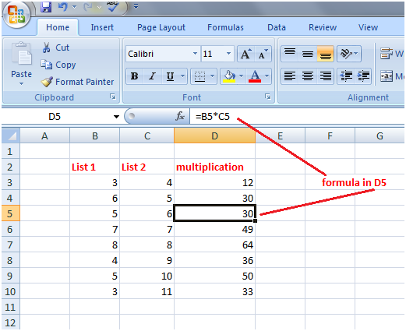

This way you can easily multiply values of list 1 with respective values of list 2 but if you want to multiply all cells of list 1 with a single cell of list 2 such as C3 then it won't work.

### Absolute Referencing

Absolute referencing helps multiply multiple values with a particular value.

See the image shown below. The list 1 values are multiplied by 4, value of cell C3. In this case, we will use symbol $ in the formula.

So we have to modify the formula for that after entering the formula press F4 key. $ Sign will appear in the formula. See cell D3 in the image. Then press Enter key to get the result. Now drag the fill handle from cell D3 till cell D10. All values of list 1 will get multiplied with 4.

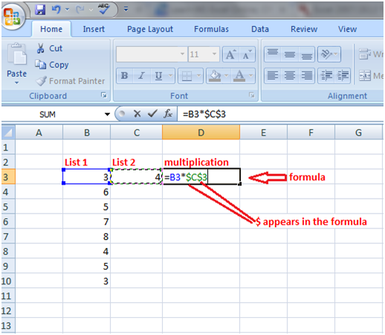

In a similar way, in the image shown below, the bonus marks are added to the marks of the students by modifying the formula from =C5+E2 to =C5+$E$2.

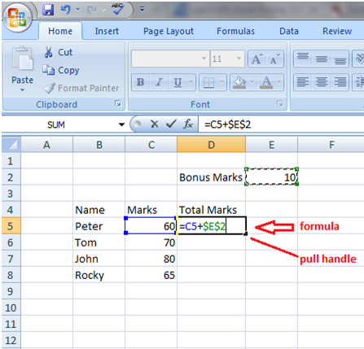

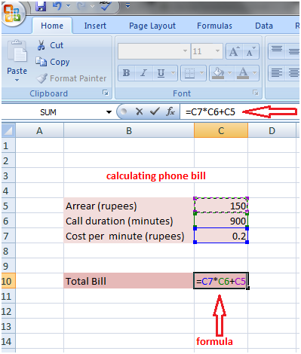

There are some quick functions in Excel that can provide you the statistics of your worksheet without using formulas such as Status Bar quick functions.

See the image given below, as soon as you select the desired range you will get the statistics in the status bar, the average of numbers, the number of cells that contain values and the sum of numbers.

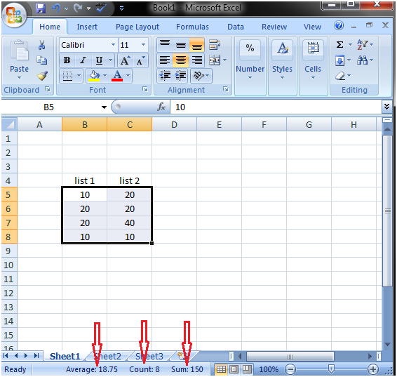

By a right click on the status bar you can customize it. You can add more functions in the status bar. Select the function from the menu which you want to add in the status bar. See the image shown below, status bar is customized. It is also showing maximum and minimum of the numbers.

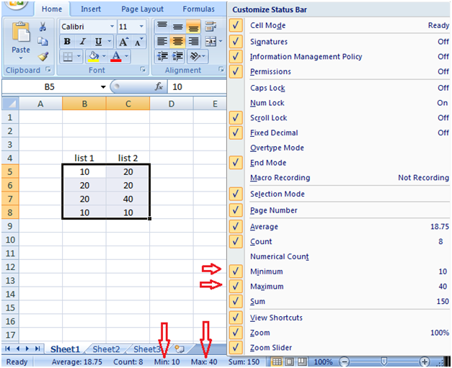

# Experiment#8

## Excel If Function

The IF function or IF statement in Excel is composed of three parts separated by commas.

* A condition
* What to display if the condition is fulfilled
* What to display if the condition is not fulfilled

See how the "IF function" is created step by step to find the safe and unsafe travelling speeds in the following example.

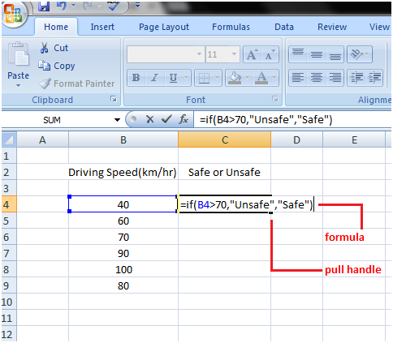

* Select the cell in which you want to create the "IF function"
* Type the code in the cell: =if(
* Type the condition with comma: B4>70,
* Type what you want to show if condition is fulfilled. If you want to display text then write it within quotation marks: "Unsafe"
* Type a comma: ,
* Type what you want to show if the condition is not fulfilled within quotation marks: "Safe"
* Then close the bracket and press the Enter key.

The IF function created above will look like this: =if(B4>70,"Unsafe","Safe")

So the IF function says if the speed or value in the cell B4 is more than 70 then display Unsafe and if it is less than 70 then display Safe.

After pressing the Enter key you will get the result for cell B4. Drag the fill handle downward till cell C9 to get status for other speeds of column B.

### Excel If Function with Calculations

"IF function" can be used in complex calculations. See the example:

If a sales executive sells more than 5 items, the company will pay incentive 40 rupees per item sold and if the sales executive sells less than 5 items, the company will pay 20 rupees per item sold.

See how the "IF function" is used with the calculation:

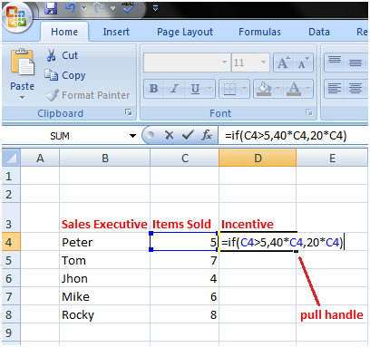

* Select the cell in which you want to create the "IF function"
* Type the code in the cell: =if(
* Type the condition with comma: C4>5,
* Type what you want to show if condition is fulfilled: 40*C4
* Type a comma: ,
* Type what you want to show if the condition is not fulfilled: 20*C4
* Then close the bracket and press the Enter key.

The IF function will look like this: =if(C4>5,40*C4,20*C4)

So the IF function says if value in cell C4 is greater than 5 then multiply it with 40. If it is less than 5 then multiply it with 20.

The IF function can be modified to perform different calculations:

Suppose in the above example the company wants to pay rupees 50 along with incentive to those employees who have completed probation period of 5 months or their job duration is more than 5 months.

In this case, we can insert one more column in the worksheet for job months and modify the IF function accordingly to get the results.

The modified IF function is: =if(C4>5,50+E4,E4)

It says if the value in cell C4 is greater than 5 then add 50 to E4 which is incentive of Peter. And if it is less than 5 then keep the incentive, the value of cell E4 same. See the image shown below:

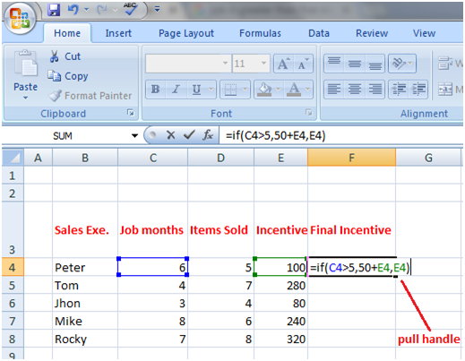

**Few more examples of IF Function:**

**=if(B2>5,B2*2,B2*4)**

The IF function can also be composed in this way: =IF(B2>5,2*B2,4*B2)

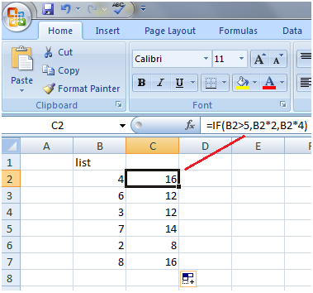

**=IF(B2<=50,B2*120%,B2)**

The IF function says if the value of cell B2 is less than 50 or equal to 50 then increase it by 20% else display the same value without any change. See the image given below:

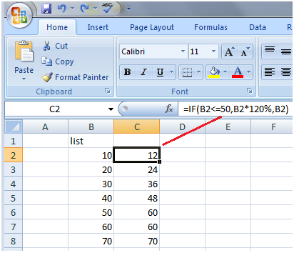

**=IF(B2=60,"",C4*D3+5)**

The IF function says if the value of cell B2 equals to 60 then leave the cell blank else multiply the cell C4 with D3 and add 5 to it. See the image given below:

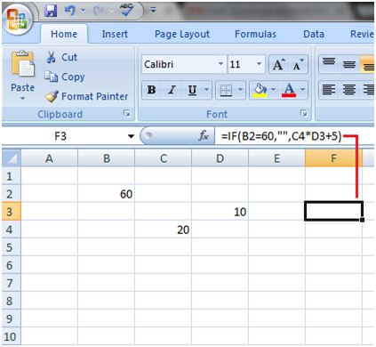

## Count, Countif, And Countifs Function:

### Excel COUNT

The COUNT function returns the absolute number of cells that include numbers. This count contains both Numbers and Dates.

### Syntax

1. COUNT (value1, [value2]...)

Where the parameters, value1, [value2], etc. can be any values or authority to cell ranges.

Example 1: The following illustration returns the number of integer values in a given range.

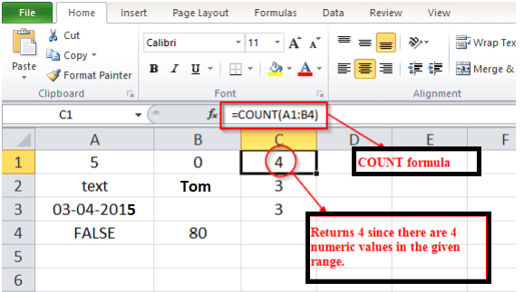

Example 2: The following illustration count integer Values in the range A1: A4 and B1:B2.

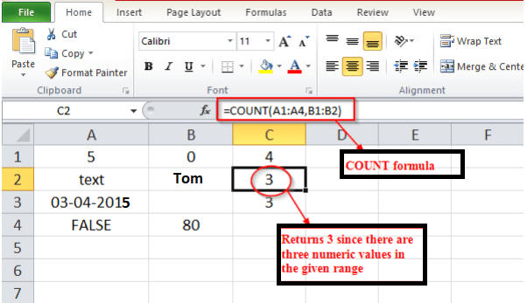

The Excel COUNTIFS function takes in at least one cell range and returns the total counts if criteria are fulfilled.

### Syntax

1. COUNTIFS (criteria_range1, criteria1, [criteria_range2, criteria2],...)

Where criteria_range1: Arrays of values (or ranges of cells including values) to be examined against the particular criteria1, criteria2 ... (The provided criteria_range arrays must all have the similar length).

criteria1: The conditions to be examined against the values in the criteria_range1, [criteria_range2],....

Example 1: The following example displays the use of the COUNTIFS function.

In this example, we want to count the number of persons who fulfilled these two criteria.

1. A person should be female.
2. A grade should be <=D, which is between A to C.

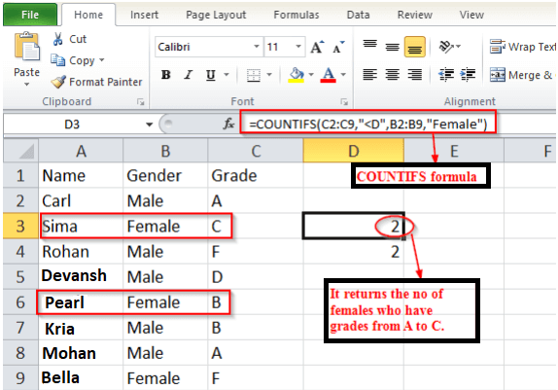

**Example 2:** Count the total number of candidates who have failed in the exam."*male" is utilized to discover the cells which end with a male.

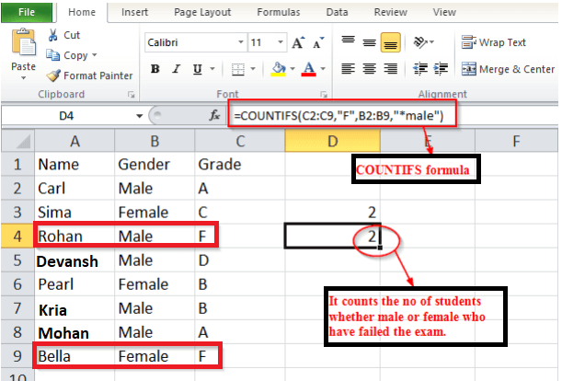

# Experiment#9

## MS PowerPoint

Microsoft PowerPoint is a software program developed by Microsoft to produce effective presentations. It is a part of Microsoft Office suite. The program comprises slides and various tools like word processing, drawing, graphing and outlining. Thus it can display text, table, chart, graphics and media in the slides.

There are three main features of the Microsoft PowerPoint window that you need to focus upon while learning PowerPoint. These features are Microsoft Office Button, Quick Access Toolbar and Ribbon.

Microsoft Office Button

Microsoft Office Button is located on the upper-left corner of the PowerPoint window.

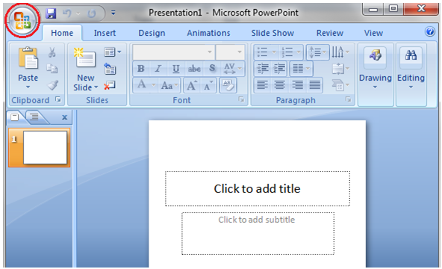

### Quick Access Toolbar

It is located beside the Microsoft Office Button. By default it shows three commands; Save, Undo and Redo.

See the image:

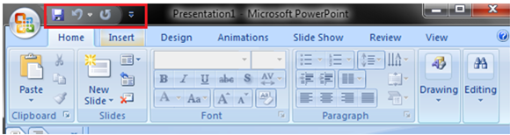

When you click the drop-down arrow at the right end of Quick Access Toolbar it offers more commands. The desired command out of these commands can be added to Quick Access Toolbar with a left click on it.

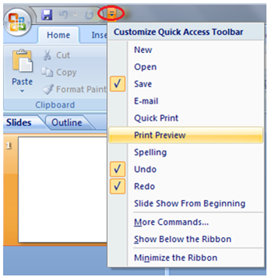

You can also add the Office Button and Ribbon commands. Just right click the command and select the "Add to Quick Access Toolbar" option. See the image, the command New Slide is added to Quick Access Toolbar.

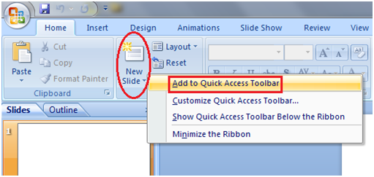

### Slide, Placeholder and Notes

Slide: Presentation is created on slides. It lies in the centre of the PowerPoint window.

Placeholder: By default two placeholders appear in the slide when you open the PowerPoint.

Click to add notes: This space is provided to create notes if needed.

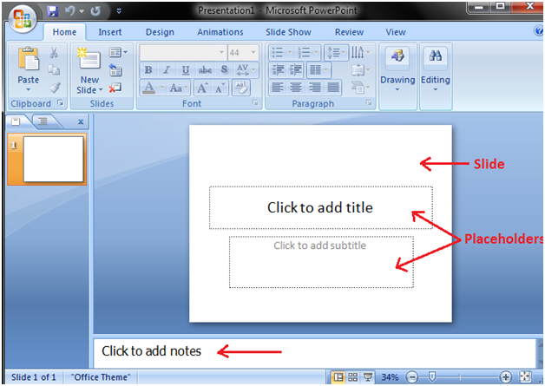

## Creating a Presentation

When you open PowerPoint window by default a slide appears. The slide has two placeholders or text boxes. Additional text boxes can be added from the Insert tab.

To start creating presentation click on the placeholder or text box a blinking cursor will appear. Then type the title and click outside the box. The text box will disappear.

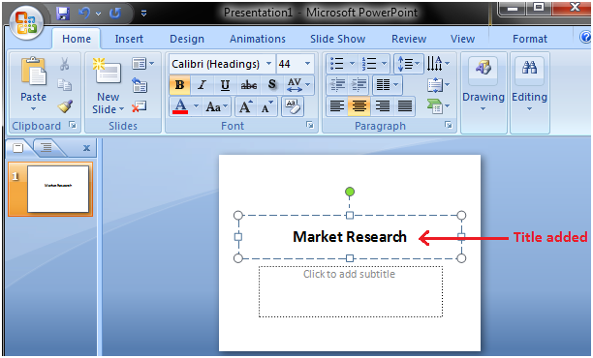

In a similar way, add text or subtitle to the other text box.

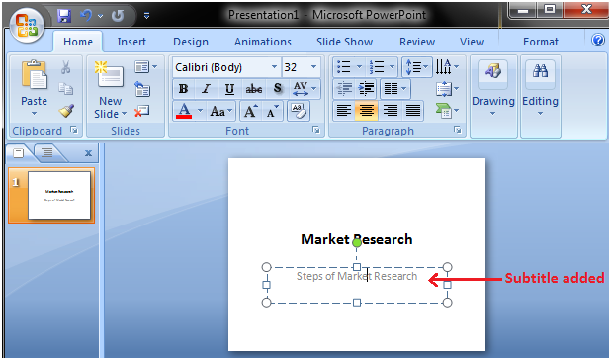

### Add Slide

There are multiple ways to add slide in PowerPoint presentation. The frequently used option is to click the New Slide button.

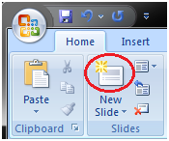

The other ways to add a slide are: Office Themes, Duplicate Selected Slide and Reuse Slides.

1) Using Office Themes to add slide:

* Select the slide next to which you want the new slide to appear
* In Home tab, click the drop-down arrow on the New Slide button
* It will display the office themes
* Select the slide choice that suits your requirement

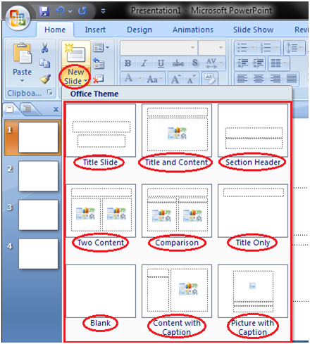

### Apply Themes

Themes are design templates that make the presentation colorful and stylist. With a single click you can apply a theme to the entire presentation.

* Open the Design tab
* Locate the Themes group
* Click the desired theme
* Theme will be added to the entire presentation

To see all available Themes click the drop- down arrow on the right bottom corner of the Themes group.

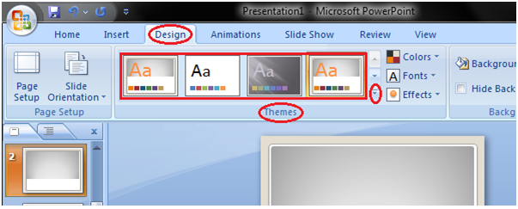

### Change the Background of a Theme

* Open the Design tab
* Locate the Background group
* Click the Background Styles button
* Select the desired background style

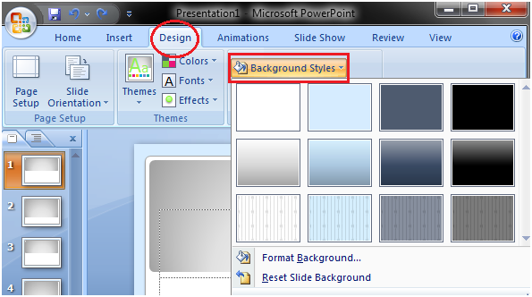

# Experiment#10

## Insert Picture and Clip Art

To Add Picture:

* Click the Insert tab
* In Illustrations group click on the Picture button
* Insert Picture dialogue box appears
* With a click select the desired picture
* Click Insert, the picture will be added to the slide
* Click and drag the picture to move it to desired location

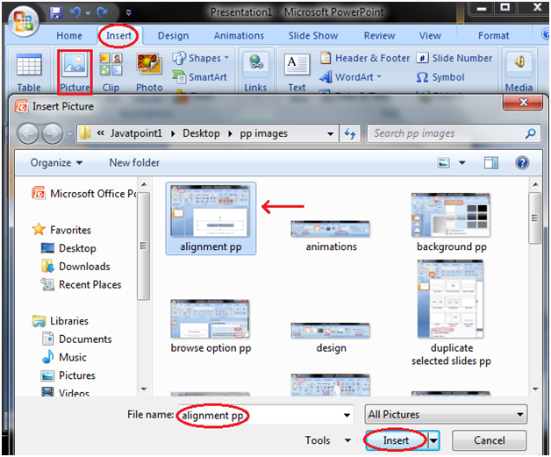

To Add Picture:

* Click the Insert tab
* In Illustrations group click the Clip Art button
* Clip Art task pane appears on the right side
* In task pane you will notice three fields: Search for, Search in, Results should be

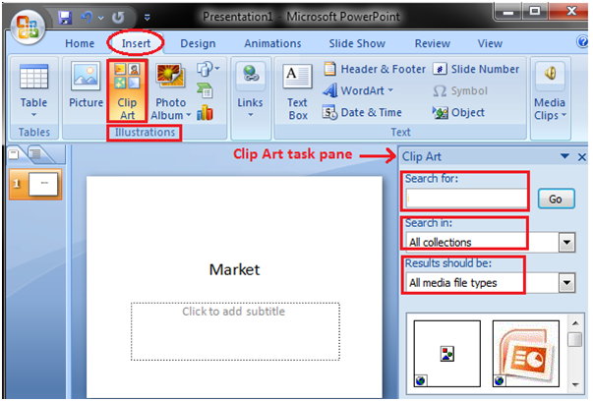

In "Search Field" you can enter the keyword related to clipart you want to insert

In "Collection Field" click the drop-down arrow. It gives four options. Choose the option that suits your requirement.

### Edit Picture and Clip Art

* Select the Picture or Clip Art that you want to edit
* Format tab appears in the Ribbon next to View tab
* It displays four groups of commands; Adjust, Picture Styles, Arrange and Size group

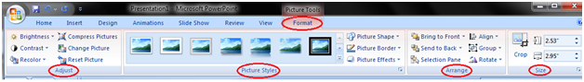

The Adjust group displays six commands.

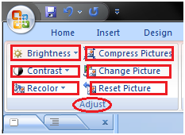

* Brightness: To increase and decrease the picture brightness
* Picture Contrast: To increase or decrease the picture contrast
* Recolor: To recolor the picture to give it special effect
* Compress Picture: To compress picture to reduce its size
* Change Picture: To change the picture
* Reset Picture: To discard all the changes made to the picture

The Picture Styles group displays picture styles and three commands.

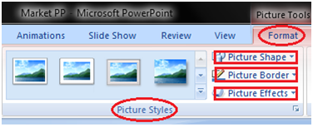

* Picture Styles: To apply a picture style to the picture or clip art
* Picture Shape: To change the shape of the picture or clip art
* Picture Border: To give colors to the picture border
* Picture Effects: To apply visual effect to the picture

The Arrange group has six commands:

How to find Nth Highest Salary in SQL

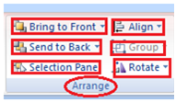

* Bring to Front: To bring the picture in front of all other objects
* Send to Back: To send the picture behind other objects
* Selection Pane: It displays selection pane with various options to format and change order of picture
* Align: To align the multiple pictures on the slide. You can distribute them evenly across the slide.
* Group: To group different objects together
* Rotate: To rotate the text or objects

The Size group has three commands.

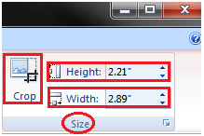

* Crop: To remove unwanted parts of the picture
* Height: To change the height of the picture
* Width: To change the width of the picture

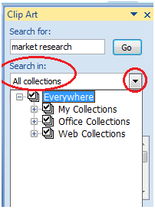

In "Results should be" filed click the drop-down arrow, you will find five options. Choose the option that suits your requirement.

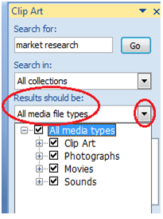

Now click the "Go". Clip Art menu will appear. Select the desired clip art or click the drop- down arrow next to clip art, it will display Insert option to add the clip art.

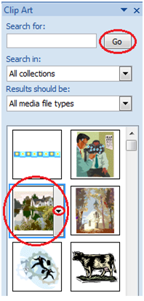

### Create Bulleted or Numbered lists

* Select the text or list to which you want to add bullets or numbering
* Select Home tab and locate the Paragraph group
* Click the Bullets or Numbering button or click the drop-down arrow next to these buttons to see more bullet styles and numbering formats
* Select the style you want to apply to text

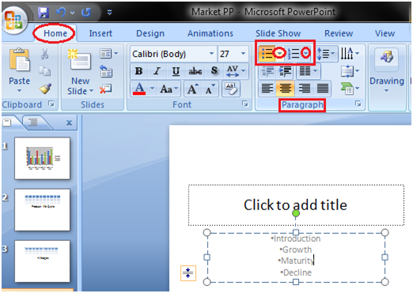

## Working with Charts

### Insert Chart

* Select the Insert tab
* In Illustrations group click on Chart command
* An Insert Chart dialogue box appears
* Select the desired Chart style and click Ok
* Chart will be added to slide and an Excel worksheet appears on right side of the slide
* 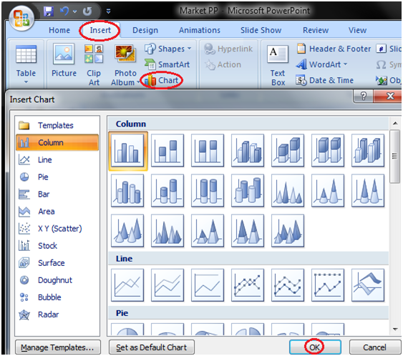

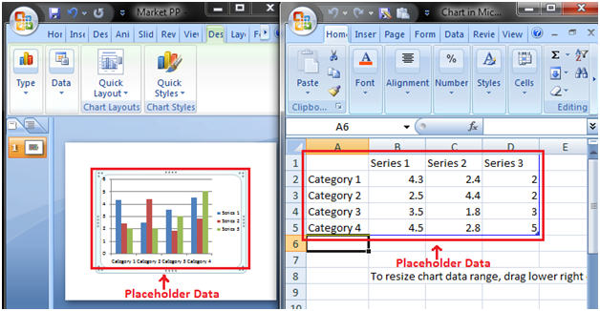

### Enter Chart Data

We can't enter data directly in charts. To enter data in chart we have to type it in excel spreadsheet that appears when you add Chart or click Edit Chart option.

The data that you enter in spreadsheet automatically appears in the Chart. Select the cell of spreadsheet and type the data it will appear in the slide. Repeat the process to enter the entire data.

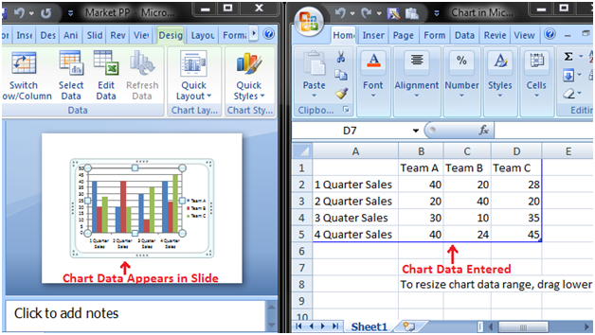

# Experiment#11

## Slide Effects

### Apply Animation Effect

* Select the text or object you want to animate
* Select the Animations tab
* In Animations group click the drop-down arrow next to Animate option
* Animation options will appear
* Move the cursor over different options to see live preview on the slide
* Select the desired animation

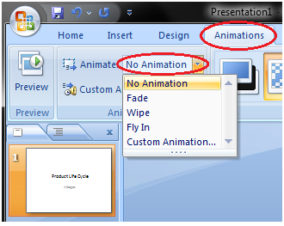

### Apply Slide Transition Effects

Transition effects appear when one slide changes into next slide in a Slide Show.

* Select the slide to which you want to apply the effect
* Select the Animation tab
* In Transition to This Slide group you will see the transition effects
* Click the drop-down arrow to see menu of transition effects
* Select the desired transition effect
* Click Apply To All to apply the effect to all slides

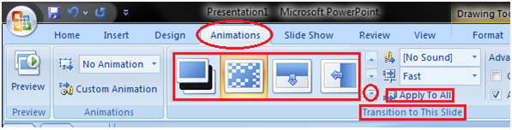

### Set Slide Transition Sound

* Select the slide to which you want to add the transition sound
* Select the Animation tab
* In Transition to This Slide group click the drop-down arrow next to Transition Sound option
* A list of different transition sounds appears
* Select the desired transition sound
* Click Apply To All to apply the effect to all slides

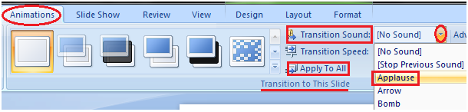

### Set Slide Transition Speed

* Select the slide
* Select the Animation tab
* In Transition to This Slide group click the drop-down arrow next to Transition Speed option
* It will display three options for transition speed
* Select the desired transition speed
* Click Apply To All to apply the same transition speed to all slides

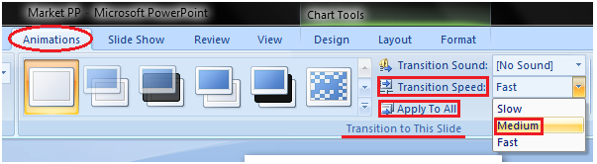

### How to Advance Slides

* Select the slide
* Select the Animations tab
* In Transition to This Slide group locate the Advance Slide section
* It shows two options; On Mouse Click and Automatically After
* Enter the desired time for the selected slide in Automatically After option
* Select the next slide and choose the desired time
* Click Apply To All If you want to apply the same timing to all slides

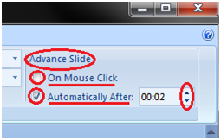

## Viewing Slides

Once you create the presentation you can view it in different ways.

Select the View tab. Locate the Presentation Views group. It displays four options to view presentations; Normal View, Slide Sorter View, Slide Show View and Notes Page View.

Normal View: The normal view appears by default when we open the PowerPoint window. We create and edit slides in Normal View. This view also offers three view options out of four options in the form of buttons on the status bar.

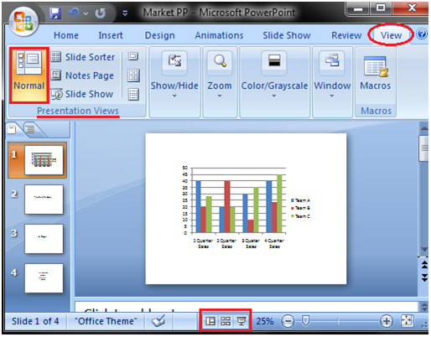

Slide Sorter View: It offers miniature or thumbnail version of all slides. You can see all your slides at one time in the screen. You can also drag or delete the slides to rearrange them.

HTML Tutorial

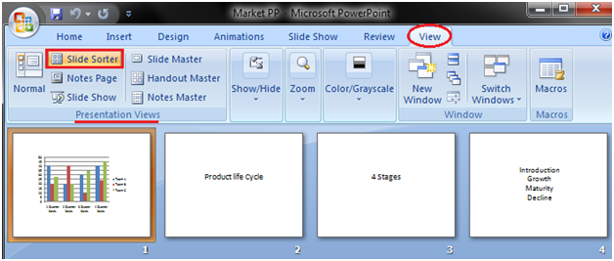

Slide Show View: It displays your presentation in full screen mode. It also offers an additional menu at the left bottom corner of the slide.

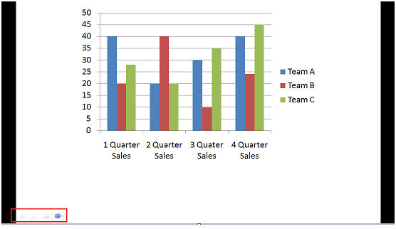

Notes Page View

This view provides space below the slide to add notes.

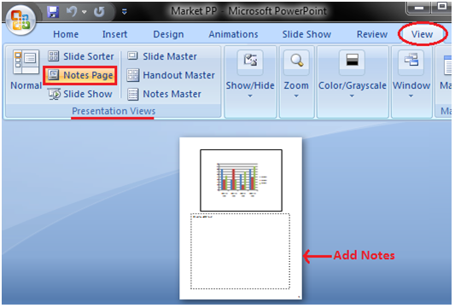

# Experiment#12

## Microsoft Access

Microsoft Access is a Database Management System offered by Microsoft. It uses the Microsoft Jet Database Engine and comes as a part of the Microsoft Office suite of application.

Microsoft Access offers the functionality of a database and the programming capabilities to create easy to navigate screens (forms). It helps you analyze large amounts of information, and manage data efficiently.

### Database File:

It is a file which stores the entire database. The database file is saved to your hard drive or other storage devices.

### Datatypes:

Datatypes are the properties of each field. Every field has one datatype like text, number, date, etc.

### Table

* A Table is an object which stores data in Row & Column format to store data.
* A Table is usually related to other tables in the database file.
* Each column must have Unique name
* We can also define Primary Key in a table.

### Query

* Queries answer a question by selecting and sorting and filtering data based on search criteria.
* Queries show a selection of data based on criteria (limitations) you provide.
* Queries can pull from one or more related Tables and other Queries.
* Types of Query can be SELECT, INSERT, UPDATE, DELETE.

### Form

* A form is a database object that you can use to create a user interface for a database application.
* Forms help you to display live data from the table. It mainly used to ease the process of data entry or editing.

### Report

* A report is an object in desktop databases primarily used for formatting, calculating, printing, and summarizing selected data.
* You can even customize the report's look and feel.

### Macros

Macros are mini computer programming constructs. They allow you to set up commands and processes in your forms, like, searching, moving to another record, or running a formula.

### Modules:

Modules are procedures(functions) which you can write using Visual Basic for Applications (VBA).

## Start Microsoft Access

Note: We assume you have the latest Microsoft Access installed which comes bundled with Microsoft Office 365 package.

There are two ways to Start MS Access.

1. From Windows, 'Start' button.
2. From Desktop, Right Click> 'New' option.

Now in this Microsoft Access tutorial, let's have a look of starting MS Access using both the ways:

### Option 1) From Windows, Start button.

Step 1) Click on the 'Windows' icon. You will find the list of installed programs.

Step 2) Check and click on Access Icon.

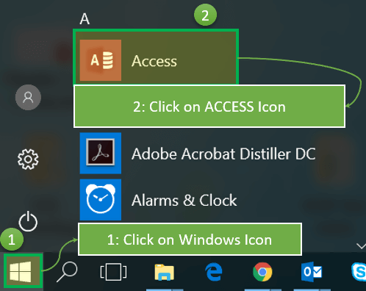

Step 3) MS Access Application window will appear

[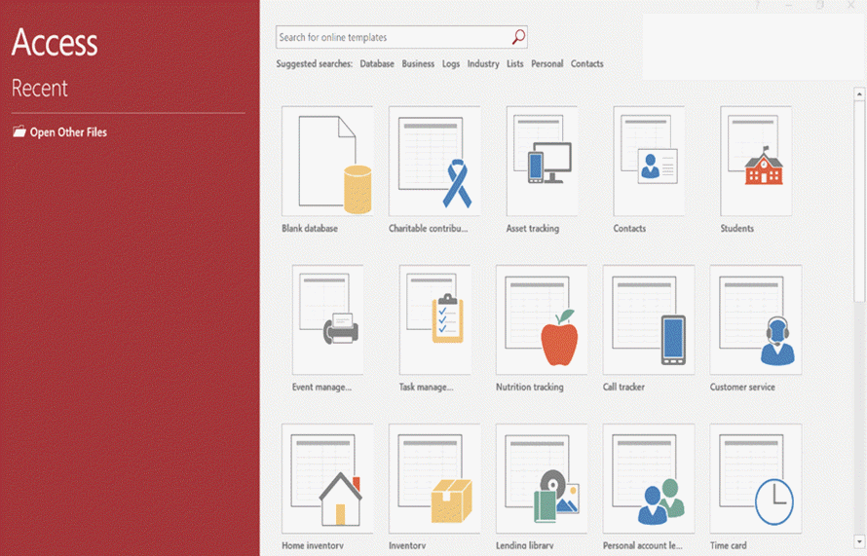](https://www.guru99.com/images/1/041519_1116_MSACCESSTut2.png)

Steps 4) Press 'Esc'

Result: This will open the MS Access windows application

[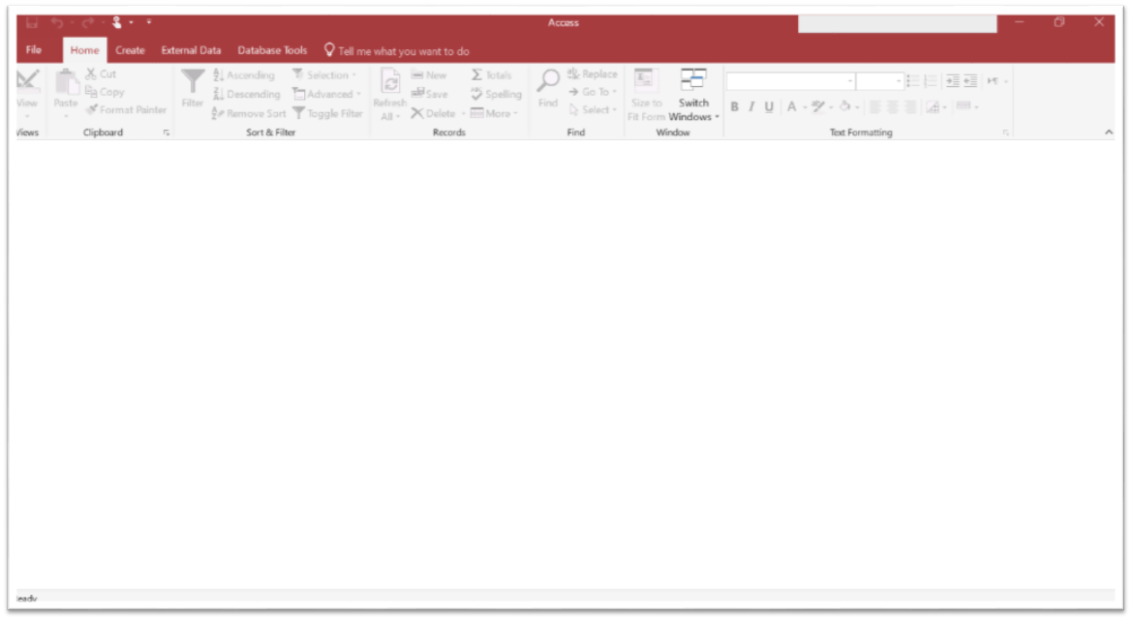](https://www.guru99.com/images/1/041519_1116_MSACCESSTut3.png)

### Option 2) From Desktop, 'New' option.

Step 1) Right Click from Desktop and Click 'New'

Step 2) Click on 'Microsoft Access Database Option'

[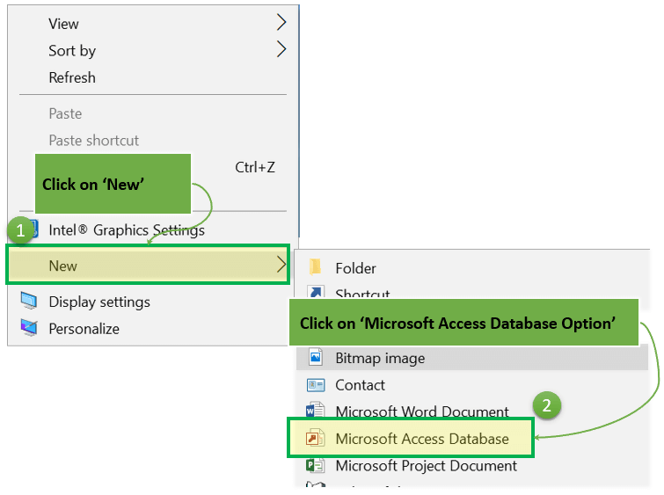](https://www.guru99.com/images/1/041519_1116_MSACCESSTut4.png)

Step 3) Below MS Access Application window will appear

[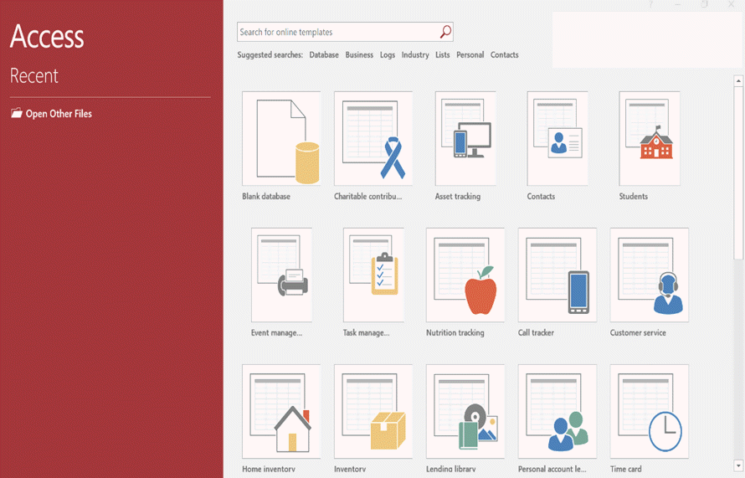](https://www.guru99.com/images/1/041519_1116_MSACCESSTut5.png)

Step 4) Press 'Esc'

Result: This will open the MS Access windows application

[](https://www.guru99.com/images/1/041519_1116_MSACCESSTut6.png)

### Create Database from Template

* There are many situations where we need to start with some readymade database template for given requirements.
* MS Access provides many ready to use templates for such types of databases requirements where the data structure is already defined.
* You can keep customizing the template structure further as per our requirement.
* MS Access Databases example includes Contacts, Student, Time tracking, etc.

Steps to create Database from Template

Step 1) With MS Access application open, Click on File.

[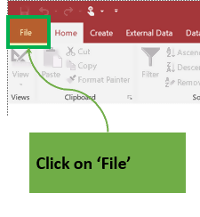](https://www.guru99.com/images/1/041519_1116_MSACCESSTut8.png)

Result: The below window will appear. All the Database templates are displayed below.

[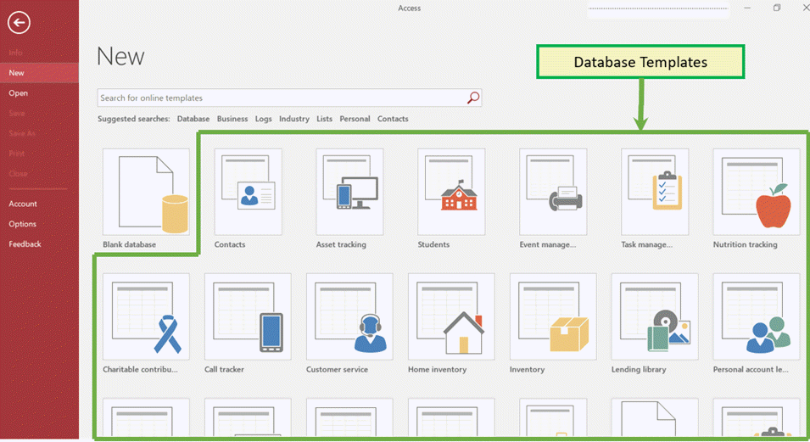](https://www.guru99.com/images/1/041519_1116_MSACCESSTut9.png)

Step 2) We can select any template by clicking on it. Click on Contact Template for further reverence.

[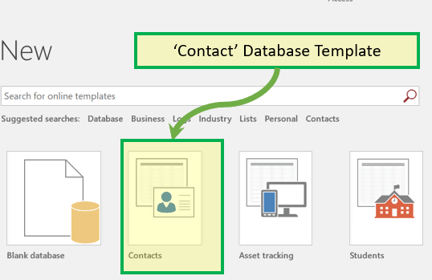](https://www.guru99.com/images/1/041519_1116_MSACCESSTut10.png)

Step 3) File name box will appear with the default file name.

[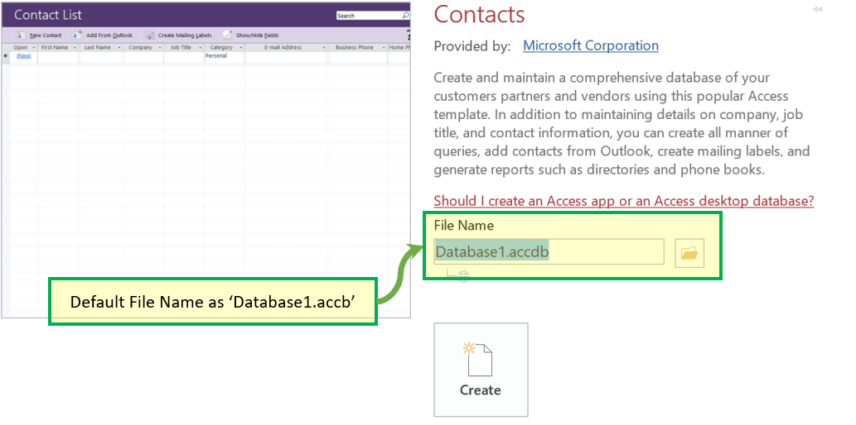](https://www.guru99.com/images/1/041519_1116_MSACCESSTut11.png)

Step 4) Enter the new Name.

[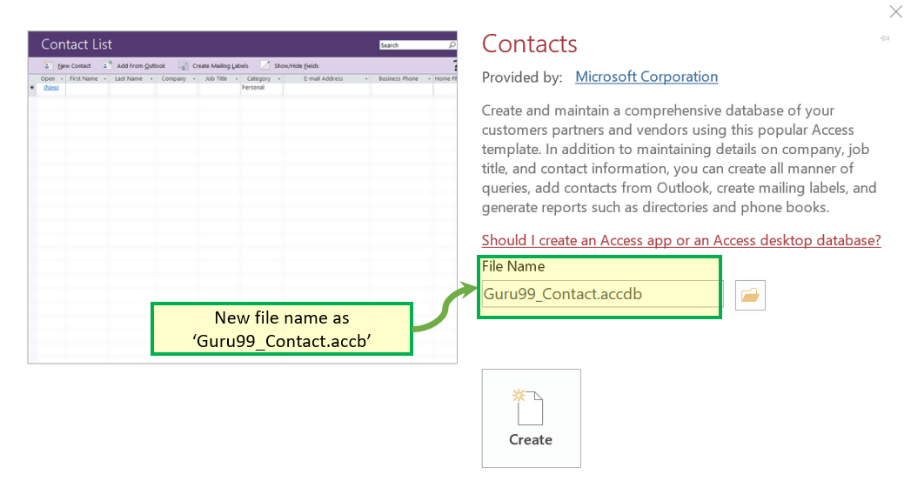](https://www.guru99.com/images/1/041519_1116_MSACCESSTut12.png)

Step 5) Click on 'Create.'

[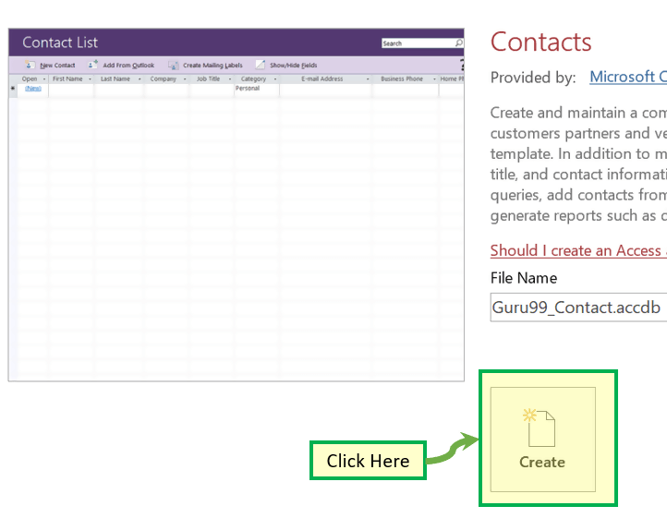](https://www.guru99.com/images/1/041519_1116_MSACCESSTut13.png)

Result: Guru99_Contact Database created and below window will appear.

[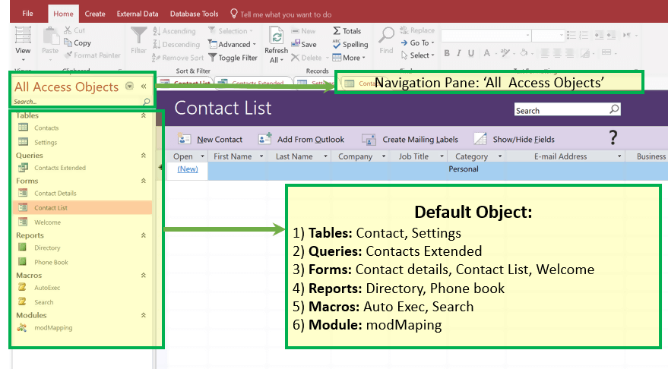](https://www.guru99.com/images/1/041519_1116_MSACCESSTut14.png)

Step 6) Optionally, you can click on any of the objects from left navigation pane and open that object for further references and work.

For, E.g., Clicking on 'Contact Detail' form will open 'Contact Detail' form as displayed below.

[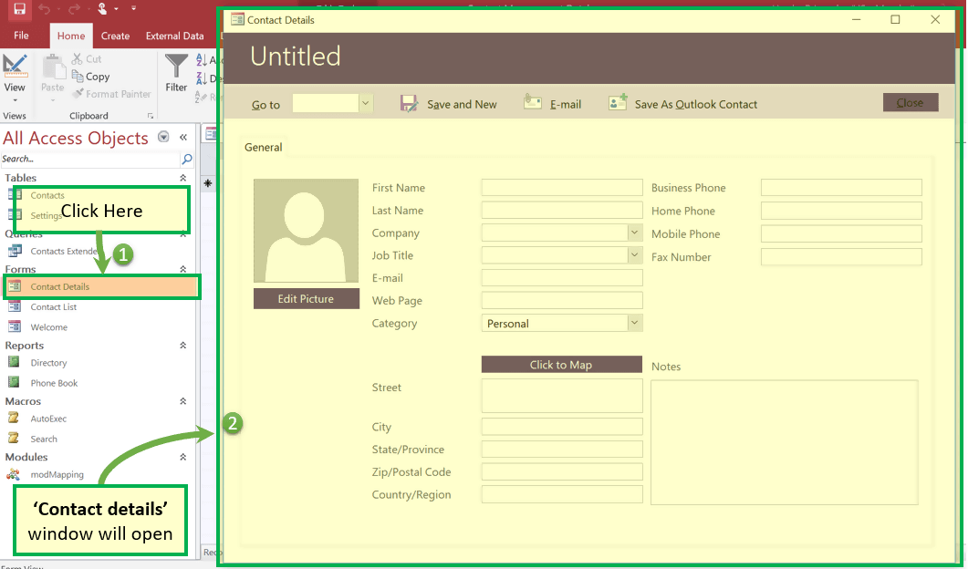](https://www.guru99.com/images/1/041519_1116_MSACCESSTut15.png)

### Create a Blank Database

Step 1) With MS Access application open, Click on File > New

[](https://www.guru99.com/images/1/041519_1116_MSACCESSTut16.png)

Step 2) Click on 'Blank Database.'

[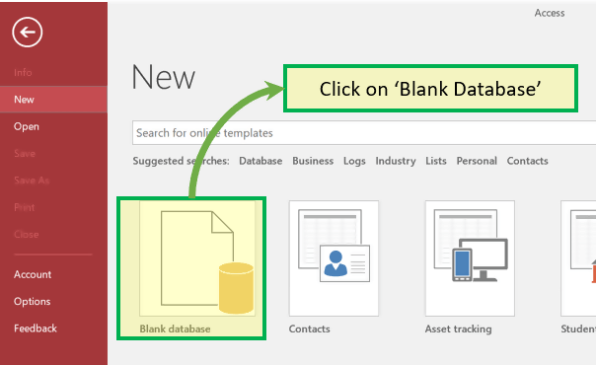](https://www.guru99.com/images/1/041519_1116_MSACCESSTut17.png)

Step 3) File name box will appear with the default file name.

[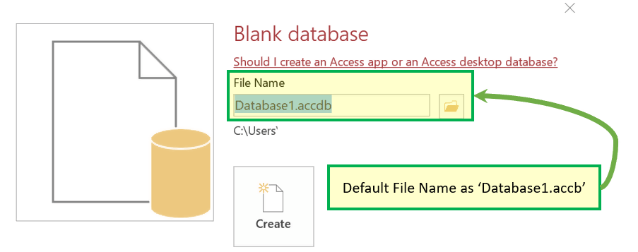](https://www.guru99.com/images/1/041519_1116_MSACCESSTut18.png)

Step 4) Enter the new name.

[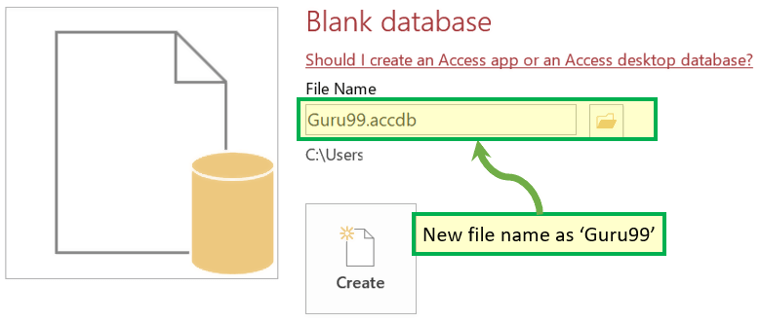](https://www.guru99.com/images/1/041519_1116_MSACCESSTut19.png)

Step 5) Click on 'Create.'

[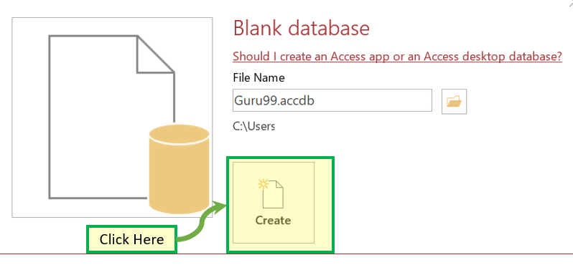](https://www.guru99.com/images/1/041519_1116_MSACCESSTut20.png)

Result: Guru99 Database created and below window will appear.

[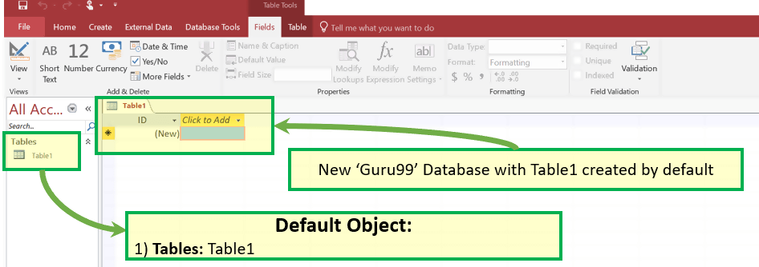](https://www.guru99.com/images/1/041519_1116_MSACCESSTut21.png)

## How to Create Table

The first step in this Microsoft Access tutorial to store data in the database is creating a Table where data will reside. Post creation of the table, we can keep inserting the rows in the table.

[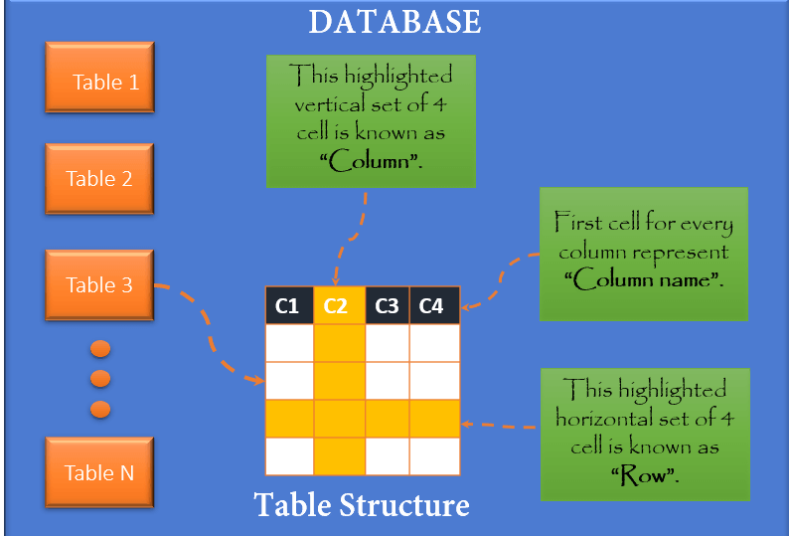](https://www.guru99.com/images/1/041519_1116_MSACCESSTut22.png)

There are two ways to create Database in MS Access

1. Create a Table from Design View
2. Create a Table from Datasheet View

## Create Table – Datasheet View

Step 1) First Click Create tab. Then from Tables group, click Table.

[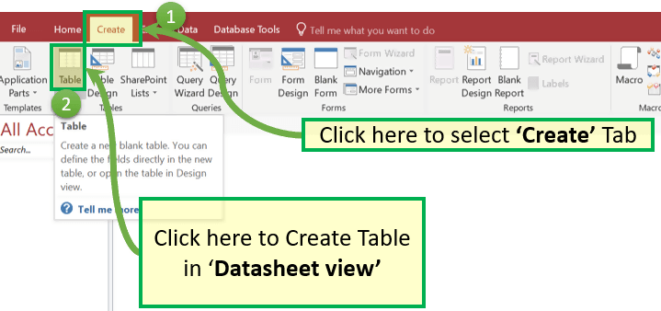](https://www.guru99.com/images/1/041519_1116_MSACCESSTut23.png)

Step 2) System will display the default table created with 'Table1' name.

[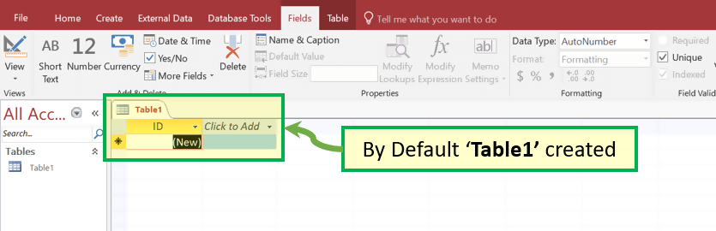](https://www.guru99.com/images/1/041519_1116_MSACCESSTut24.png)

Step 3) To Rename Column, double click on Column Header and enter the new column Name.

[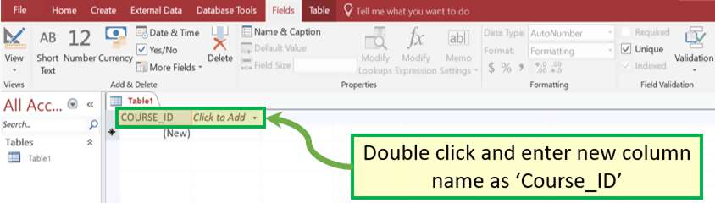](https://www.guru99.com/images/1/041519_1116_MSACCESSTut25.png)

Note that the Data type of Course_ID is 'AutoNumber.' Hence this is also the Unique Key of the table.

[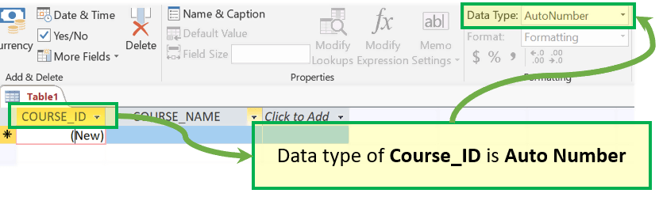](https://www.guru99.com/images/1/041519_1116_MSACCESSTut26.png)

Step 4) You can Add Column by clicking on any category from the 'Add & Delete' group. Alternatively, you can also add a column by clicking on 'Click to Add'

For Example, click on 'Short Text' from the 'Add & Delete' group.

[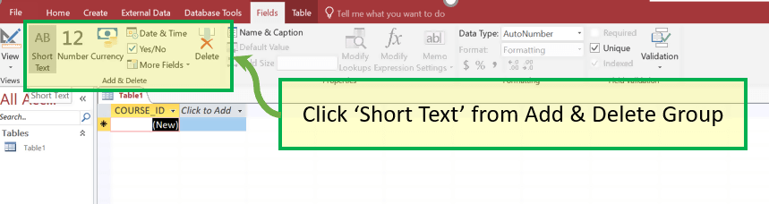](https://www.guru99.com/images/1/041519_1116_MSACCESSTut27.png)

Step 5) Column will be added with the default name as 'Field1.'

[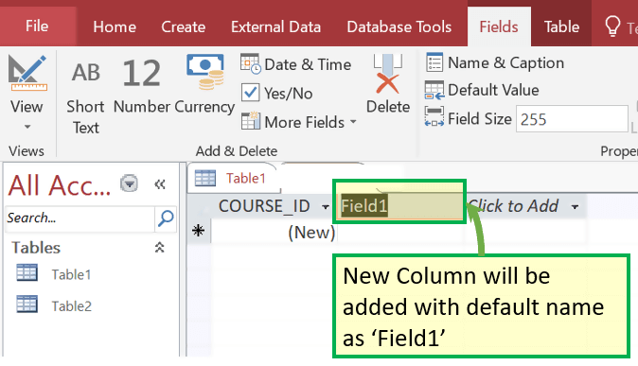](https://www.guru99.com/images/1/041519_1116_MSACCESSTut28.png)

Step 6) Click on Header and rename as 'COURSE_NAME.'

[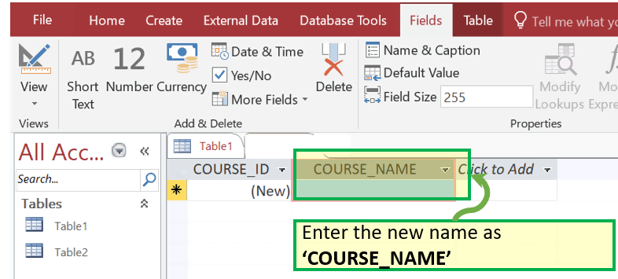](https://www.guru99.com/images/1/041519_1116_MSACCESSTut29.png)

Step 7) Press 'Ctrl + S' and Enter the new table name to save the table.

[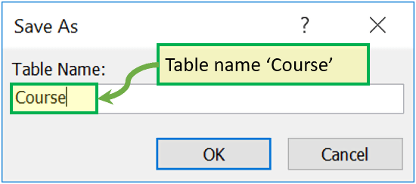](https://www.guru99.com/images/1/041519_1116_MSACCESSTut30.png)

Step 8) You can also save new Name, Caption and Short description for any Column by clicking on 'Name and Caption.' Click on it

[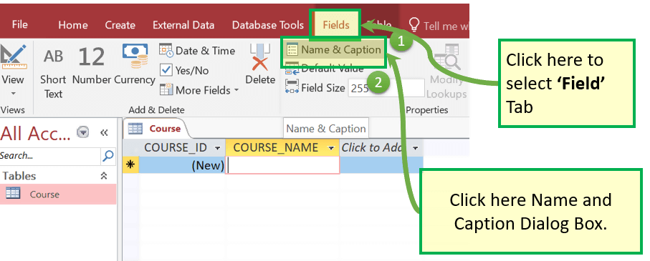](https://www.guru99.com/images/1/041519_1116_MSACCESSTut31.png)

Step 9) Dialog Box will appear. Add the following and Click on 'OK'

* 'Name' - This is the actual name of the column.
* 'Caption' - This is the user view name of the column.
* 'Description' - This is the short description of the column name.

[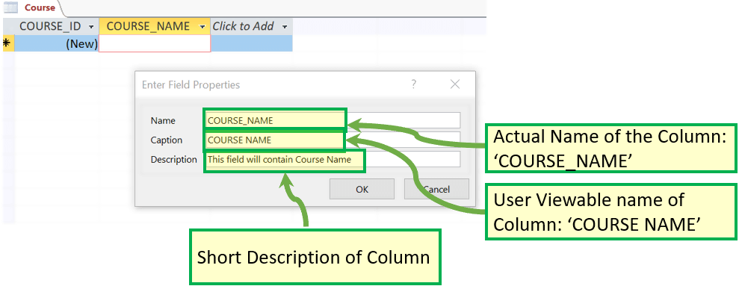](https://www.guru99.com/images/1/041519_1116_MSACCESSTut32.png)

Result: Name, Caption, and Description now exist.

[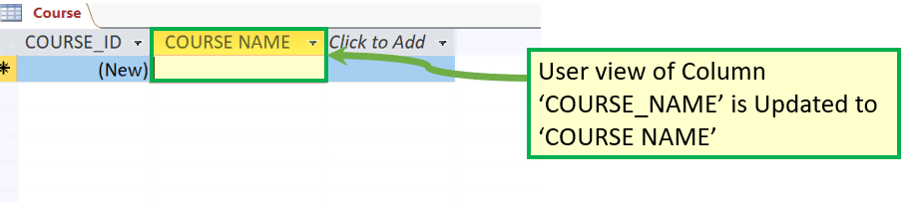](https://www.guru99.com/images/1/041519_1116_MSACCESSTut33.png)

## Create Table – Design View

Step 1) First Click Create tab. Then from Tables group, click Table.

[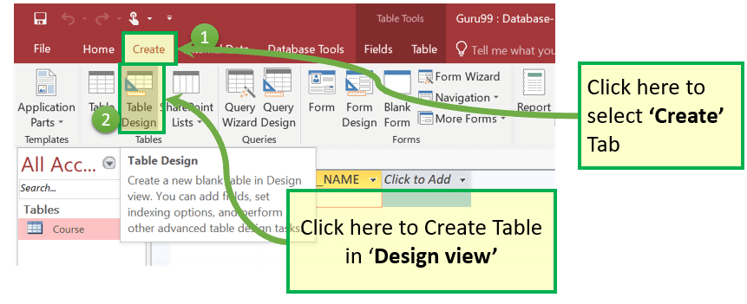](https://www.guru99.com/images/1/041519_1116_MSACCESSTut34.png)

Step 2) Table Dialog box appears. For each Field enter Filed Name, Data Type and Description.

[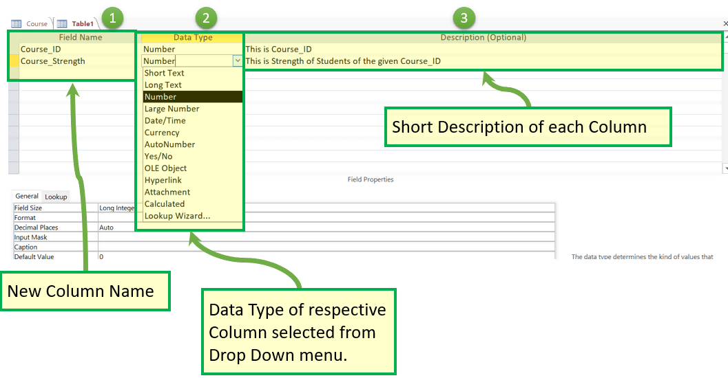](https://www.guru99.com/images/1/041519_1116_MSACCESSTut35.png)

Steps 3) To Add Course_ID as Primary Key, select it and Click on 'Primary Key.' Course_Id will be Preceded by KEY ICON as shown below:

[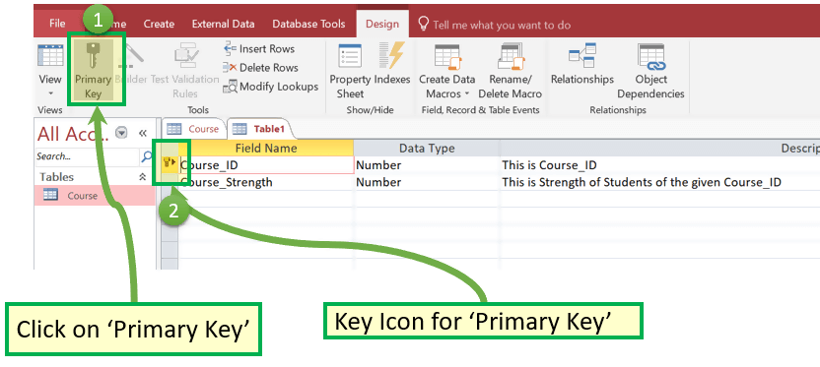](https://www.guru99.com/images/1/041519_1116_MSACCESSTut36.png)

Steps 4) Press 'Ctrl+S.' Enter the Table Name and Click OK

[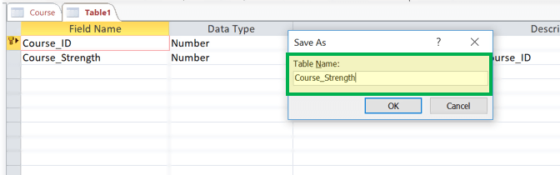](https://www.guru99.com/images/1/041519_1116_MSACCESSTut37.png)

[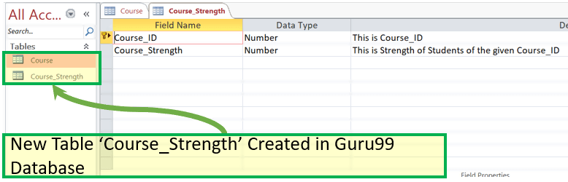](https://www.guru99.com/images/1/041519_1116_MSACCESSTut38.png)

### How to Switch views between Datasheet and Design

Now in this MS Access tutorial, we will learn how to switch views between Datasheet and Design:

To switch views, between the datasheet (spreadsheet view) and the design view, click the 'View' button in the top-left hand corner of the Access Ribbon (shown in the Home/Help/Design Tabs). And Click on the View you need to display.

For Example: Let's Assume You want to switch to the newly created table 'Course_strength' from 'Design view' to 'Data Sheet' View.

Step 1) Click on Datasheet View

[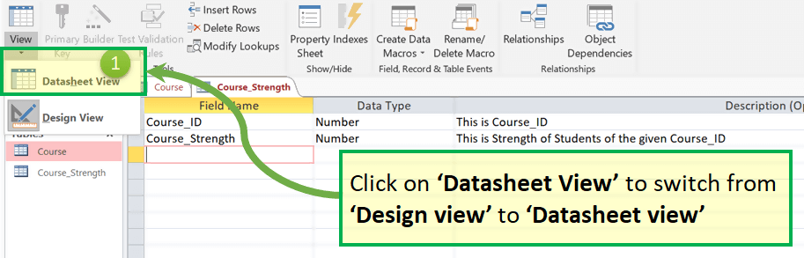](https://www.guru99.com/images/1/041519_1116_MSACCESSTut39.png)

Result:

[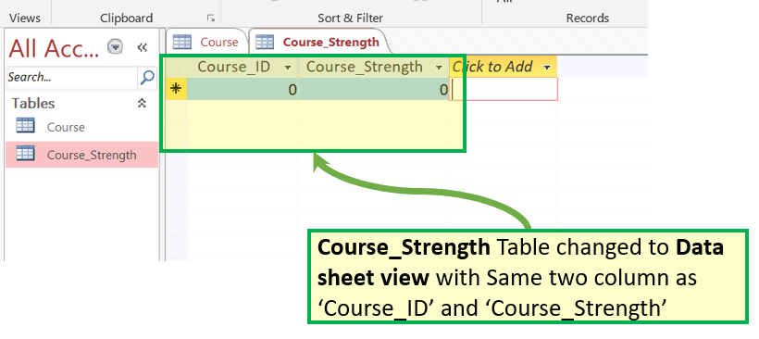](https://www.guru99.com/images/1/041519_1116_MSACCESSTut40.png)

## MS Access- Adding Data

* You have created tables Course and Course_Strength.
* There are two ways to add data. One is Datasheet view and other from Form. We will learn to add data from Datasheet view in this section.
* There is no need to save the data manually. Once you click other rows, Access automatically saves the data.
* The only thing you need to take care while adding data is, you should enter the correct data type, i.e., if Column is defined as Number we can add only number and not text.

Let's add some data in your table by opening the Access database you have created earlier.

Step 1) Select the 'Course' table

[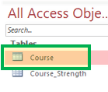](https://www.guru99.com/images/1/041519_1116_MSACCESSTut41.png)

Steps 2) Select the Datasheet view option in the ribbon and add some data by entering the values in It. Updated Data will be Autosaved.

[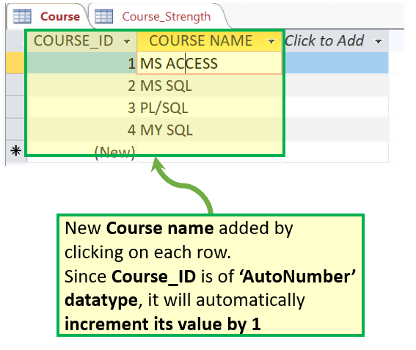](https://www.guru99.com/images/1/041519_1116_MSACCESSTut42.png)

Now let's say You want to delete 4th row with 'My SQL' as Course name.

Step 3) Select the row by clicking on the leftmost column and Right Click on the row. The options menu will appear with the 'Delete Record' Option

[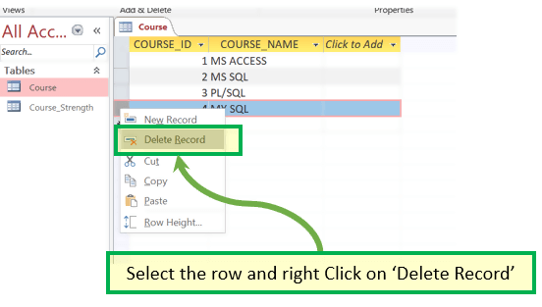](https://www.guru99.com/images/1/041519_1116_MSACCESSTut43.png)

Step 4) Popup Window will appear to confirm the deletion of the record. Click 'OK'

[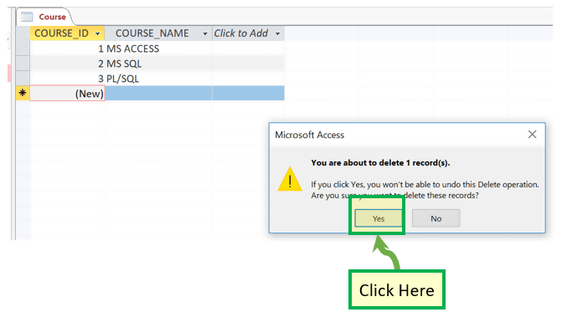](https://www.guru99.com/images/1/041519_1116_MSACCESSTut44.png)

Result:

[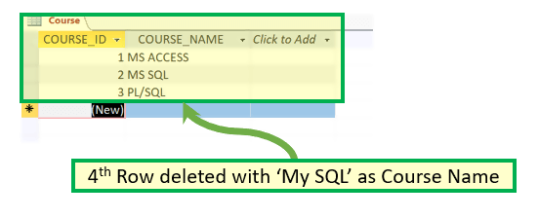](https://www.guru99.com/images/1/041519_1116_MSACCESSTut45.png)

### Summarizing views:

Datasheet View:

Displays in the view, which allows you to enter raw data into your database table.

Design view:

Displays the view, which allows you to enter fields, data types, and descriptions into your database table.

# Experiment#13

## Forms in MS Access

* A form is a database object that you can use to create a user interface for a database application.
* It mainly used to ease the process of data entry or editing.
* Data in a form can be selected from one or more tables.
* Forms can also be used to control access to data, like which fields or rows of data are visible to which users.
* Forms have a Form View.
* Help you to display live data with easy creation of new data.

To understand form lets first create two new Record in Contact Table (from the prebuilt Contact Database discussed [here](https://www.guru99.com/ms-access-tutorial.html#Create_Database_from))

Step 1) Select the 'Contact' table from Left Navigation.

Step 2) Create two rows by entering some relevant data in two rows.

[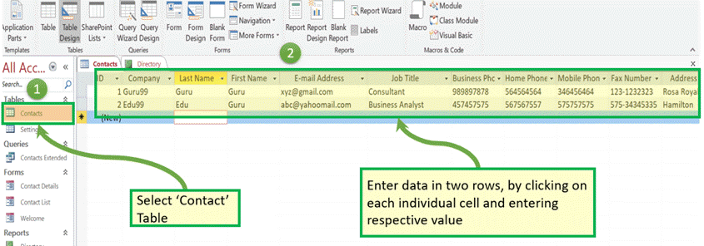](https://www.guru99.com/images/1/041519_1116_MSACCESSTut46.png)

create Form, and then we will see how forms can be leverage for easy display, editing, and creation of new data.

### How to Create a form

There are four primary ways to create the form as mentioned below:

* Form Wizard
* Form
* Multiple Item
* Split Form

Let's have a look at each option to create the form, one by one:

### 1. Create using Form Wizard

This option allows the user to create the form with the wizard and select the column from the available list of column form in legacy Select window format.

Step 1) Click on 'Form Wizard.'

[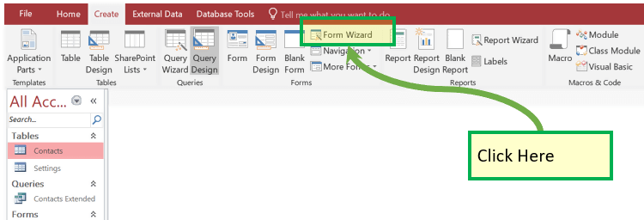](https://www.guru99.com/images/1/041519_1116_MSACCESSTut47.png)

Step 2) System will display below the screen.

[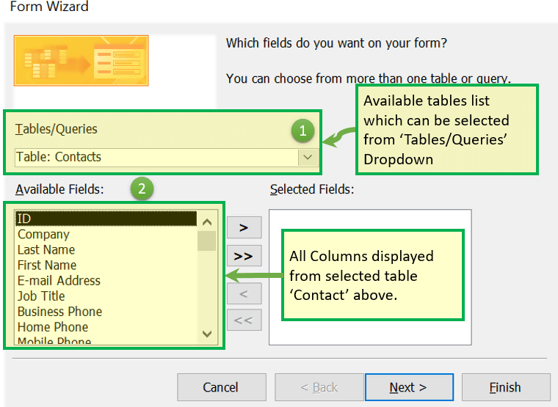](https://www.guru99.com/images/1/041519_1116_MSACCESSTut48.png)

Step 3) Select the columns which you want to be there in final form.

[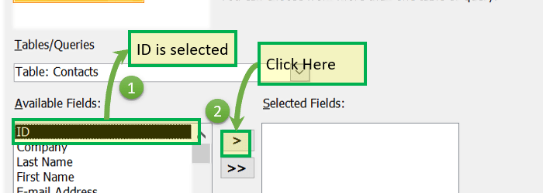](https://www.guru99.com/images/1/041519_1116_MSACCESSTut49.png)

Result: ID is selected

[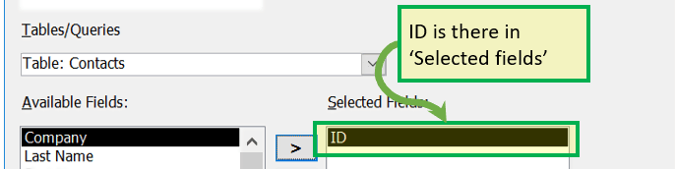](https://www.guru99.com/images/1/041519_1116_MSACCESSTut50.png)

Step 4) Keep selecting all required column as explained in Step 3 above and then click 'Next.'

[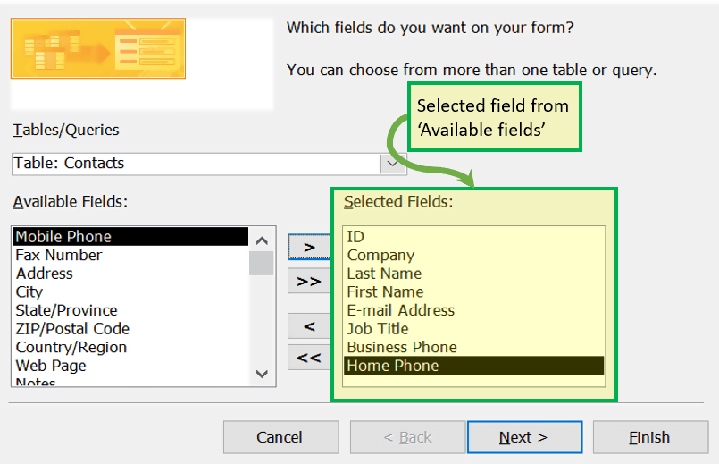](https://www.guru99.com/images/1/041519_1116_MSACCESSTut51.png)

Step 5) Layout selection box will appear which allows the user to select the different type of form layout. Click 'NEXT'

[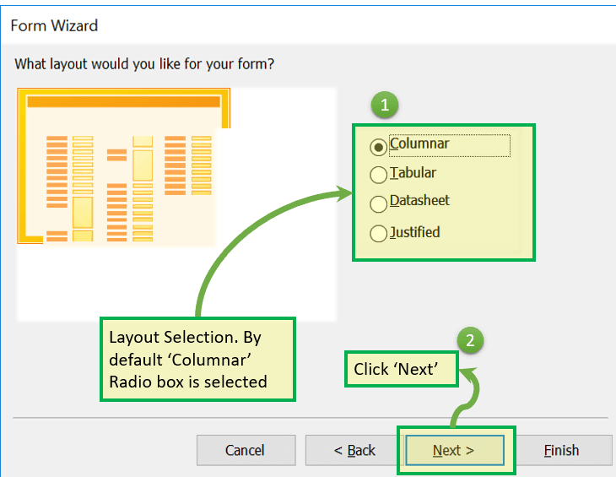](https://www.guru99.com/images/1/041519_1116_MSACCESSTut52.png)

Step 6) Enter the name of the form as "Contact_Form" and click 'Finish.'

[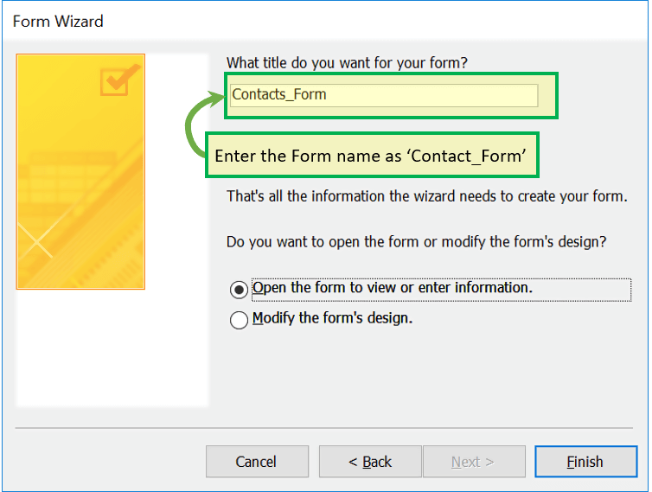](https://www.guru99.com/images/1/041519_1116_MSACCESSTut53.png)

Result: Contact_Form now exist with all column displayed which are there in step 4 in the Selected column list.

[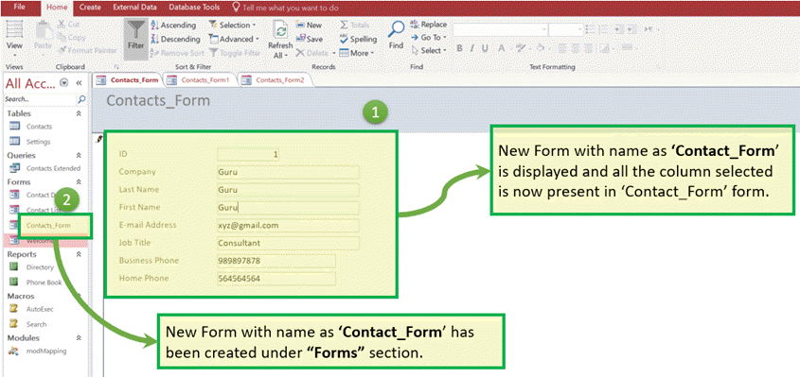](https://www.guru99.com/images/1/041519_1116_MSACCESSTut54.png)

### 2. Create using Form

It is the simplest way to create the form which will:

* By default, populate all the column from the selected table in 'form view,'
* The user can delete non-required column manually

Step 1) Select the table for which we want to create the form and click on 'Form.'

[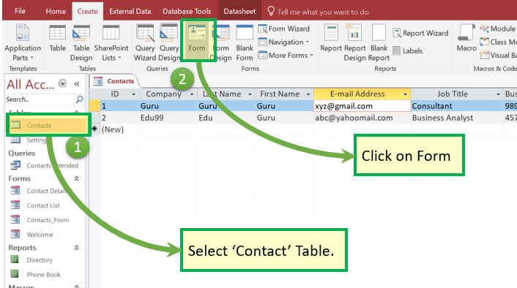](https://www.guru99.com/images/1/041519_1116_MSACCESSTut55.png)

Step 2) Below window will appear.

[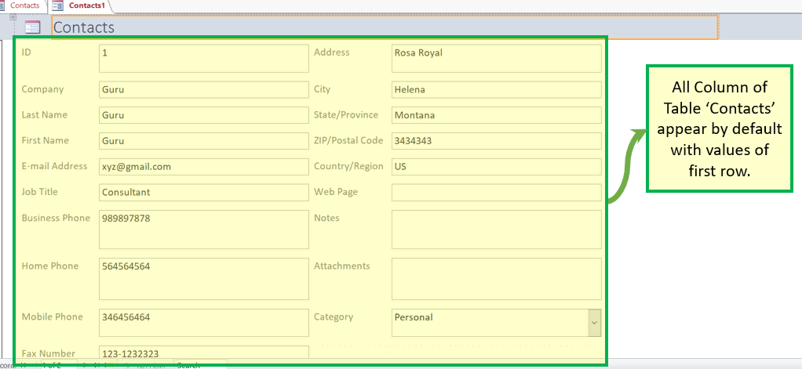](https://www.guru99.com/images/1/041519_1116_MSACCESSTut56.png)

Step 3) Right-click on any cell which we don't want to be part of final forms and click on 'Delete.'

[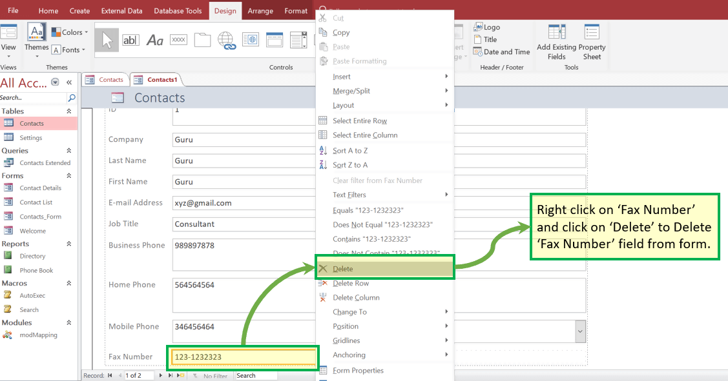](https://www.guru99.com/images/1/041519_1116_MSACCESSTut57.png)

Result: 'Fax Number' field does not exist now.

[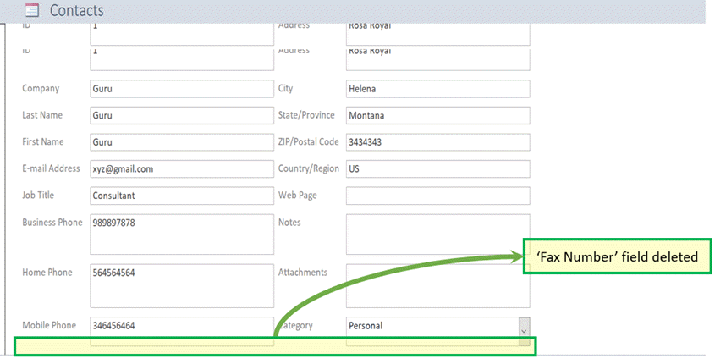](https://www.guru99.com/images/1/041519_1116_MSACCESSTut58.png)

Step 4) Press 'Ctrl+S' and enter new Form Name as 'Contact_Form2'. Click 'OK'.

[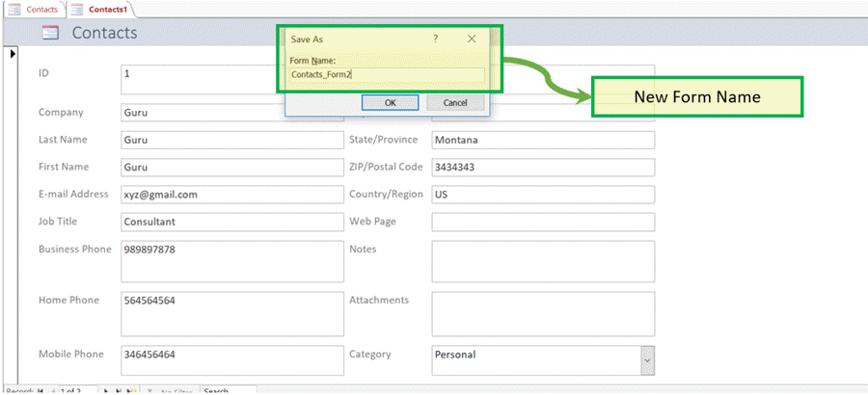](https://www.guru99.com/images/1/041519_1116_MSACCESSTut59.png)

Result: New form with the name as 'Contact_Form2' exists under the "Forms" section.

[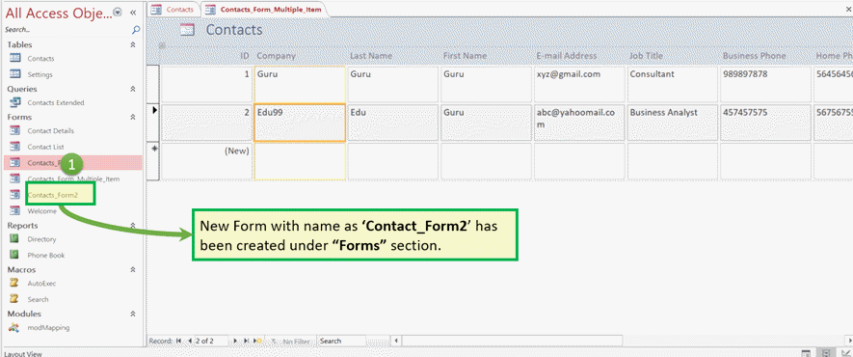](https://www.guru99.com/images/1/041519_1116_MSACCESSTut60.png)

### 3. Create form by 'Multiple Item.'

It is another type wherein All the records already created will be displayed in Form with an option to Add new record.

Step 1) From the 'Create' tab. Click on 'More forms' and select 'Multiple Items.'

[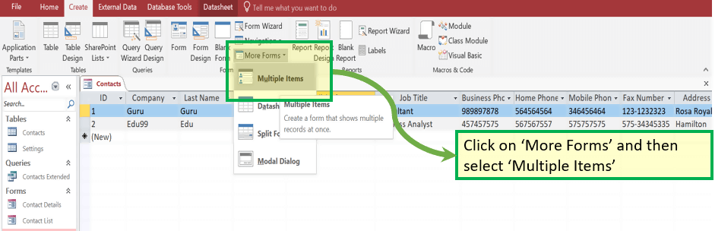](https://www.guru99.com/images/1/041519_1116_MSACCESSTut61.png)

Result: Below Multiple lines, the window will appear

[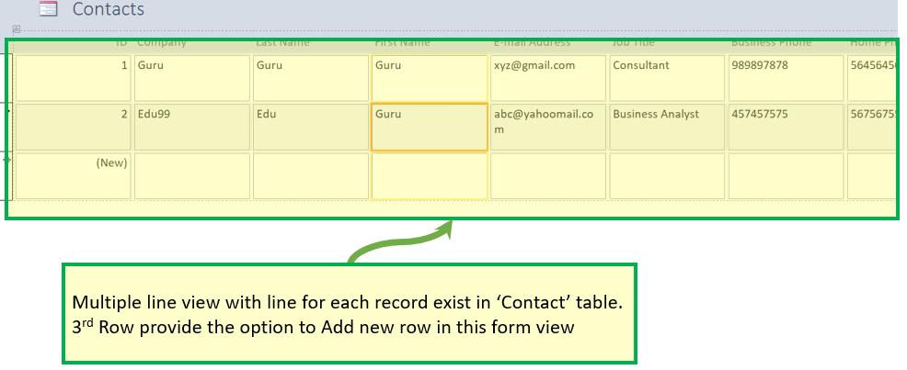](https://www.guru99.com/images/1/041519_1116_MSACCESSTut62.png)

Step 2) Press 'Ctrl+S'. Enter the new form name and click 'OK.'

[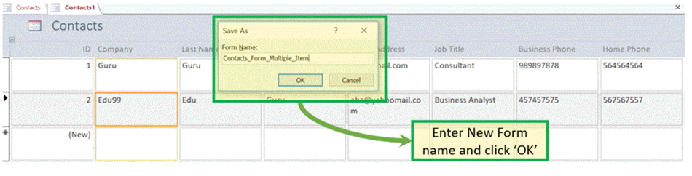](https://www.guru99.com/images/1/041519_1116_MSACCESSTut63.png)

Result: New Form with the name as 'Contact_Form_Multiple_Item' exists under the "Forms" section.

[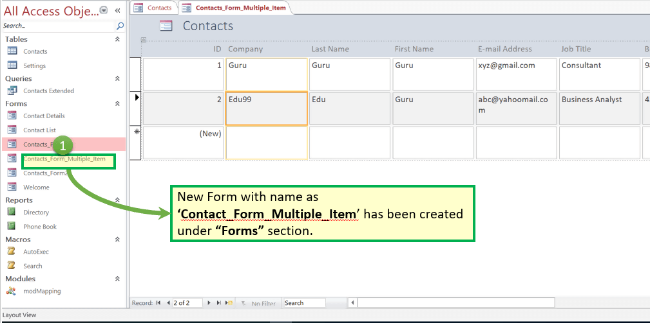](https://www.guru99.com/images/1/041519_1116_MSACCESSTut64.png)

### 4. Create form by 'Split from'.

It is a mix of simple form and split form in a way that this form provides the view of Form and datasheet in a split window.

Whatever the user enters in Form is visible directly in Datasheet view immediately and vice versa.

Step 1) From the 'Create' tab, click on 'More forms' and select 'Split Form.'

[](https://www.guru99.com/images/1/041519_1116_MSACCESSTut65.png)

Result: Below window will appear with the Form and data sheet together.

[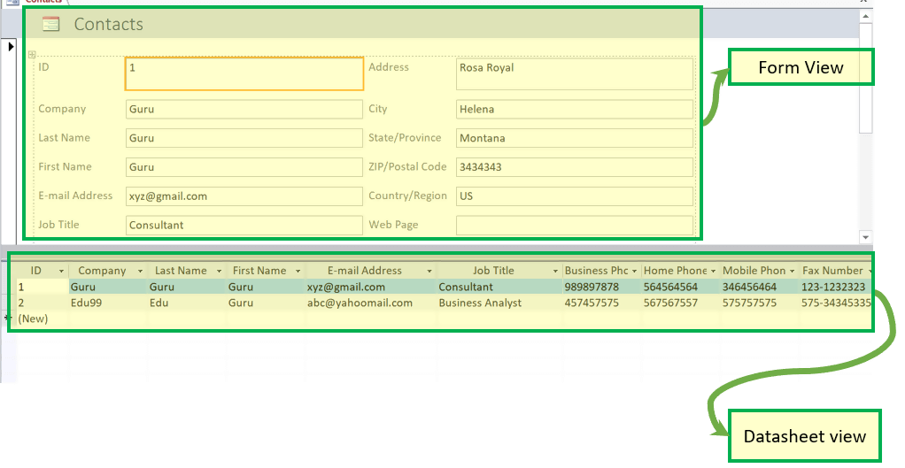](https://www.guru99.com/images/1/041519_1116_MSACCESSTut66.png)

Step 2) Press 'Ctrl+S' and enter the new form name. Click 'OK.'

[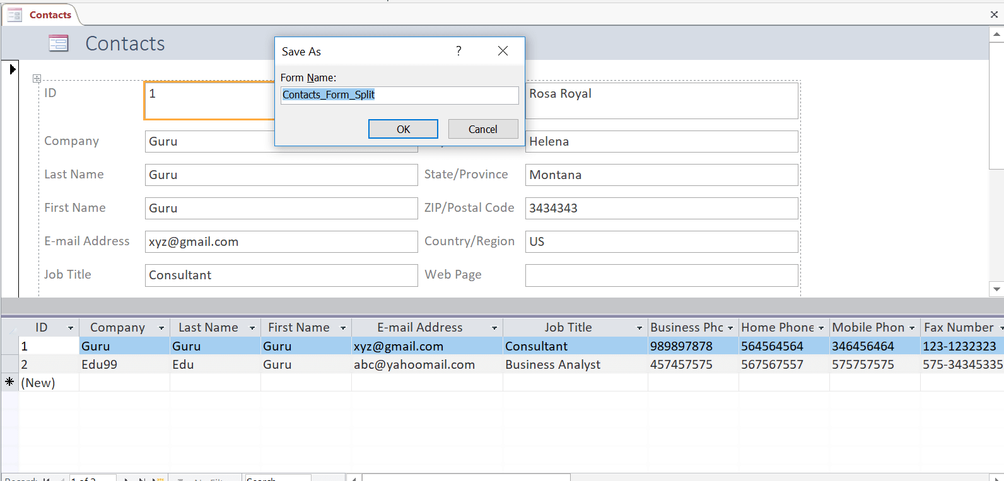](https://www.guru99.com/images/1/041519_1116_MSACCESSTut67.png)

Result: New Form with the name as 'Contact_Form_Split' exists under the "Forms" section.

[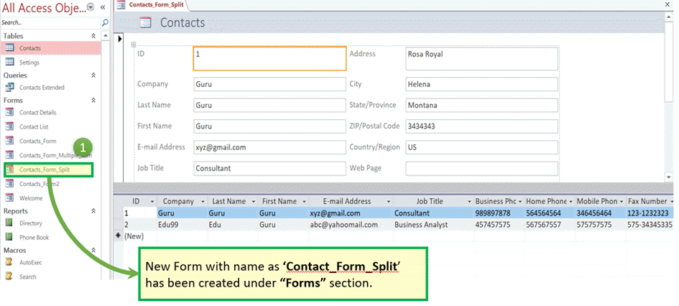](https://www.guru99.com/images/1/041519_1116_MSACCESSTut68.png)

### Edit the existing record via Form.

* One of the features of forms is that we can edit the values and data directly from the form.
* It is more user-friendly because as compared to row format in the table, forms have better visibility of selected fields and the user can do the direct updates.
* These values updated from forms will also be reflected in original tables immediately.

Let's have a look at how to edit value from the form:

Step 1) Click on 'Contact_Form'

[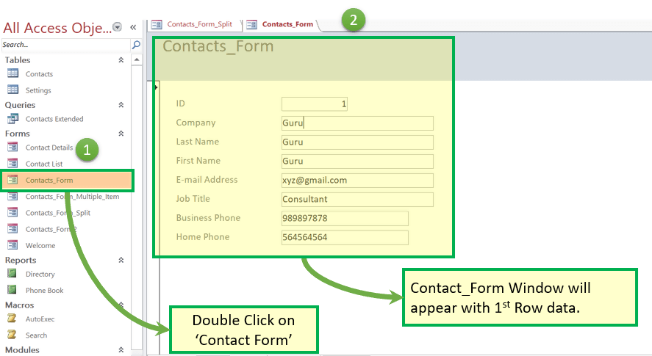](https://www.guru99.com/images/1/041519_1116_MSACCESSTut69.png)

Step 2) Update some values on 'Contact_Form' value

[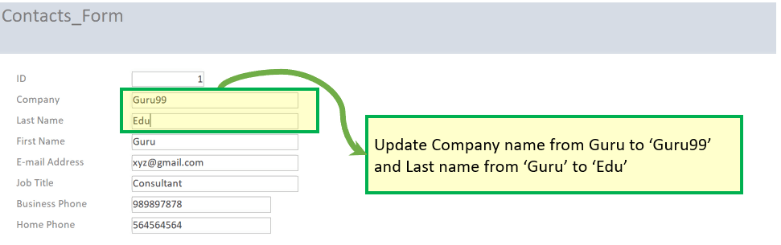](https://www.guru99.com/images/1/041519_1116_MSACCESSTut70.png)

Step 3) Double Click on 'Contact' table.

[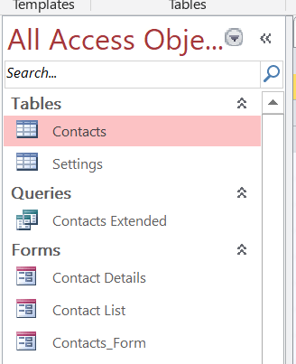](https://www.guru99.com/images/1/041519_1116_MSACCESSTut71.png)

Result: Updated value is present in the original table record.

[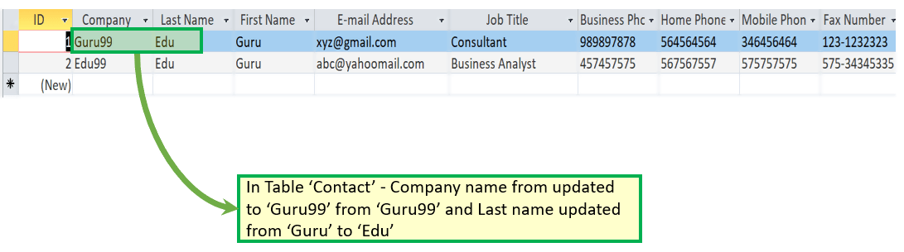](https://www.guru99.com/images/1/041519_1116_MSACCESSTut72.png)

### Add a record to a Form.

* Forms also give the flexibility to Add records.
* Again, this is a user-friendly and appealing way of adding records as compared to adding records in a row form.
* Here, we will take the Microsoft Access databases example of Split from 'Contact_Form_Split' created above.

Step 1) Open 'Contact_Form_Split'

[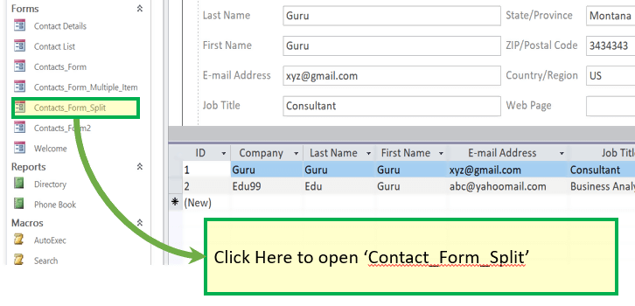](https://www.guru99.com/images/1/041519_1116_MSACCESSTut73.png)

Step 2) To Add record, click on 'New (blank) Record Icon.'

[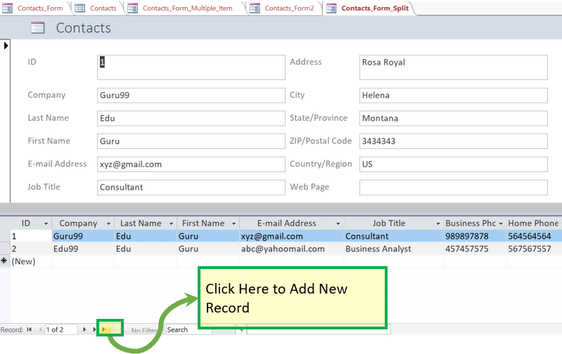](https://www.guru99.com/images/1/041519_1116_MSACCESSTut74.png)

Result: New record window appear in:

1. Form View and
2. Datasheet View.

[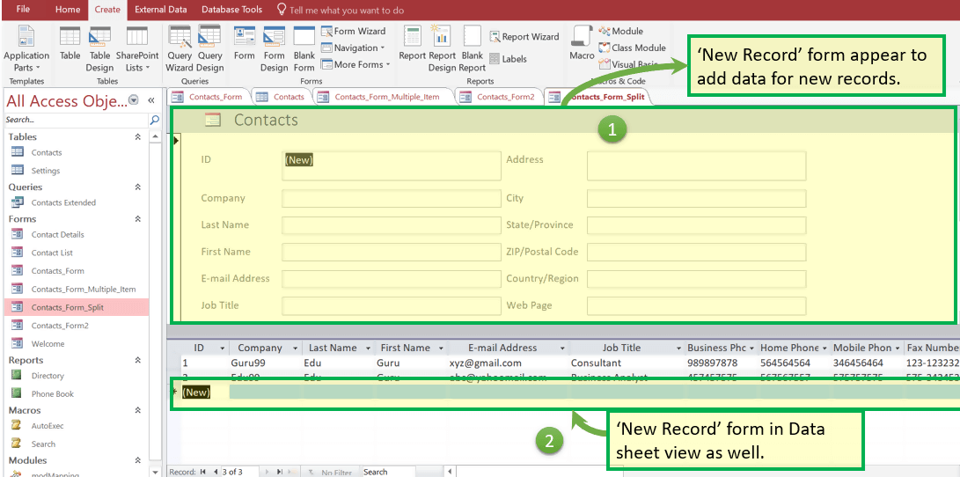](https://www.guru99.com/images/1/041519_1116_MSACCESSTut75.png)

Step 3) Manually fill the data from Form. Note that in split form all data will be automatically reflected in below data sheet as well.

[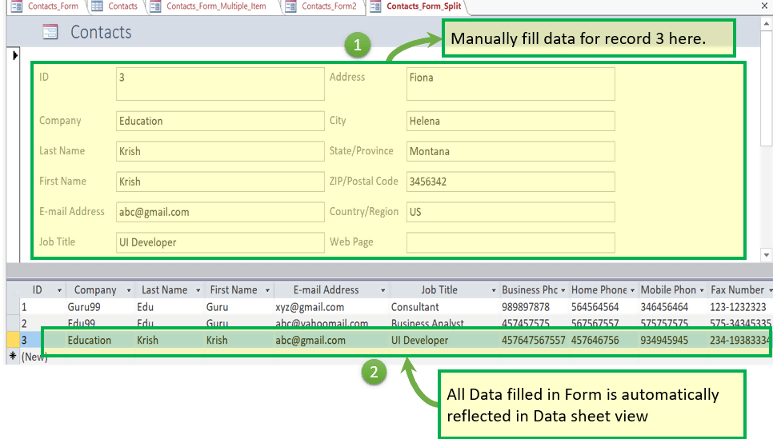](https://www.guru99.com/images/1/041519_1116_MSACCESSTut76.png)

Step 4) Double Click on 'Contact' table.

[](https://www.guru99.com/images/1/041519_1116_MSACCESSTut77.png)

Result: New Record updated to 'Contact' Table added from Form 'Contact_Form_Multiple_Item'

[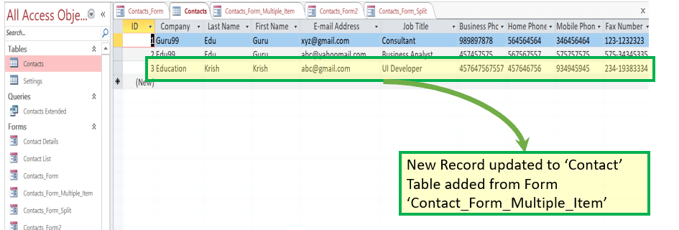](https://www.guru99.com/images/1/041519_1116_MSACCESSTut78.png)

## Report

* A report is an object in MS Access that is designed for formatting, calculating and printing selected data in an organized way.
* It contains information from tables and also information that are there in the report design.
* Reports are helpful as they allow you to present all information of your database in an easy-to-read format.

Let's take an MS Access databases example of 'Contact' DB default report – 'Phone Book.'

Step 1) Click on 'Phone Book' under 'Report' section. The system will open the inbuilt 'Phone Book' report.

It will display Contact Name, Home, Business and Mobile name displayed

for each record present.

[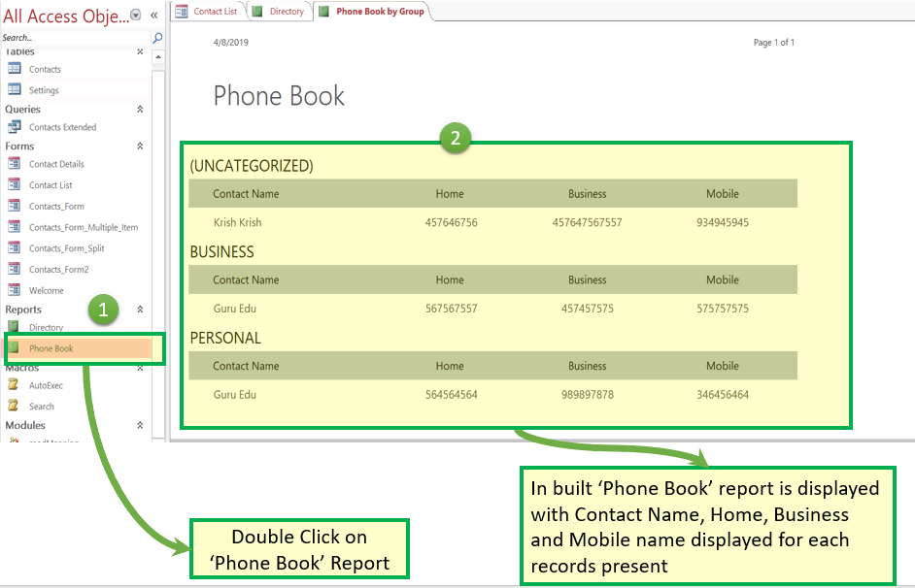](https://www.guru99.com/images/1/041519_1116_MSACCESSTut79.png)

Step 2) Now suppose that we want to edit the report Heading from 'Home' to 'Home Number.' Right click and click on 'Design View.'

[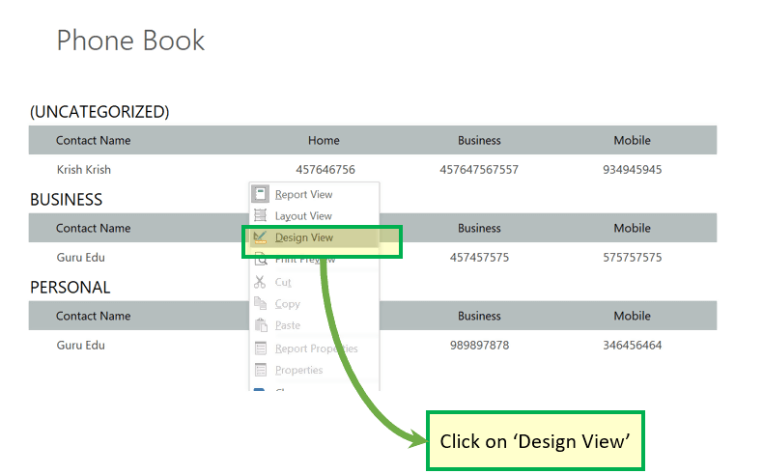](https://www.guru99.com/images/1/041519_1116_MSACCESSTut80.png)

The system will open the Report in Design view.

[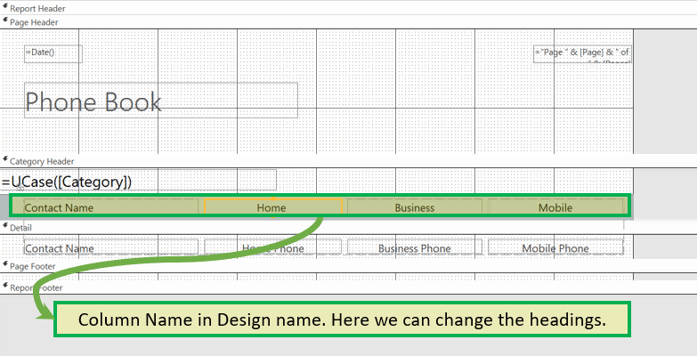](https://www.guru99.com/images/1/041519_1116_MSACCESSTut81.png)

Step 3) Edit the name you want to update and Press 'Ctrl+S'.

[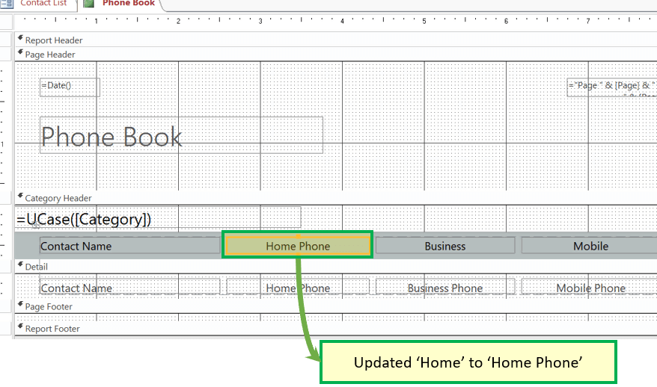](https://www.guru99.com/images/1/041519_1116_MSACCESSTut82.png)

Step 4) Double click 'Phone book' under reports

Result: Label is updated from 'Home' to 'Home Phone.'

[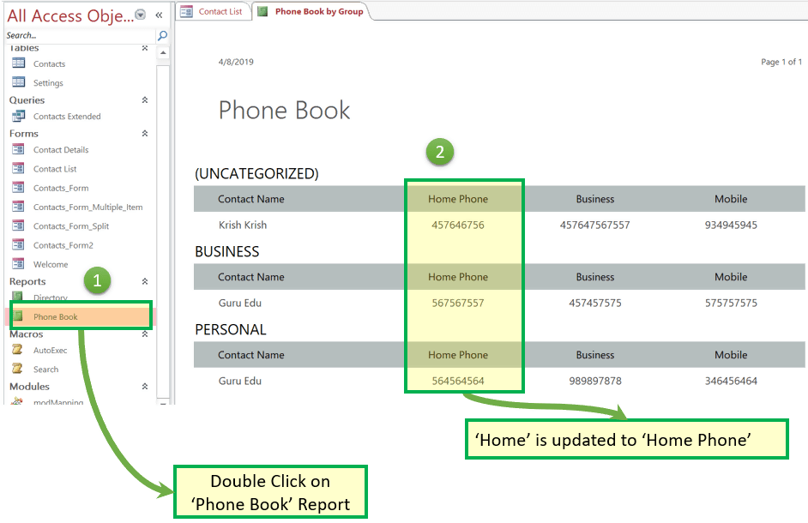](https://www.guru99.com/images/1/041519_1116_MSACCESSTut83.png)

# Experiment#14

## Macro

* Macro in MS Access is a time-saving feature that allows you to add functionality or automate simple tasks.
* Steps that are of frequently used can be automated using a macro
* It can add a quick and easy approach to link all other objects together to create a simple database application.

Let take an Microsoft Access databases example of 'Contact' DB default Macro – 'AutoExec.'

Step 1) Click on 'AutoExec' under 'Report' section. The system will open the inbuilt 'Welcome' Macro. It will display Welcome note and other data related to contacts Database which has its code into default 'AutoExec' Macro

[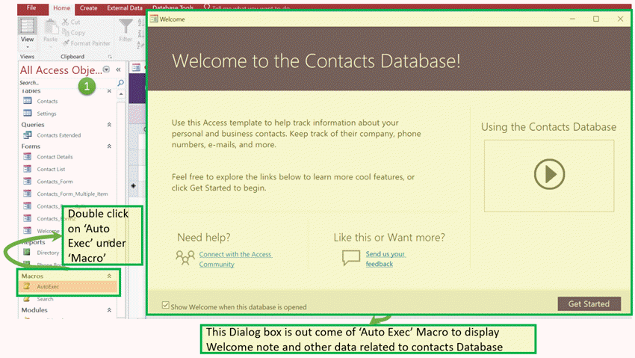](https://www.guru99.com/images/1/041519_1116_MSACCESSTut84.png)

Step 2) If you want to see the code behind this macro right click.

[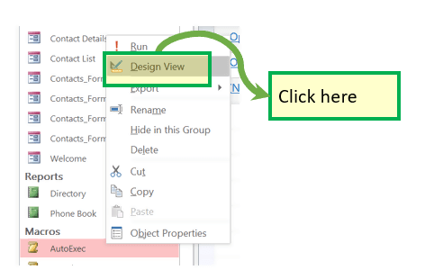](https://www.guru99.com/images/1/041519_1116_MSACCESSTut85.png)

[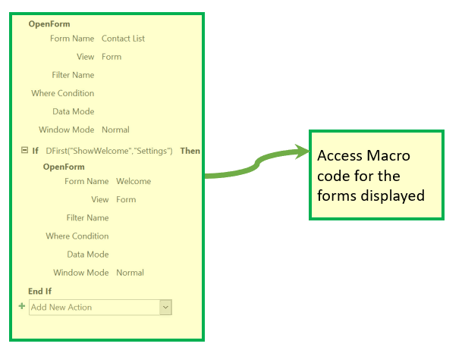](https://www.guru99.com/images/1/041519_1116_MSACCESSTut86.png)

## Module

* It is a collection of user-defined functions, declarations, statements, and procedures that are stored together as a unit.
* It perhaps a standalone object having functions that you can call from anywhere in your Access database.

MS Access databases example from 'Contact' DB

Step 1) Click on 'modMapping'

[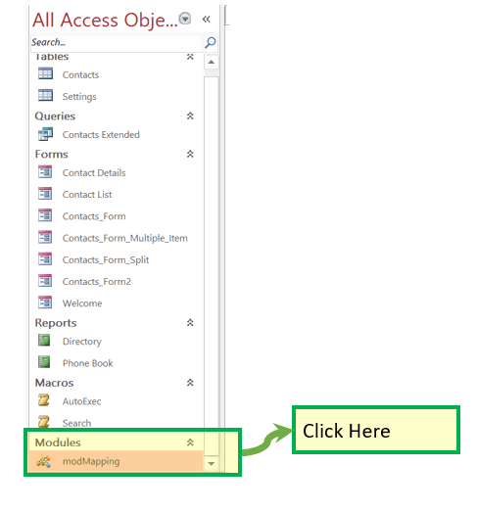](https://www.guru99.com/images/1/041519_1116_MSACCESSTut87.png)

[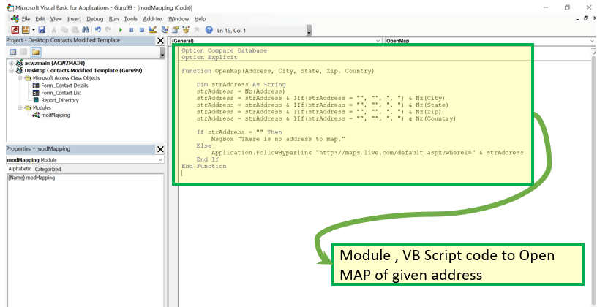](https://www.guru99.com/images/1/041519_1116_MSACCESSTut88.png)

# Experiment#15

# OBJECTIVES

After these Lab students shall be able to perform

* **What are macros.**
* **What are Window Forms**
* **Create From in Excel and manage them**
* **Develop an CURD Application in Excel using Forms and Macros.**
* **Design Cart on Data entered from Form**

# PRE-LAB READING ASSIGNMENT

Remember the previous Lab.

# How to Create User Forms in Excel?

Excel User Forms are automated interactive graphical user interfaces that are proven to be handy while storing and manipulating complex organized data.

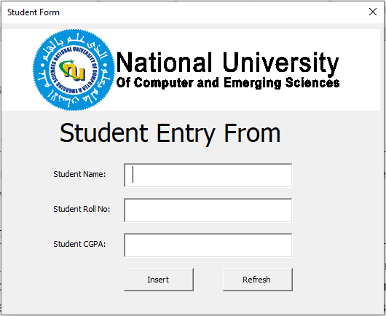

# What Are Excel User Forms?

The Excel  User Forms are customized user interfaces that can be designed and developed within [Excel VBA](https://www.simplilearn.com/tutorials/excel-tutorial/excel-vba). The Excel User Forms enable interaction between the excel spreadsheet or the database via a graphical user interface and helps in data storage, manipulation, and retrieval.

Following this brief introduction of Excel user forms, you will now look into how to create the excel user forms in real-time.

# How to Create an Excel User Form?

It is possible to create the Excel user forms using the Excel VBA. Hence, it is necessary to enable the Excel Developer tools. **Let's Get Started!**

Open up Microsoft Excel.

Enable the Developer tab to bring up the Visual Basic for Applications Editor. Go to File (top left of Excel).

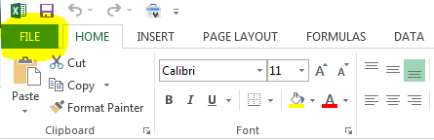

Select "Options" at the bottom.

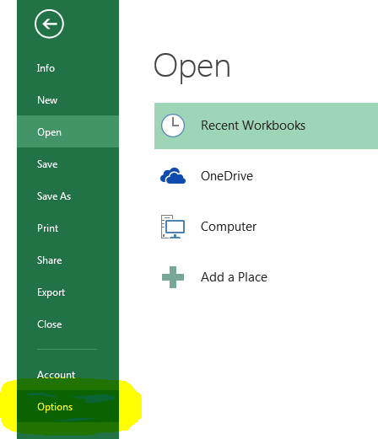

Select Customize Ribbon in the Excel Options window.

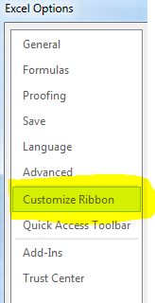

Under Main Tabs, check the Developer box. Click OK.

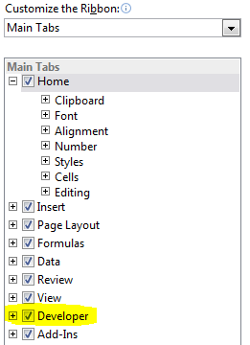

The Developer tab should now be visible in the Microsoft Excel ribbon.

This will navigate you to the Excel Options. Here, choose the customize ribbon option and click on the check box of the developer option as shown below.

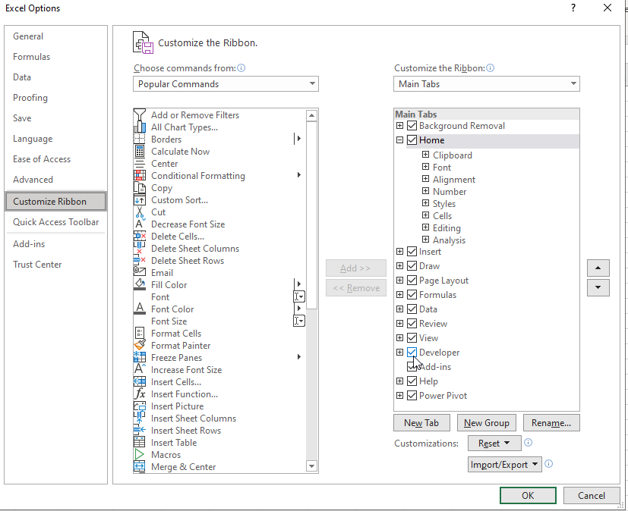

Now you have the developer option enabled on your toolbar in Excel, as explained.

You can see the first option that reads as Visual Basics. This is our VBA. Click on the option, and it will redirect you to Visual Basic for Applications window, as shown below.

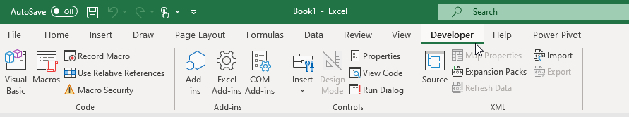

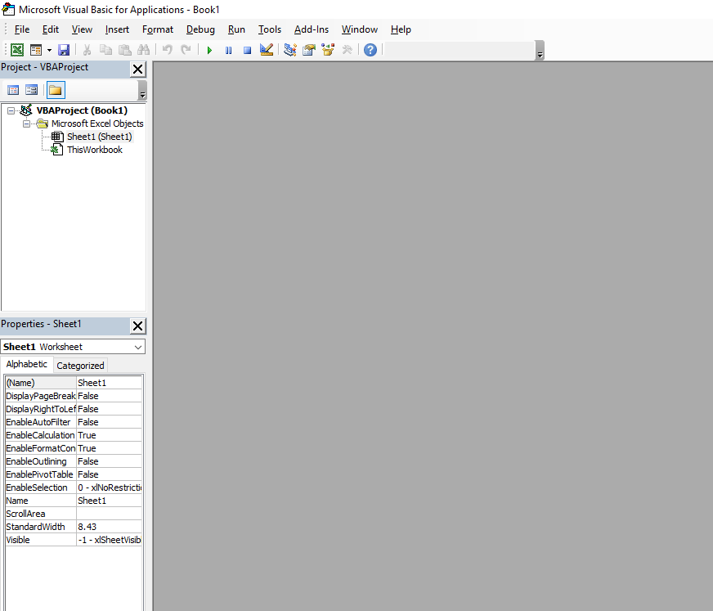

Select the insert option and select the user from the option. This will help you with a new user form in Excel, as shown below.

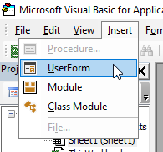

The tiny tray on the right side is a toolbar helps you with a variety of options, such as the following:

* Text box
* Label
* Toggle button
* Command Button
* Frame
* Tab Strip, etc

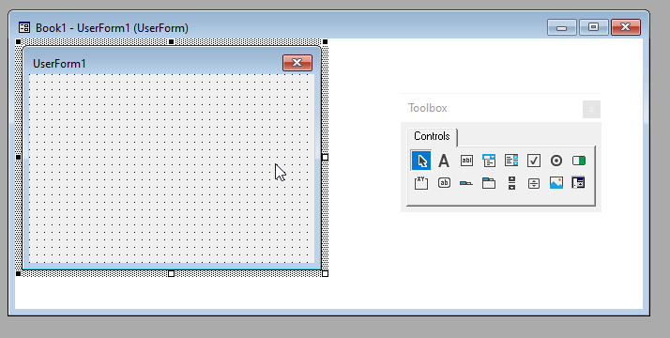

Another crucial tiny window is the Excel user forms property window. This is where you edit the properties of Excel user forms. The properties include the following:

* Visual themes
* Name of the user form
* Colour of the labels and icons on the user form, etc.

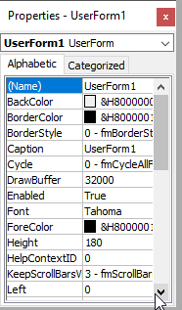

Now, to create user forms in Excel, all you need to do is have a design idea and use the options of label, text box, and other available options to build it. You can build your own Excel user forms by selecting the options from the tool tray or dragging and dropping the options onto the user form.

Here, this example has created an Employee User From in Excel that includes the following:

## Labels:

* Student Name
* Student Roll No:
* CGPA

Text Boxes for the Labels as mentioned above:

* A text box for Student Name: StudentName
* A text box for Student Roll No: StudentRollNo
* A text box for CGPA: CGPA

## Command Buttons:

* Insert Entry – Button: InsertBtn

Refresh the User Form – Button: RefreshBtn

## Images:

* Image: for University Logo

After the creation of the Excel user form, it appears as follows.

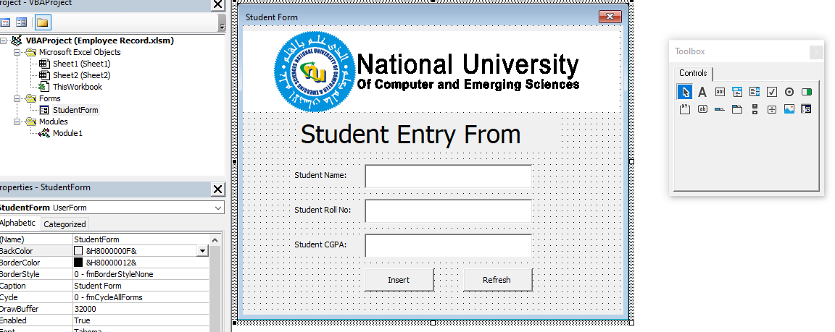

Now, head back to the Excel sheet and create the columns for the data labels. Here, there are three data labels, namely:

* Student Name:
* Student Roll No:
* CGPA

The three data columns need to be created in the sheet, as shown below.

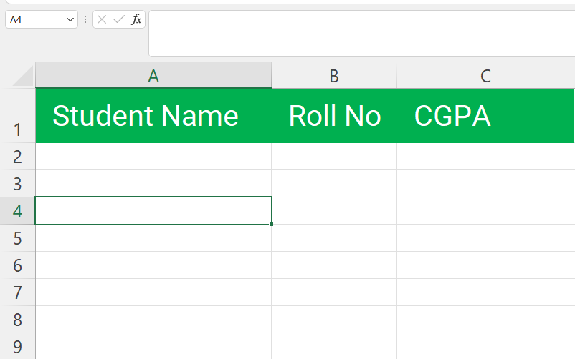

After you create the fundamental requirements of an Excel user form, the next major step is to code the Excel User Form in VBA for operations.

# Coding an Excel User Form

There are two significant instances to code in this particular Excel user form. They are the insert button and refresh button.

You can edit the button code by double-clicking on the button. The following code window will pop up, as shown below.

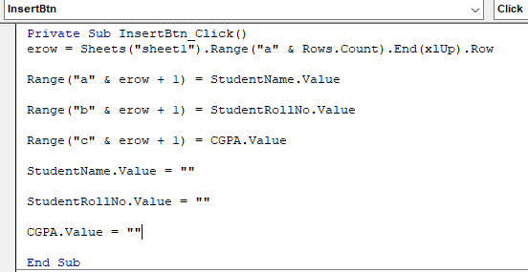

In this window, you need to type in your code for the buttons.

The code used in this example is mentioned below. The first code segment is for click button one or Insert button.

*Private Sub InsertBtn_Click()*

*erow = Sheets("sheet1").Range("a" & Rows.Count).End(xlUp).Row*

*Range("a" & erow + 1) = StudentName.Value*

*Range("b" & erow + 1) = StudentRollNo.Value*

*Range("c" & erow + 1) = CGPA.Value*

*StudentName.Value = ""*

*StudentRollNo.Value = ""*

*CGPA.Value = ""*

*End Sub*

The Second Code segment is for click button two or the refresh button.

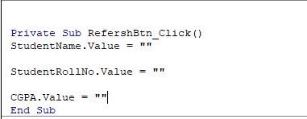

*Private Sub RefershBtn_Click()*

*StudentName.Value = ""*

*StudentRollNo.Value = ""*

*CGPA.Value = ""*

*End Sub*

Once you are done with the coding part, you can choose to run the program using the play option from the toolbar.

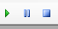

The following user form will appear on your screen, and you can enter the data in the user form, and it will reflect the same on your sheet as shown below.

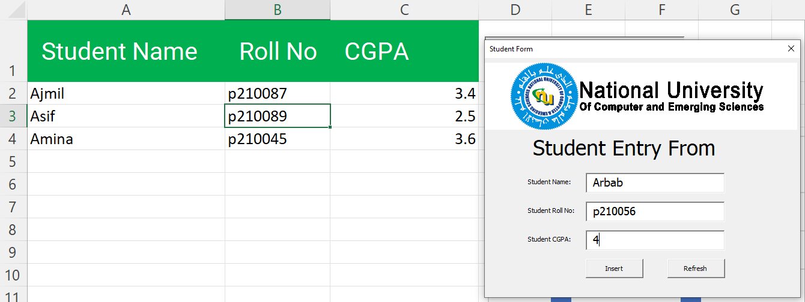

The next part is not mandatory but can be helpful as a creative shortcut for your user form in Excel. This is developed using the Macros in Excel.

# Creating a Macro for Excel User Form

To create a shortcut button for your user form using macros in Excel, you need to follow the steps mentioned below.

Select the Insert option and choose the new module option as shown below.

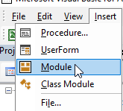

A new code editor will be open on your screen, type the following code mentioned below and save it as shown below.

*Sub ShowStudentFrom()*

*StudentForm.Show*

*End Sub*

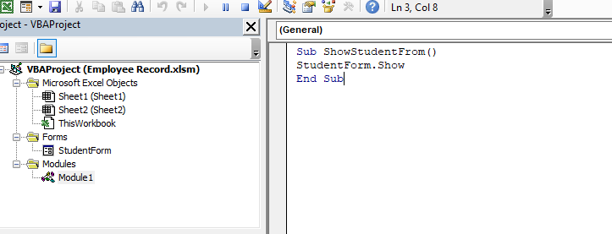

Now, get back to your Excel sheet and enter the developer tool window and insert a button as shown below.

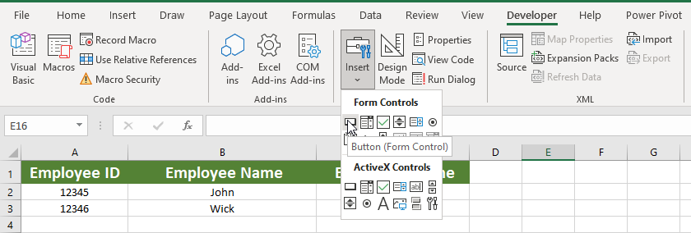

It will show a new window on the screen, which asks you to assign a new macro. You have already designed, developed, and declared a Macro by the name "*ShowStudentFrom*". Select the macro and press ok.

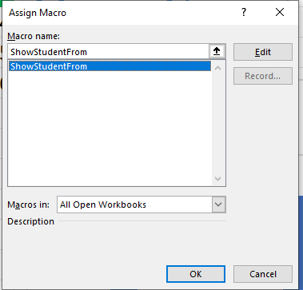

Now, edit the button name as per your requirement, and the process is finished. The final button will look as follows.

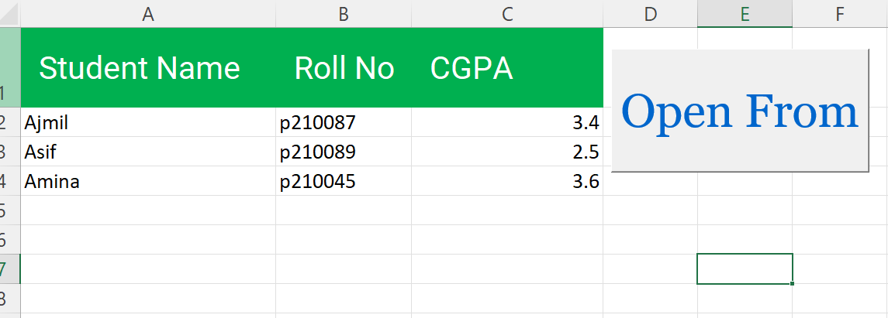

# Create Cart on students records

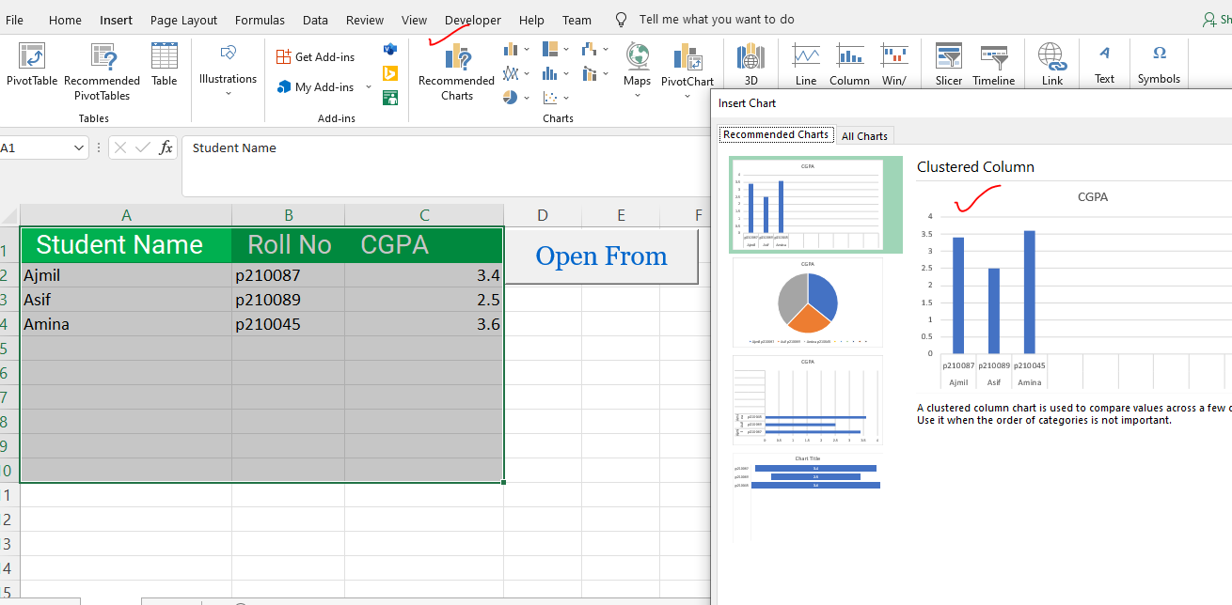

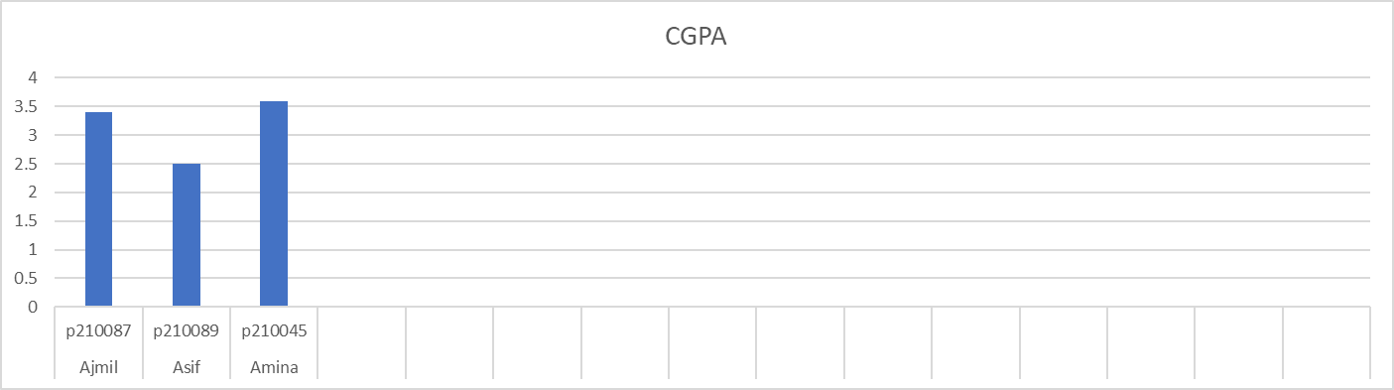

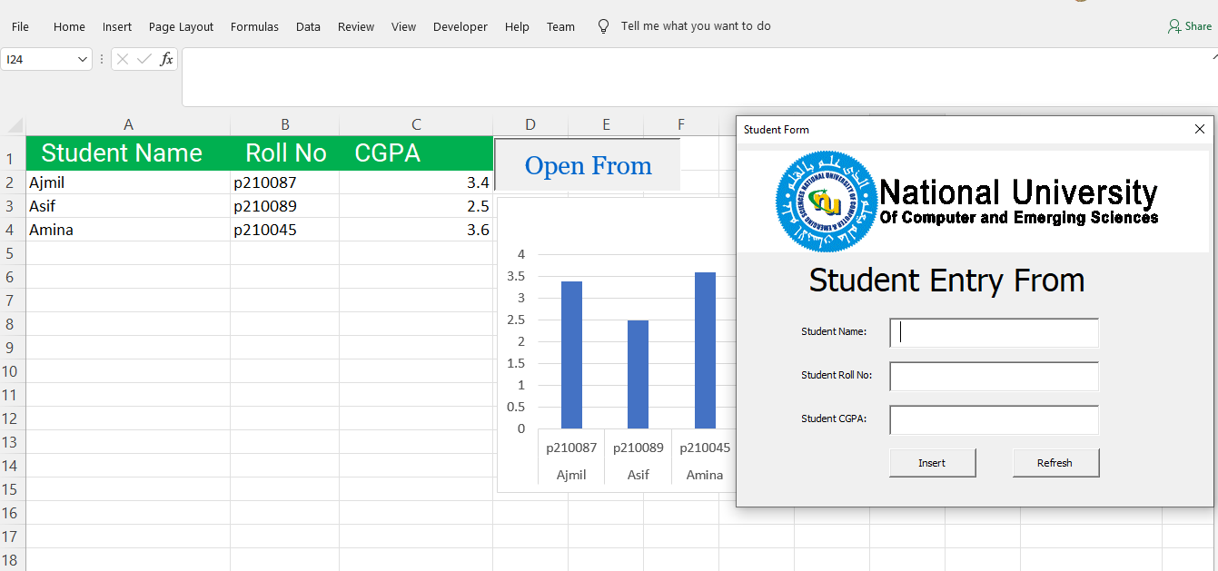

# Tasks for students:

* **Perform CRUD Operation for Students attendance.**

# References

## <https://www.simplilearn.com/tutorials/excel-tutorial/userform-in-excel?source=sl_frs_nav_playlist_video_clicked>

## <https://powerspreadsheets.com/create-excel-userforms/>

## <https://www.contextures.com/xluserform01.html>

## <https://trumpexcel.com/data-entry-form/>

## <https://thedatalabs.org/how-to-create-a-multi-user-data-entry-form-in-excel-step-by-step-guide/>

# Experiment#16